Spherical Bodies: Shape Evidence
  - GROW · Science · 40 minutes
I can use observations from different viewpoints to describe the Sun, Earth and Moon as approximately spherical bodies.
Name: __________________________ Date: ______________
You may write, type, say, sign, point or direct a partner. An adult can read the words and record your exact response. Keep the choice and explanation your own.

Words for this lesson
Word | Meaning
sphere | ball shape
disc | flat circle
approximately | close to

First idea
A distant body looks like a circle in one photograph. What shape do you predict it is? First ideas are held, not marked.
A. It must be a flat disc.
B. It must be a sphere.
C. One view is not enough; collect shape evidence from other views.
My first idea and reason:

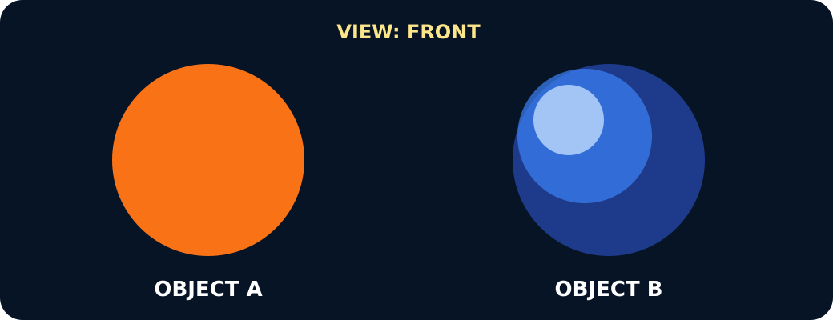
A disc and a sphere both look round from the front

We do · choose, explain, check
Which observation best separates a sphere from a flat disc?
A. Both look circular from directly in front.
B. The sphere keeps a round outline when turned; the disc narrows.
C. Both can roll in some way.
My choice: ______ Evidence or reason:

Shape evidence sorter
Sort model observations and real space evidence. Use both kinds before making the shape claim.
Read or hear one card. Choose a group. Give the evidence. A partner checks your reason before you move on. Point or write card numbers; cutting is optional.
Group | Card numbers and evidence
Flat disc evidence
Sphere model evidence
Real space evidence

Activity cards
1 · Object A · front | 2 · Object A · edge
It looks circular from the front but becomes oval as it turns. | It becomes a very thin line when viewed edge-on.

3 · Object A · full turn | 4 · Object B · front
Its outline repeats circle, oval, line, oval, circle. | It has a round outline from the first viewpoint.

5 · Object B · quarter turn | 6 · Object B · edge direction
After a quarter turn, its outline remains round rather than becoming oval. | From the direction that made the disc a line, this object still looks round.

7 · Spacecraft views | 8 · Lunar eclipse
Pictures taken from changing positions and times show Earth and the Moon with round whole-body outlines. | When Earth passes between the Sun and Moon, Earth's shadow moving across the Moon has a curved edge.

9 · Curved day-night edge | 10 · Sun observations
Space images show a curved line between day and night moving across Earth and the Moon as lighting and viewpoint change. | Space instruments show the Sun's curved edge, while visible features move across its face as the Sun rotates.

Use one model comparison and one real space observation to justify your conclusion.

Your lesson record
Create a multi-view evidence case that distinguishes a disc from a sphere and applies the conclusion to the Sun, Earth and Moon.

Model helps us see
Use the comparison frame: When turned, the disc __, but the sphere __. Therefore…

Model does not show
A smooth classroom ball hides mountains, valleys, craters and slight flattening. It models overall shape only.

Supported
Sort six view cards, then complete: A disc changes from __ to __. A sphere stays __.
Use picture choices and the words disc, sphere, flat, round. An adult may scribe exact words.

Standard
Record three views of each model, then add one real space observation before making the shape claim.
Use one model difference, one real observation and the phrase approximately spherical.

Stretch
Explain why one circular picture is insufficient and why perfect sphere is also too strong.
Discuss another possible shape, several pieces of evidence that agree and a model limitation.

Evidence target
A three-view model comparison, one cited real space observation and a conclusion naming the Sun, Earth and Moon as approximately spherical.

Exit, Audience and evidence · W9A
Supported: Point or complete: a disc is __; a sphere is __. The Sun, Earth and Moon are close to __ shapes.

Standard: Use one model observation and one real space observation to explain why Earth is described as approximately spherical.
Stretch: Explain why both ‘flat disc’ and ‘perfect sphere’ are weaker than the scientific description.

What I said, and what it changed
________________________________________________

Next I will ______.

Adult witness note
What was observed, and with what level of independence?

My evidence and explanation

What does this evidence not show?

Visual reference cards
These are diagrams or model views from the uploaded lesson. Use their labels and the card descriptions; they are not photographs of your own results.
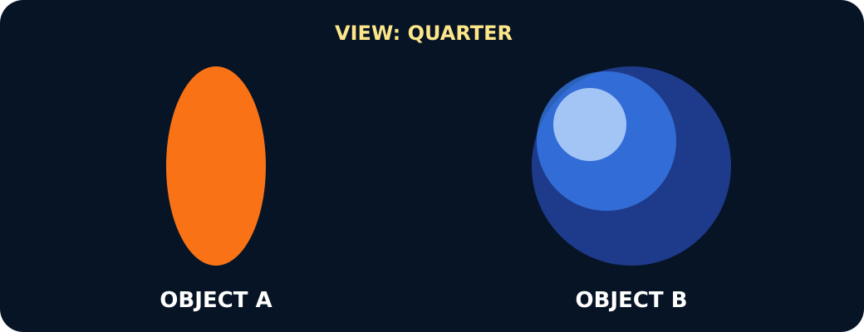
After a quarter turn the disc looks oval, the sphere still round
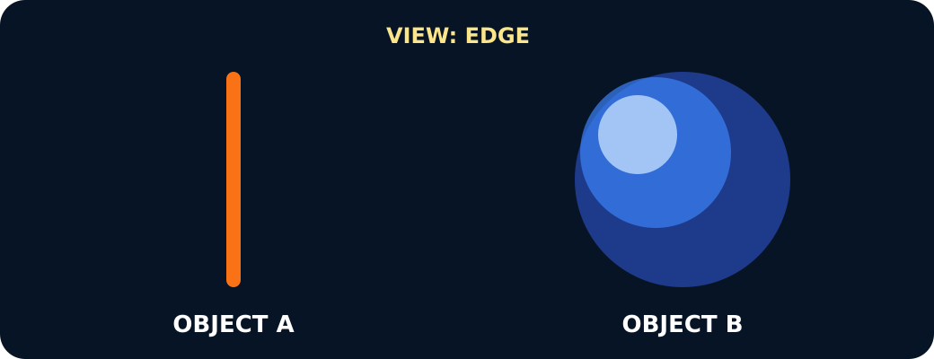
From the edge the disc is a line, the sphere still round

A disc and a sphere seen from the chosen viewpoint

Exit · one next step
After the adult has listened, what will you keep, improve or check next?

