Spherical Bodies: World Shape Lab
  - GROW · Science · 40 minutes
I can collect fair comparison observations and combine them with real space evidence to describe the Sun, Earth and Moon as approximately spherical.
Name: __________________________ Date: ______________
You may write, type, say, sign, point or direct a partner. An adult can read the words and record your exact response. Keep the choice and explanation your own.

Words for this lesson
Word | Meaning
observation | what is noticed
comparison | same test for both
conclusion | what the evidence means

First idea
Which result would most strongly challenge a flat-disc model? Commit before seeing the method.
A. The body looks circular from the front.
B. The outline stays round from front, quarter and edge directions.
C. The object can move across a table.
My first idea and reason:

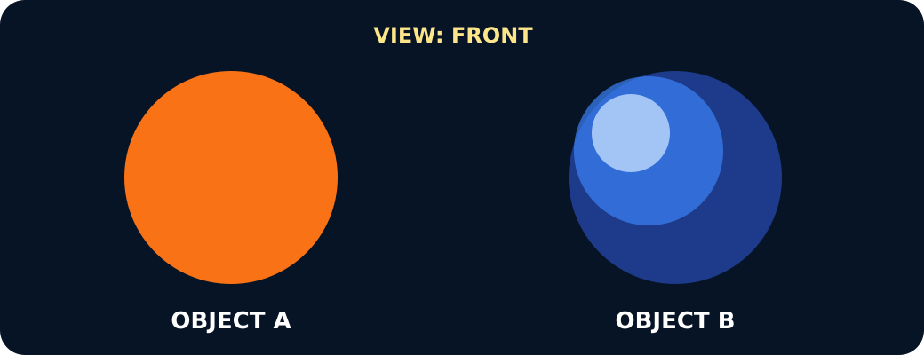
Both objects round from the front

We do · choose, explain, check
Which method gives the fairest shape comparison?
A. View the disc close-up and the sphere from across the room.
B. Use the same distance and the same three viewpoints for both.
C. View only the front of whichever object looks roundest.
My choice: ______ Evidence or reason:

Six-observation world shape lab
Sort the model results and real space observations, then freeze enough evidence for a careful conclusion.
Read or hear one card. Choose a group. Give the evidence. A partner checks your reason before you move on. Point or write card numbers; cutting is optional.
Group | Card numbers and evidence
Disc record
Sphere model record
Real space record

Activity cards
1 · Front result | 2 · Quarter-turn result
Round from the front, then oval after the object turns. | An oval outline reveals that the circular face is tilted away.

3 · Edge result | 4 · Front result
A thin line is seen from the edge direction. | A round outline is seen from the first direction.

5 · Quarter-turn result | 6 · Edge-direction result
The outline remains round after the same quarter turn. | The outline is still round from the direction that made the disc a line.

7 · Changing spacecraft views | 8 · Earth's eclipse shadow
Images from changing positions and times show Earth and the Moon with round whole-body outlines. | During a lunar eclipse, the edge of Earth's shadow moving across the Moon is curved.

9 · Moving day-night edge | 10 · Sun's curved edge
Space images show a curved day-night line moving across Earth and the Moon as the view and lighting change. | Space instruments show a curved Sun edge and features moving across its face as the Sun rotates.

Use one paired model view and one real space observation in your conclusion.

Your lesson record
Complete the fair three-view comparison and present an evidence-led conclusion about Solar System body shape.

Model helps us see
Record with the frame: From the __ view, the disc looked __ while the sphere looked __.

Model does not show
The models show overall shape but not real size, surface detail, gravity, distance or the slight flattening of rotating bodies.

Supported
Complete a six-row picture table and choose the conclusion supported.
Use outline choices: round, oval, line. Finish: This supports __ because….

Standard
Record all six model observations, add one real space observation and justify the approximately spherical description.
Cite a matched model view and a real observation; keep observations separate from the conclusion.

Stretch
Evaluate the evidence, identify an alternative explanation from one view and state why combined views are stronger.
Include a fair comparison, several pieces of evidence that agree and a model limitation.

Evidence target
Six model observations, one named real space observation, an approximately spherical conclusion and one model limitation.

Exit, Audience and evidence · W9B
Supported: Choose the result that shows a sphere and say or point to why it is different from a disc.

Standard: Cite one paired model view and one real space observation to justify approximately spherical.
Stretch: Evaluate how strong the lab evidence is and name one extra real-world observation that would strengthen it.

What I said, and what it changed
________________________________________________

Next I will ______.

Adult witness note
What was observed, and with what level of independence?

My evidence and explanation

What does this evidence not show?

Visual reference cards
These are diagrams or model views from the uploaded lesson. Use their labels and the card descriptions; they are not photographs of your own results.
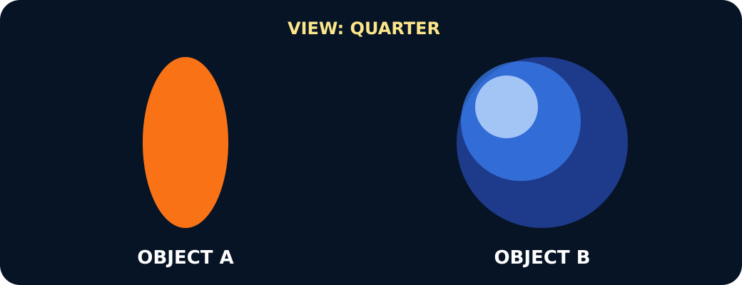
One oval, one round after the same turn
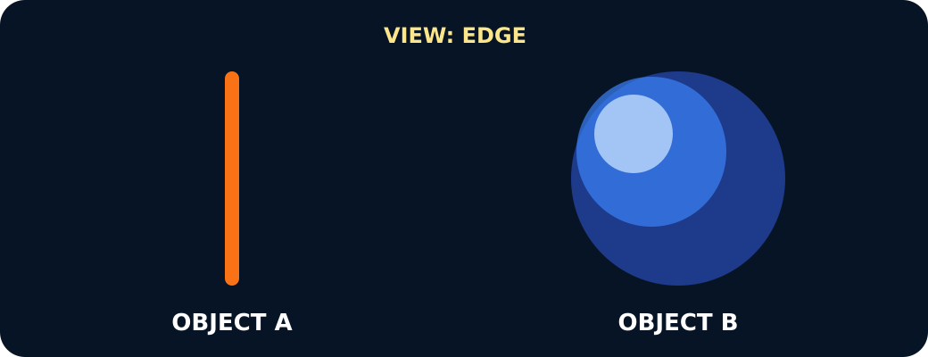
One a line, one round from the edge

A disc and a sphere seen from the chosen viewpoint

Exit · one next step
After the adult has listened, what will you keep, improve or check next?

