Topics 2 and 3 assessment review map
  - LAUNCH · Science · 40 minutes
Organise the Topic 2 and 3 knowledge to be reviewed and plan how to show it in the supplied assessment.
Name: __________________________ Date: ______________
You may write, type, say, sign, point or direct a partner. An adult can read the words and record your exact response. Keep the choice and explanation your own.

We do · make a choice and give a reason
An approved response route can be written, selected, spoken, signed, pointed to or exactly scribed. A missing or uncertain item stays visible for the next authorised check instead of being guessed.
My choice and the evidence I used:

Resources and independent record
LAUNCH Science · Week 15L1 · Topics 2 and 3 assessment review map
Objective: Organise the Topic 2 and 3 knowledge to be reviewed and plan how to show it in the supplied assessment.

A topic 2 and 3 assessment review map working record
Use each row to show the supplied evidence or genuine action, the response about a Topic 2 and 3 assessment review map, and one explanation, boundary or authorised next check.
Focus | Record or action | Explanation, response or limit
Supplied evidence
Reasoning or action
Boundary and next check

LAUNCH Science · route, audit and learner confirmation

Choose a route

Supported
Match approved question cards to headings, choose a response mode and complete one retrieval frame per heading.

Standard
Organise the full supplied review set, retrieve without the model first and justify the order in which sections will be attempted.

Stretch
Diagnose two likely confusions from the supplied set, design a discriminating retrieval check and explain why it separates the ideas.

Evidence audit
- Source, material or action locator visible:
- Reasoning can be checked:
- Safety and missing status honest:
- Learner's next action received exactly:

Paper route · discuss the lesson choices
Use these choices with the matching teaching stage. Point to or number a choice, explain it, then revisit it after feedback. The original HTML keeps the live controls.
- the order of mitosis stages
- percentage change = (final − initial) ÷ initial × 100
- why observed ratios differ from 3:1
- A pairs with T, C pairs with G
- embryonic vs adult stem cell range
- whether a stem-cell lab result would work in patients
- secure — I can retrieve it now
- needs retrieval practice
- an authorised check is needed
Choice / card | My reason or evidence | My revision after feedback

Visual evidence from the lesson
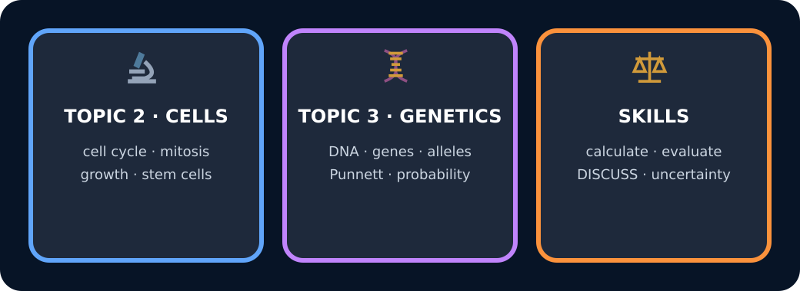
Topics 2 and 3 review map

Exit · one next step
After the adult has listened, what will you keep, improve or check next?

