Topics 2 and 3 evidence task lab
  - LAUNCH · Science · 40 minutes
Work through supplied Topic 2 and 3 questions, recording each response and any uncertainty before choosing a final response.
Name: __________________________ Date: ______________
You may write, type, say, sign, point or direct a partner. An adult can read the words and record your exact response. Keep the choice and explanation your own.

We do · make a choice and give a reason
A response choice is justified by a named feature, pattern or calculation from the supplied task. Uncertainty is not failure: it identifies the exact concept, word or step to retrieve before the assessment response is final.
My choice and the evidence I used:

Resources and independent record
LAUNCH Science · Week 15L2 · Topics 2 and 3 evidence task lab
Objective: Work through supplied Topic 2 and 3 questions, recording each response and any uncertainty before choosing a final response.

Approved topic 2 and 3 evidence tasks working record
Use each row to show the supplied evidence or genuine action, the response about approved Topic 2 and 3 evidence tasks, and one explanation, boundary or authorised next check.
Focus | Record or action | Explanation, response or limit
Supplied evidence
Reasoning or action
Boundary and next check

LAUNCH Science · route, audit and learner confirmation

Choose a route

Supported
Use a prepared OBSERVED / EXPLAINED frame and select the supported response from three approved options.

Standard
Interpret each supplied source, justify a response with a visible evidence link and revise one over-strong answer.

Stretch
Compare two plausible responses, evaluate which uses the evidence more precisely and write a discriminating next check.

Evidence audit
- Source, material or action locator visible:
- Reasoning can be checked:
- Safety and missing status honest:
- Learner's next action received exactly:

Paper route · discuss the lesson choices
Use these choices with the matching teaching stage. Point to or number a choice, explain it, then revisit it after feedback. The original HTML keeps the live controls.
- Observed 31 purple of 40 ≈ 77.5%, consistent with the 75% expected
- The treatment will work in humans
- Strand 2 is TACGGT because A–T and C–G
- The optimum pH is exactly 7.0
- Daughter cells are genetically identical because DNA was copied before division
- supported by the evidence
- uncertainty — must stay visible
Choice / card | My reason or evidence | My revision after feedback

Visual evidence from the lesson
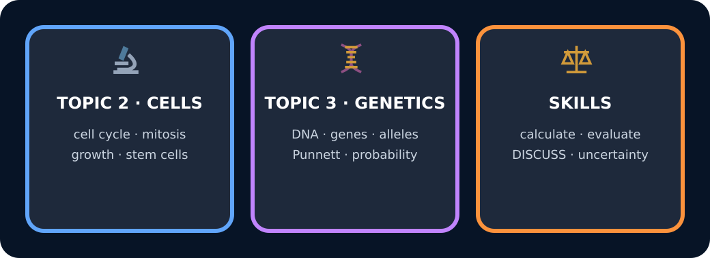
Topics 2 and 3 review map

Exit · one next step
After the adult has listened, what will you keep, improve or check next?

