Growth and Differentiation: Building an Organism
  - LAUNCH · Science · 40 minutes
I can describe how animals and plants grow and explain how differentiation produces cells specialised for particular functions.
Name: __________________________ Date: ______________
You may write, type, say, sign, point or direct a partner. An adult can read the words and record your exact response. Keep the choice and explanation your own.

Words for this lesson
Word | Meaning
growth | increase in size or cell number
elongation | cells become longer
differentiation | cells become specialised

First idea
A young root becomes longer. Which explanation is the most complete starting model?
A. Every root cell simply swells, and no new cells are produced.
B. Cells divide near the tip; some new cells elongate and differentiate as the root grows.
C. Each root cell gains more chromosomes, so the whole root lengthens.
My first idea and reason:

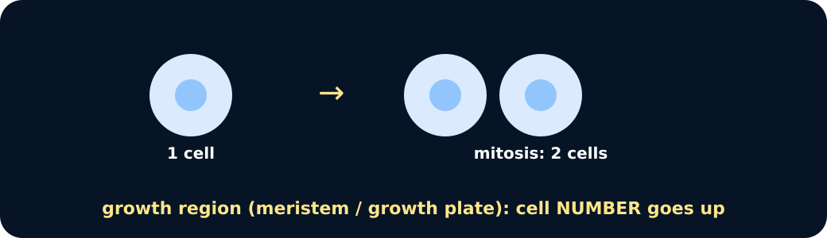
Mitosis increases cell number

We do · choose, explain, check
Which statement correctly compares animal and plant growth?
A. Only animals use mitosis; plants grow only by cells stretching.
B. Both use cell division and differentiation; cell elongation is a particularly important part of plant growth.
C. Both grow because every body cell increases its chromosome number.
My choice: ______ Evidence or reason:

Growth-process routing lab
Route each observation to cell division, cell elongation or differentiation, then build one complete animal or plant explanation.
Read or hear one card. Choose a group. Give the evidence. A partner checks your reason before you move on. Point or write card numbers; cutting is optional.
Group | Card numbers and evidence
CELL DIVISION
CELL ELONGATION
DIFFERENTIATION

Activity cards
1 · More cells near root tip | 2 · Skin repair cells
A labelled image sequence shows one cell giving rise to two cells in the meristem region. | Cell counts beside a small wound increase over several days.

3 · Longer root-zone cells | 4 · Shoot cells extend
Mean cell length rises from 40 µm to 120 µm beyond the dividing region. | Marked cells below a shoot tip become longer while remaining in the same tissue row.

5 · Xylem structures form | 6 · Neurone structures form
Some new plant cells develop thickened walls and a hollow transport pathway. | Some animal cells develop long extensions and specialised connections.

Use one routed observation to explain growth without claiming that chromosome number or every cellular process increased.

Your lesson record
Create and apply a comparison model of animal and plant growth, including one growth-data calculation and one evidence-bounded explanation.

Model helps us see
Use the chain process → cellular change → organ effect. For data, DESCRIBE the measured pattern before using cellular knowledge to EXPLAIN it.

Model does not show
Block and arrow models separate processes that overlap in living tissues. They omit signalling, nutrition, hormones and cell death, and a growth curve cannot show individual cells dividing or differentiating.

Supported
Complete an animal-versus-plant process table, calculate one simple change and use a because sentence to explain one observation.
Choose from division, elongation and differentiation; use final − initial with a pre-set calculator sequence.

Standard
Compare animal and plant growth, calculate percentage change from a supplied dataset and explain one trend using cell processes.
Use COMPARE = similarity plus difference; show equation, substitution and unit for the calculation.

Stretch
Evaluate how far organism-level growth data support claims about division, elongation and differentiation, then propose one additional measurement.
Separate observation from inference and name the model/data limitation before extending the conclusion.

Evidence target
A two-column animal/plant growth model, one shown calculation, a data description and an explanation that distinguishes direct evidence from cellular inference.

Exit, Audience and evidence · W10L1
Supported: Complete: division makes more __; elongation makes plant cells __; differentiation makes cells __.

Standard: Compare animal and plant growth using one similarity and one difference.
Stretch: Explain how genetically identical daughter cells can become different specialised cell types.

What I said, and what it changed
________________________________________________

Next I will ______.

Adult witness note
What was observed, and with what level of independence?

My evidence and explanation

What does this evidence not show?

Visual reference cards
These are diagrams or model views from the uploaded lesson. Use their labels and the card descriptions; they are not photographs of your own results.

Plant cell elongation
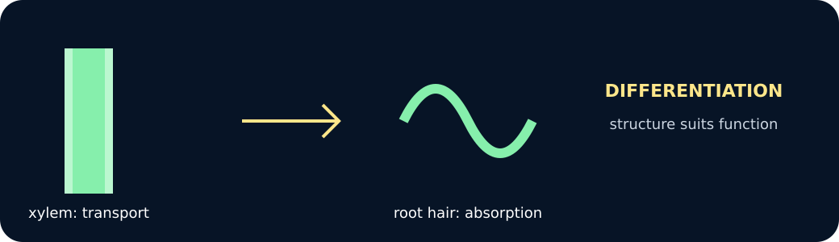
Differentiated cells

Exit · one next step
After the adult has listened, what will you keep, improve or check next?

