Stem Cells and Meristems: Potential Compared
  - LAUNCH · Science · 40 minutes
I can compare embryonic stem cells, adult tissue stem cells and plant meristem cells using evidence about self-renewal, differentiation range and function.
Name: __________________________ Date: ______________
You may write, type, say, sign, point or direct a partner. An adult can read the words and record your exact response. Keep the choice and explanation your own.

Words for this lesson
Word | Meaning
stem cell | unspecialised source cell
self-renewal | maintain the source
meristem | plant growth tissue

First idea
Which claim is accurate enough to test against the comparison evidence?
A. Every stem cell can become absolutely any cell in any organism.
B. Different stem-cell sources can have different differentiation ranges and biological roles.
C. A stem cell is already fully specialised and cannot divide.
My first idea and reason:


A stem cell dividing into many cell types

We do · choose, explain, check
Which comparison is best supported by GCSE-level evidence?
A. Embryonic stem cells can form many animal cell types, while many adult stem cells form a more limited tissue-related range.
B. Adult stem cells can never divide after birth.
C. Meristems are specialised animal organs that make blood cells.
My choice: ______ Evidence or reason:

Stem-cell identity and evidence console
Route each evidence card to embryonic stem cells, adult tissue stem cells or plant meristems, then justify one comparison.
Read or hear one card. Choose a group. Give the evidence. A partner checks your reason before you move on. Point or write card numbers; cutting is optional.
Group | Card numbers and evidence
EMBRYONIC STEM CELLS
ADULT TISSUE STEM CELLS
PLANT MERISTEMS

Activity cards
1 · Broad animal-cell range | 2 · Early embryo source
Under suitable laboratory conditions, cells from an early embryo form several different animal cell types. | The unspecialised cells are obtained from an early-stage animal embryo in the supplied research summary.

3 · Blood-cell replacement | 4 · Skin maintenance
Stem cells in bone marrow produce the range of blood cell types needed for continuing replacement. | A small population divides to replace cells lost from the skin surface.

5 · Root-tip growth | 6 · Shoot and leaf tissues
Dividing unspecialised cells near a root tip supply cells that elongate and differentiate. | Cells near a shoot tip continue dividing and contribute to new shoot and leaf tissues.

7 · Plant clone potential
Under controlled culture conditions, some meristem cells can generate a genetically identical plant.

Compare two groups using one shared property, one difference in potential or role and one limit of the evidence.

Your lesson record
Build an evidence-led comparison of embryonic stem cells, adult tissue stem cells and plant meristems, including one percentage calculation and one bounded application claim.

Model helps us see
COMPARE with at least one similarity and one difference. Use source → evidence → differentiation range → limitation so a headline does not outrun the dataset.

Model does not show
A branching diagram makes developmental choices look fixed and equal. Real differentiation depends on signals, gene activity and conditions; the model omits failure, cell death, timing and ethical questions reserved for the next sequence.

Supported
Sort six cards, complete one similarity-and-difference frame and calculate a percentage from a worked fraction.
Use colour-coded source icons and the stem: Both can __. Unlike __, __ can __ under the tested conditions.

Standard
Compare all three groups, calculate one outcome percentage and explain one biological role using evidence.
Use COMPARE and CALCULATE separately; then add a sentence beginning The evidence does not show __.

Stretch
Evaluate a claimed application by combining source, potential, quantitative outcome and limitations without moving into unsupported cure language.
Distinguish laboratory differentiation, tissue function, treatment safety and patient benefit.

Evidence target
A three-way comparison, correct use of self-renewal/differentiation, one shown percentage calculation and a claim explicitly limited to the supplied evidence.

Exit, Audience and evidence · W10L2
Supported: Match each source to embryonic, adult tissue or meristem, then state one shared stem-cell property.

Standard: Compare embryonic and adult tissue stem cells using differentiation potential and one tissue role.
Stretch: Evaluate why a high differentiation percentage in culture is not sufficient evidence for a safe, effective treatment.

What I said, and what it changed
________________________________________________

Next I will ______.

Adult witness note
What was observed, and with what level of independence?

My evidence and explanation

What does this evidence not show?

Visual reference cards
These are diagrams or model views from the uploaded lesson. Use their labels and the card descriptions; they are not photographs of your own results.
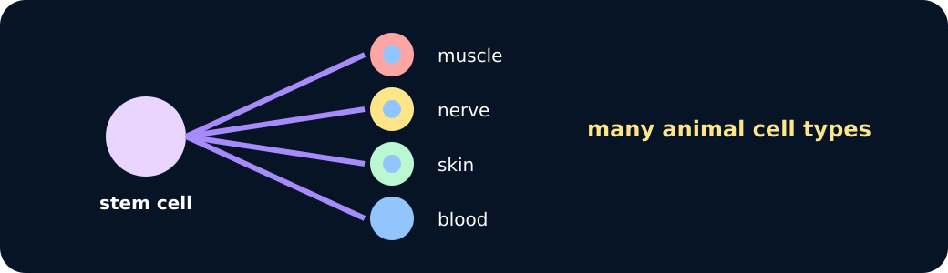
Embryonic range

Adult and meristem

Exit · one next step
After the adult has listened, what will you keep, improve or check next?

