Growth and Stem-Cell Data: Evidence Before Claims
  - LAUNCH · Science · 40 minutes
I can interpret growth and stem-cell data, calculate changes or proportions, and evaluate application claims using evidence and biological limitations.
Name: __________________________ Date: ______________
You may write, type, say, sign, point or direct a partner. An adult can read the words and record your exact response. Keep the choice and explanation your own.

Words for this lesson
Word | Meaning
percentile | position in a reference distribution
efficacy | how well an intervention works
inference | reasoned interpretation

First idea
A fictional culture study reports that 72 of 90 cells show the intended marker. Which response is scientifically strongest?
A. The treatment is guaranteed to cure 80% of patients.
B. 80% showed the marker in this culture; clinical safety and benefit still require separate evidence.
C. All 90 cells differentiated because 72 is close to 90.
My first idea and reason:


Proportion

We do · choose, explain, check
A fictional pupil's height follows approximately the same percentile line at three time points. Which conclusion is justified by this chart alone?
A. The measurements show a broadly consistent relative growth pattern across these time points.
B. Every cell divided at the same rate and no health check could ever be needed.
C. The chart proves exactly which genes were active in each tissue.
My choice: ______ Evidence or reason:

Claim-strength evidence triage
Route each statement to directly supported, reasonable inference or unsupported overclaim before composing the evaluation.
Read or hear one card. Choose a group. Give the evidence. A partner checks your reason before you move on. Point or write card numbers; cutting is optional.
Group | Card numbers and evidence
DIRECTLY SUPPORTED
REASONABLE INFERENCE
UNSUPPORTED OVERCLAIM

Activity cards
1 · Measured increase | 2 · Marker percentage
Mean fictional tissue thickness increased from 1.8 mm to 2.4 mm over the stated interval. | 80% of observed culture cells carried the stated differentiation marker.

3 · Cell-process link | 4 · Potential repair
The tissue increase is consistent with cell division and growth, although these processes were not imaged directly. | If differentiated cells function and persist safely, they could potentially contribute to tissue repair.

5 · One-point diagnosis | 6 · Guaranteed cure
One fictional measurement below a percentile line proves a specific disease. | A high marker percentage proves the stem-cell treatment is safe and will cure everyone.

7 · Single-cause claim
Because two variables change together, the stem cells must be the only possible cause.

State one direct result, one justified inference and one claim the dataset cannot support.

Your lesson record
Complete a GCSE application pack containing a growth-chart interpretation, two shown calculations and an evidence-led evaluation of a fictional stem-cell claim.

Model helps us see
Use DATA → CALCULATION → BIOLOGICAL EXPLANATION → LIMIT → JUDGEMENT. Do not replace a measured culture or growth outcome with a medical conclusion.

Model does not show
Simplified datasets omit individual variation, full methods, longer-term outcomes and many confounders. Percentile charts and cell markers are useful evidence tools but cannot diagnose or establish a treatment's complete safety and effectiveness alone.

Supported
Read two graph values, calculate one change and one worked percentage, then select and justify a bounded conclusion.
Use highlighted axes, calculator key sequence and stems: The data show __. This could mean __, but they do not show __.

Standard
Interpret the growth pattern, calculate change and cell percentage, then evaluate the fictional application using one benefit and two evidence limitations.
Work in DESCRIBE → CALCULATE → EXPLAIN → EVALUATE order and quote at least two values.

Stretch
Compare groups using quantitative evidence, examine variation or control quality, and reach a conditional judgement that separates efficacy, safety and ethics.
Identify what further data would reduce uncertainty and explain why; do not decide the W11 ethical question yet.

Evidence target
A value-and-unit growth description, shown calculation, stem-cell data comparison, biological explanation, limitation and supported judgement ready to feed W11 ethics work.

Exit, Audience and evidence · W10L3
Supported: Calculate 18 ÷ 24 × 100 and complete: this percentage shows __, not __.

Standard: Use one value to support a stem-cell application claim and one limitation to bound it.
Stretch: Evaluate why biological potential, efficacy, safety and ethical acceptability require different evidence.

What I said, and what it changed
________________________________________________

Next I will ______.

Adult witness note
What was observed, and with what level of independence?

My evidence and explanation

What does this evidence not show?

Visual reference cards
These are diagrams or model views from the uploaded lesson. Use their labels and the card descriptions; they are not photographs of your own results.

Percentage
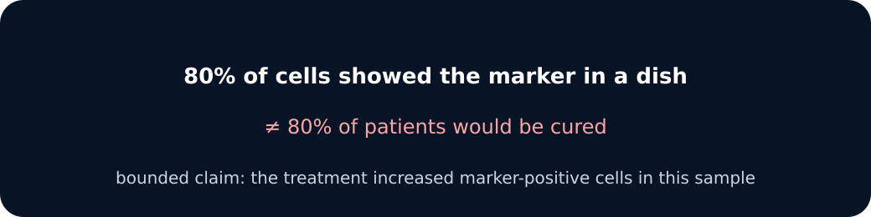
Bounded claim

Exit · one next step
After the adult has listened, what will you keep, improve or check next?

