Stem Cells: Evidence Before Judgement
  - LAUNCH · Science · 40 minutes
I can describe stem-cell functions and distinguish scientific evidence, ethical concern and uncertainty.
Name: __________________________ Date: ______________
You may write, type, say, sign, point or direct a partner. An adult can read the words and record your exact response. Keep the choice and explanation your own.

Words for this lesson
Word | Meaning
stem cell | unspecialised starting cell
differentiate | become specialised
ethical | about what ought to be done

First idea
A headline says, 'Stem cells will cure every damaged organ.' What should a scientist do first?
A. Accept it because stem cells can differentiate.
B. Check the evidence, the cell type, the outcomes and the risks.
C. Reject every possible medical use of stem cells.
My first idea and reason:


Claim

We do · choose, explain, check
Which statement describes a stem-cell function rather than only a property?
A. It can divide and produce cells that differentiate, supporting growth or replacement.
B. It is called undifferentiated.
C. It cures every disease.
My choice: ______ Evidence or reason:

Evidence, ethics or uncertainty?
Place each statement by its main role. Then explain why one statement could matter to more than one column.
Read or hear one card. Choose a group. Give the evidence. A partner checks your reason before you move on. Point or write card numbers; cutting is optional.
Group | Card numbers and evidence
SCIENTIFIC EVIDENCE
ETHICAL CONCERN
UNCERTAINTY

Activity cards
1 · Observed division | 2 · Consent matters
Cells in a controlled culture divided and some differentiated into a named cell type. | People disagree about when and how cells may be donated and used.

3 · Long-term outcome unknown
The study has not followed participants for long enough to measure later effects.

Which column contains a fact, which contains a value question and which names a gap in evidence?

Your lesson record
Build a stem-cell evidence glossary and classify three short statements before writing one cautious scientific claim.

Model helps us see
The three-column model keeps scientific findings, ethical concerns and uncertainty visible without pretending they are the same type of statement.

Model does not show
Real decisions involve more evidence, different stakeholders and changing medical knowledge; three cards cannot settle an ethical question.

Supported
Match stem cell, differentiate and ethical to icon-backed meanings; sort three statements.
Keep the word bank visible and use: This is __ because it says __.

Standard
Classify three statements and describe one stem-cell function before writing one cautious claim.
Use: Evidence shows __. It does not yet show __.

Stretch
Classify three statements, identify one overlap and explain why function alone cannot prove treatment success.
Name evidence, value and uncertainty separately; avoid adding Higher-tier content.

Evidence target
An accurate glossary, classified statements and one cautious claim that distinguishes possibility from evidence.

Exit, Audience and evidence · W11L1
Supported: Complete: a stem cell can divide and __.

Standard: Distinguish scientific evidence from an ethical concern in this context.
Stretch: Why does a plausible biological mechanism not prove that a treatment is safe and effective?

What I said, and what it changed
________________________________________________

Next I will ______.

Adult witness note
What was observed, and with what level of independence?

My evidence and explanation

What does this evidence not show?

Visual reference cards
These are diagrams or model views from the uploaded lesson. Use their labels and the card descriptions; they are not photographs of your own results.

Evidence
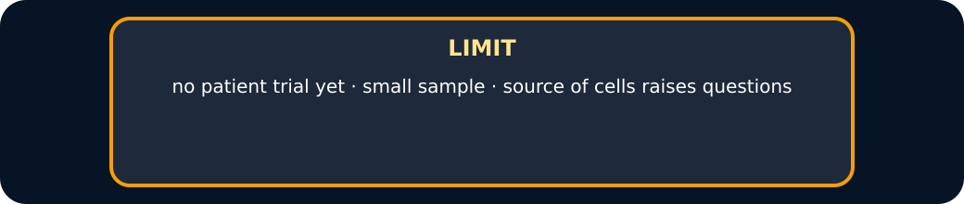
Limit

Exit · one next step
After the adult has listened, what will you keep, improve or check next?

