Stem-Cell Evidence: Benefit, Risk, Uncertainty
  - LAUNCH · Science · 40 minutes
I can analyse simulated stem-cell evidence by calculating outcomes and identifying benefits, risks and limitations.
Name: __________________________ Date: ______________
You may write, type, say, sign, point or direct a partner. An adult can read the words and record your exact response. Keep the choice and explanation your own.

Words for this lesson
Word | Meaning
benefit | possible helpful outcome
risk | chance of harm
uncertainty | what is not yet secure

First idea
In a fictional training study, 12 participants improved. Which missing fact is needed first?
A. How many participants were in the group.
B. The colour of the data table.
C. Whether a headline called it a breakthrough.
My first idea and reason:

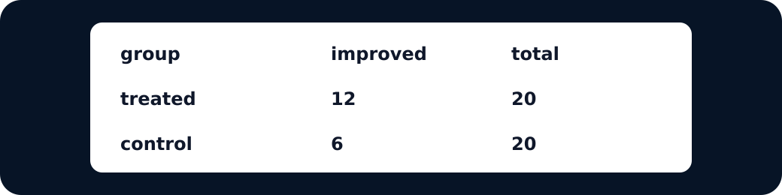
Simulated results table

We do · choose, explain, check
Four of 20 participants experienced the defined adverse event. Which calculation gives the participant percentage?
A. 4 ÷ 20 × 100 = 20%
B. 20 ÷ 4 × 100 = 500%
C. 4% because four events occurred
My choice: ______ Evidence or reason:

Benefit-risk-uncertainty analysis lab
Place each evidence statement, then use the frozen set to make one cautious analysis.
Read or hear one card. Choose a group. Give the evidence. A partner checks your reason before you move on. Point or write card numbers; cutting is optional.
Group | Card numbers and evidence
BENEFIT EVIDENCE
RISK EVIDENCE
UNCERTAINTY / LIMIT

Activity cards
1 · Improvement frequency | 2 · Adverse-event frequency
12/20 in treatment and 6/20 in comparison improved in the simulation. | 4/20 in treatment and 1/20 in comparison had the defined adverse event.

3 · Short follow-up
Participants were followed for only eight weeks.

What benefit, risk and uncertainty must appear in a scientifically cautious analysis?

Your lesson record
Analyse the simulated table: calculate four percentages, classify benefit and risk, and state two uncertainties.

Model helps us see
The table makes frequencies, totals and percentages comparable and keeps benefit, risk and uncertainty in the same view.

Model does not show
The numbers are invented for classroom reasoning, the sample is small and no real treatment conclusion can be drawn from them.

Supported
Complete two percentage calculations with the formula shown, then match one benefit, risk and limit.
Numbers are pre-positioned: frequency ÷ 20 × 100. Use icons and exact scribing if needed.

Standard
Calculate all four percentages and write a three-part analysis.
Use: The data suggest __. However __. We cannot conclude __ because __.

Stretch
Calculate all outcomes, compare groups and evaluate how sample size and follow-up affect confidence.
Do not add new biology; deepen the evidence judgement and propose one useful next-data need.

Evidence target
Visible percentage working plus a benefit-risk-uncertainty analysis that does not overclaim.

Exit, Audience and evidence · W11L2
Supported: Calculate 6 out of 20 as a percentage.

Standard: State one benefit finding and one uncertainty from the simulated data.
Stretch: Why can the same dataset suggest benefit and still be insufficient for a confident treatment claim?

What I said, and what it changed
________________________________________________

Next I will ______.

Adult witness note
What was observed, and with what level of independence?

My evidence and explanation

What does this evidence not show?

Visual reference cards
These are diagrams or model views from the uploaded lesson. Use their labels and the card descriptions; they are not photographs of your own results.
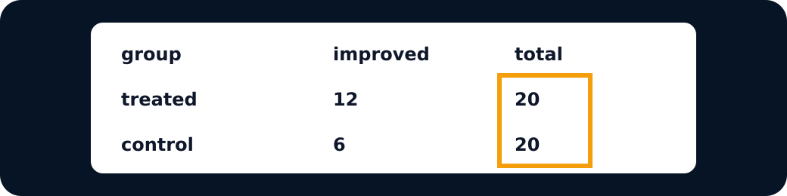
Totals highlighted
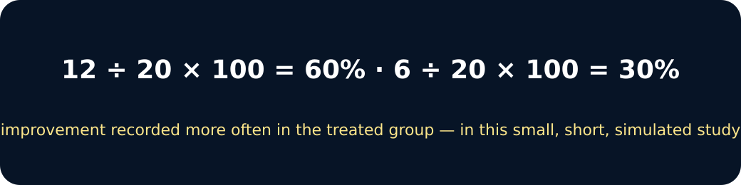
Percentages

Exit · one next step
After the adult has listened, what will you keep, improve or check next?

