Stem Cells: Structured DISCUSS
  - LAUNCH · Science · 40 minutes
I can write or dictate a structured DISCUSS judgement and improve it after feedback.
Name: __________________________ Date: ______________
You may write, type, say, sign, point or direct a partner. An adult can read the words and record your exact response. Keep the choice and explanation your own.

Words for this lesson
Word | Meaning
discuss | consider more than one side
justify | give the evidence-based reason
proportionate | matched to benefit and harm

First idea
Which opening best fits DISCUSS?
A. Stem cells are cells. They divide.
B. A possible benefit is..., while a possible risk or concern is...
C. The answer is obvious and no evidence is needed.
My first idea and reason:


Benefit

We do · choose, explain, check
Which sentence is a justified judgement rather than an unsupported opinion?
A. The evidence suggests possible benefit, but the short follow-up and adverse events mean a confident safety claim cannot yet be made.
B. I like stem cells, so the treatment is safe.
C. Some people disagree, so the science data do not matter.
My choice: ______ Evidence or reason:

DISCUSS answer-shape lab
Place each sentence in the role it performs, then repair the incomplete response.
Read or hear one card. Choose a group. Give the evidence. A partner checks your reason before you move on. Point or write card numbers; cutting is optional.
Group | Card numbers and evidence
BENEFIT + EVIDENCE
RISK / CONCERN
JUSTIFIED JUDGEMENT

Activity cards
1 · Possible benefit | 2 · Possible harm
The simulated treatment group recorded more improvement than the comparison group. | The adverse event was recorded more often in the simulated treatment group.

3 · Cautious conclusion
Longer, larger real studies would be needed before a confident safety and effectiveness claim.

Which part of the answer would you strengthen, and what exact edit will you make?

Your lesson record
DISCUSS: Based only on the simulated evidence, should this fictional stem-cell treatment proceed to a larger, longer controlled study? Write or dictate a judgement, receive one feedback point, then edit the same response.

Model helps us see
The paragraph frame makes the DISCUSS structure visible and preserves the difference between evidence, values and conclusion.

Model does not show
A frame cannot decide which evidence is strongest, and a balanced answer does not require pretending all claims have equal evidence.

Supported
Choose one benefit, one risk/concern and one cautious conclusion; order them and add because.
Use the three-part frame and icon cards. Adult exact-scribing is valid.

Standard
Write or dictate a structured DISCUSS paragraph, then make one evidence-led edit.
Use: One possible benefit... However... On this evidence...

Stretch
Weigh evidence, ethical concern and uncertainty, then edit an overclaim into a proportionate judgement.
Depth comes from weighting and precision, not Higher-tier content or extra length.

Evidence target
A balanced first response, one genuine audience comment, a visible edit and the pupil's statement of what changed.

Exit, Audience and evidence · W11L3
Supported: Name the three parts of today's DISCUSS answer.

Standard: What did you edit, and why is the new line more scientific?
Stretch: Why does fair consideration not require treating all claims as equally well supported?

What I said, and what it changed
________________________________________________

Next I will ______.

Adult witness note
What was observed, and with what level of independence?

My evidence and explanation

What does this evidence not show?

Visual reference cards
These are diagrams or model views from the uploaded lesson. Use their labels and the card descriptions; they are not photographs of your own results.

Risk
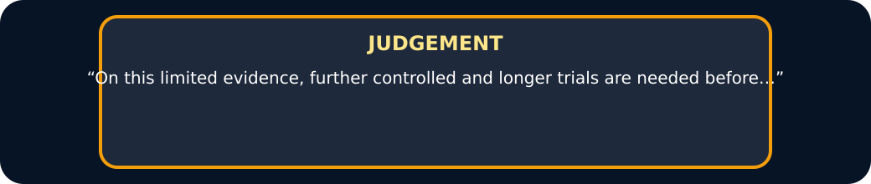
Judgement

Exit · one next step
After the adult has listened, what will you keep, improve or check next?

