Genetic Information: Cell to Gene
  - LAUNCH · Science · 40 minutes
I can describe where genetic information is stored and how chromosomes, DNA, genes and the genome are related.
Name: __________________________ Date: ______________
You may write, type, say, sign, point or direct a partner. An adult can read the words and record your exact response. Keep the choice and explanation your own.

Words for this lesson
Word | Meaning
chromosome | packaged DNA
gene | section of DNA
genome | all an organism's DNA

First idea
Which order moves from a large biological structure to a smaller part of its genetic material?
A. Cell → nucleus → chromosome → DNA → gene
B. Gene → cell → DNA → nucleus → chromosome
C. Cell → protein → nucleus → gene → chromosome
My first idea and reason:

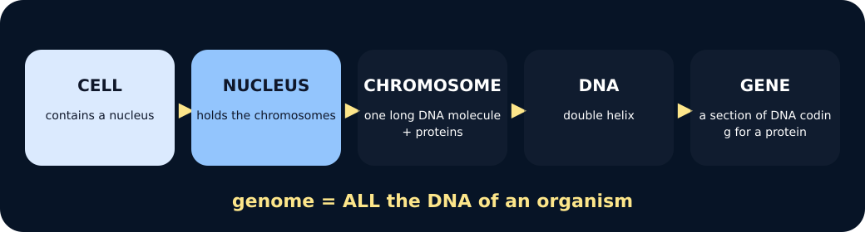
Cell and nucleus

We do · choose, explain, check
Which relationship is correct?
A. A gene is a section of DNA located on a chromosome.
B. A chromosome is a section of a gene located outside the cell.
C. A genome is one protein made by one gene.
My choice: ______ Evidence or reason:

Genetic hierarchy placement lab
Place each description at the correct level, then read the complete hierarchy aloud or by pointing.
Read or hear one card. Choose a group. Give the evidence. A partner checks your reason before you move on. Point or write card numbers; cutting is optional.
Group | Card numbers and evidence
CELL / NUCLEUS LEVEL
CHROMOSOME / DNA LEVEL
GENE / GENOME IDEA

Activity cards
1 · Location | 2 · Long molecule
The membrane-bound compartment that contains chromosomes in a eukaryotic cell. | The molecule associated with proteins to form a chromosome.

3 · Coding section
A section of DNA that codes for a specific protein.

Use contains and section of to describe the full hierarchy without reversing it.

Your lesson record
Build and annotate the genetic-information hierarchy, then explain one model strength and one limitation.

Model helps us see
Nested cards show part-whole relationships and let pupils physically trace from a cell to one gene.

Model does not show
The cards are not to scale, omit most molecular detail and can wrongly imply chromosomes are always X-shaped if the limitation is not stated.

Supported
Order five icon-backed cards and complete: a gene is a section of __.
Two cards are pre-positioned; use contains and part of arrows.

Standard
Build the full hierarchy and write two linked relationship sentences.
Use: The nucleus contains __. A gene is __.

Stretch
Explain the hierarchy, include genome and critique the permanent-X and scale misconceptions.
Keep to Foundation content; depth comes from relational precision and model evaluation.

Evidence target
An ordered hierarchy, accurate definitions and one honest statement about scale or shape.

Exit, Audience and evidence · W12L1
Supported: Complete: a gene is a section of __.

Standard: Describe how a chromosome, DNA and a gene are related.
Stretch: Why can the nesting model be useful even though it is not to scale?

What I said, and what it changed
________________________________________________

Next I will ______.

Adult witness note
What was observed, and with what level of independence?

My evidence and explanation

What does this evidence not show?

Visual reference cards
These are diagrams or model views from the uploaded lesson. Use their labels and the card descriptions; they are not photographs of your own results.
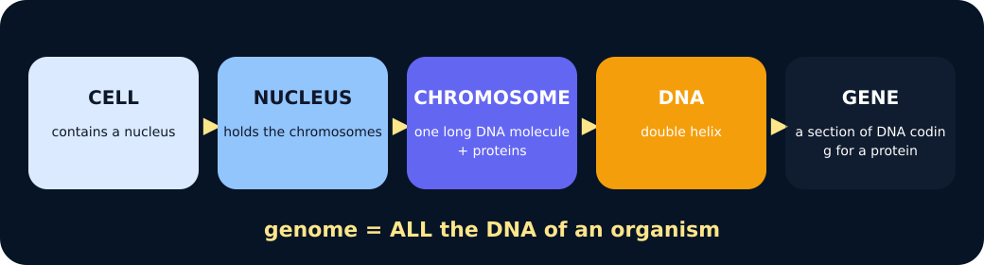
To DNA
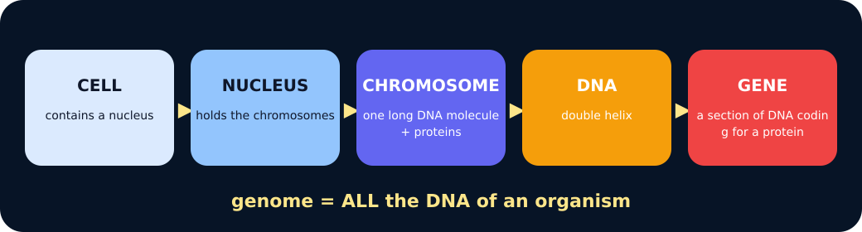
To gene

Exit · one next step
After the adult has listened, what will you keep, improve or check next?

