DNA Structure: Pair, Twist, Critique
  - LAUNCH · Science · 40 minutes
I can construct a complementary DNA section and describe the strengths and limitations of the model.
Name: __________________________ Date: ______________
You may write, type, say, sign, point or direct a partner. An adult can read the words and record your exact response. Keep the choice and explanation your own.

Words for this lesson
Word | Meaning
nucleotide | one DNA building unit
complementary | fits by a pairing rule
double helix | two-strand twist

First idea
One DNA strand reads A-C-G-T. Which complementary strand fits the pairing rule?
A. T-G-C-A
B. A-C-G-T
C. A-A-A-A
My first idea and reason:

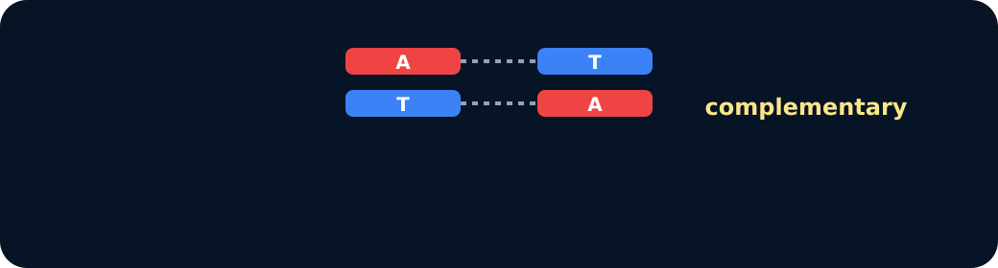
A T pairs

We do · choose, explain, check
A short strand reads G-A-T-C. Which complementary sequence is correct?
A. C-T-A-G
B. G-A-T-C
C. A-C-T-G
My choice: ______ Evidence or reason:

Complementary base-pair lab
Match each base to its complementary partner, freeze the sequence, then critique one feature of the model.
Read or hear one card. Choose a group. Give the evidence. A partner checks your reason before you move on. Point or write card numbers; cutting is optional.
Group | Card numbers and evidence
A ↔ T PAIR
C ↔ G PAIR
MODEL LIMIT

Activity cards
1 · Adenine | 2 · Cytosine
Base A needs its complementary partner. | Base C needs its complementary partner.

3 · Not to scale
The classroom pieces are far larger and farther apart than atoms and molecules.

Read the two sequences, then name what the model helps us see and what it cannot show.

Your lesson record
Construct a complementary DNA section, annotate its structure and evaluate the model.

Model helps us see
The manipulable ladder makes complementary pairing and two-strand structure visible and checkable.

Model does not show
The model is enormously enlarged, uses arbitrary colours, simplifies chemical bonds and cannot show the full chromosome or molecular dynamics.

Supported
Complete a six-base sequence with A-T and C-G cards, then point to the two strands.
Pairing key stays visible; one base at a time and exact scribing are allowed.

Standard
Complete a ten-base complementary sequence and describe nucleotide, two strands and double helix.
Use: Base __ pairs with __; the two strands __.

Stretch
Construct and check the sequence, then evaluate two useful features and two limitations of the model.
Do not add Higher-tier protein synthesis; deepen model evaluation.

Evidence target
A correct complementary sequence, labelled two-strand/double-helix description and one valid model limitation.

Exit, Audience and evidence · W12L2
Supported: Which base pairs with C?

Standard: Write the complement of A-G-C-T.
Stretch: State one strength and one limitation of today's DNA model.

What I said, and what it changed
________________________________________________

Next I will ______.

Adult witness note
What was observed, and with what level of independence?

My evidence and explanation

What does this evidence not show?

Visual reference cards
These are diagrams or model views from the uploaded lesson. Use their labels and the card descriptions; they are not photographs of your own results.

C G pairs
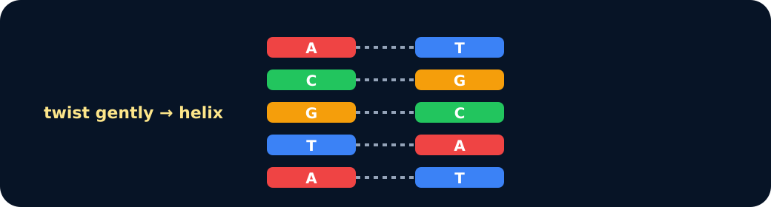
Ladder

Exit · one next step
After the adult has listened, what will you keep, improve or check next?

