Fruit DNA: Extract, Observe, Evaluate
  - LAUNCH · Science · 40 minutes
I can explain the steps in fruit-DNA extraction, record an observation and evaluate the evidence cautiously.
Name: __________________________ Date: ______________
You may write, type, say, sign, point or direct a partner. An adult can read the words and record your exact response. Keep the choice and explanation your own.

Words for this lesson
Word | Meaning
filtrate | liquid through the filter
precipitate | material appearing from solution
extract | remove from a mixture

First idea
White stringy material appears where the fruit filtrate meets cold ethanol. What is the safest scientific claim?
A. The material is pure DNA and nothing else.
B. A DNA-containing precipitate formed; the appearance alone does not show purity.
C. Fruit cannot contain DNA because it is not an animal.
My first idea and reason:

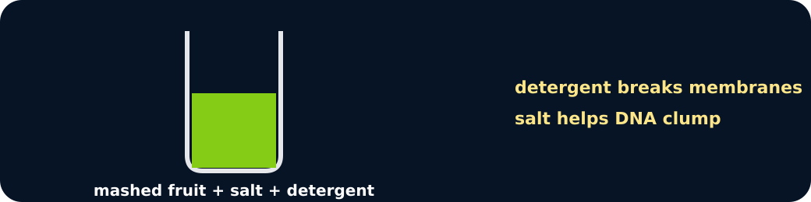
Release

We do · choose, explain, check
Why is detergent used in this extraction?
A. To disrupt cell and nuclear membranes so DNA can be released.
B. To colour each DNA base.
C. To copy genes by mitosis in the tube.
My choice: ______ Evidence or reason:

Observation, inference or limitation?
Classify each statement after the practical or parity dataset, then repair any overclaim.
Read or hear one card. Choose a group. Give the evidence. A partner checks your reason before you move on. Point or write card numbers; cutting is optional.
Group | Card numbers and evidence
DIRECT OBSERVATION
SCIENTIFIC INFERENCE
METHOD LIMITATION

Activity cards
1 · White strands | 2 · DNA-containing material
White stringy material appeared at the liquid boundary. | The method and expected chemistry support that the precipitate contains DNA.

3 · Purity unknown
The white material may contain substances other than DNA.

Say what was observed, what was inferred and what cannot be concluded.

Your lesson record
Carry out or direct the non-core fruit-DNA extraction, record the result and evaluate the evidence.

Model helps us see
The visible method sequence links cell structures to separation techniques and makes observation-versus-inference explicit.

Model does not show
The precipitate is not purified DNA, yield is not measured accurately by appearance and the activity cannot show a gene, base pair or double helix directly.

Supported
Order four method pictures, select the observed result and complete one limitation sentence.
Use release, filter, precipitate and not pure. An adult handles all materials.

Standard
Record method and observation, explain two reagent/separation roles and evaluate one limitation.
Use Observation → Inference → Limitation headings.

Stretch
Compare practical/parity outcomes, identify variables that affect visible yield and propose one fair improvement.
Do not claim molecular identity or purity; no Higher-tier analytical chemistry is needed.

Evidence target
An ordered method, precise observation, DNA/chromosome/gene connection and one valid evaluation point.

Exit, Audience and evidence · W12L3
Supported: What does detergent help release from cells?

Standard: Why is 'DNA-containing precipitate' better than 'pure DNA'?
Stretch: Explain why this extraction cannot show an individual gene or DNA base sequence.

What I said, and what it changed
________________________________________________

Next I will ______.

Adult witness note
What was observed, and with what level of independence?

My evidence and explanation

What does this evidence not show?

Visual reference cards
These are diagrams or model views from the uploaded lesson. Use their labels and the card descriptions; they are not photographs of your own results.
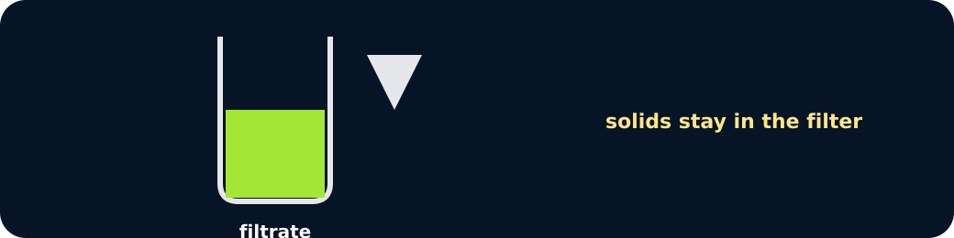
Filter
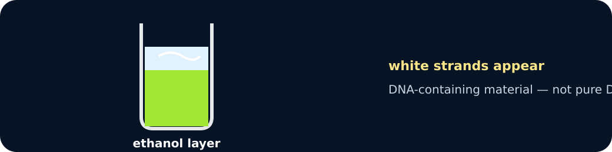
Precipitate

Exit · one next step
After the adult has listened, what will you keep, improve or check next?

