Inheritance Language: Allele to Phenotype
  - LAUNCH · Science · 40 minutes
I can use inheritance vocabulary to connect alleles, genotype and phenotype in a simple monohybrid model.
Name: __________________________ Date: ______________
You may write, type, say, sign, point or direct a partner. An adult can read the words and record your exact response. Keep the choice and explanation your own.

Words for this lesson
Word | Meaning
allele | version of a gene
genotype | allele-letter combination
phenotype | observed characteristic

First idea
In a simplified pea model, P is a purple-flower allele and p is a white-flower allele. Which item is a genotype?
A. Pp
B. purple flowers
C. the whole pea plant
My first idea and reason:

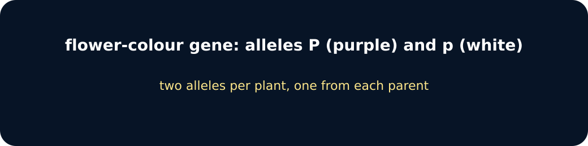
Gene and alleles

We do · choose, explain, check
Which statement is correct for the simplified P/p model?
A. Pp is a heterozygous genotype with the purple phenotype.
B. P is dominant because purple is biologically better.
C. pp is heterozygous because the letters are lowercase.
My choice: ______ Evidence or reason:

Genotype-phenotype decoder
Classify each card, then justify the phenotype using the simplified dominance rule.
Read or hear one card. Choose a group. Give the evidence. A partner checks your reason before you move on. Point or write card numbers; cutting is optional.
Group | Card numbers and evidence
HOMOZYGOUS
HETEROZYGOUS
PHENOTYPE STATEMENT

Activity cards
1 · PP | 2 · Pp
Two copies of the dominant allele. | One dominant and one recessive allele.

3 · White flowers
The observable characteristic produced by pp in this model.

Use genotype, phenotype and homozygous/heterozygous in one accurate explanation.

Your lesson record
Decode six genotypes, identify phenotypes and explain the limits of the simple P/p model.

Model helps us see
Letter tiles make allele combinations and genotype-to-phenotype mapping visible before probability is introduced.

Model does not show
The model assumes one gene, two alleles and complete dominance; many human and organism characteristics are more complex and influenced by environment.

Supported
Match PP, Pp and pp to same/different alleles and purple/white phenotype.
Keep the P/p key and icon-backed word mat visible.

Standard
Classify six genotype/phenotype statements and explain two matches.
Use: __ is the genotype; __ is the phenotype because __.

Stretch
Correct three dominance misconceptions and evaluate the one-gene complete-dominance model.
Do not introduce codominance, sex linkage or Higher-tier drift.

Evidence target
Accurate use of allele, genotype, phenotype, homozygous and heterozygous plus one model limitation.

Exit, Audience and evidence · W13L1
Supported: Genotype or phenotype: Pp?

Standard: Explain why Pp is heterozygous and gives purple flowers in this model.
Stretch: Why does dominant not mean better or more common?

What I said, and what it changed
________________________________________________

Next I will ______.

Adult witness note
What was observed, and with what level of independence?

My evidence and explanation

What does this evidence not show?

Visual reference cards
These are diagrams or model views from the uploaded lesson. Use their labels and the card descriptions; they are not photographs of your own results.
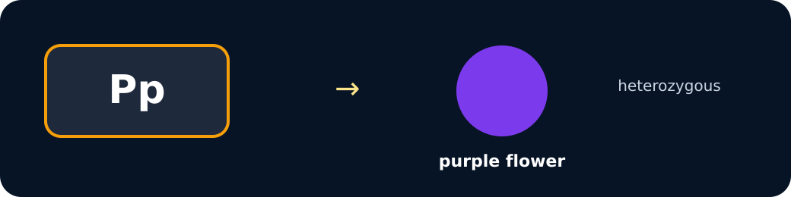
Pp genotype

pp genotype

Exit · one next step
After the adult has listened, what will you keep, improve or check next?

