Inheritance Data: Predict, Calculate, Evaluate
  - LAUNCH · Science · 40 minutes
I can calculate inheritance probabilities, ratios and percentages and evaluate why observed results can differ from predictions.
Name: __________________________ Date: ______________
You may write, type, say, sign, point or direct a partner. An adult can read the words and record your exact response. Keep the choice and explanation your own.

Words for this lesson
Word | Meaning
probability | chance of an outcome
ratio | relative amounts
sample size | number observed

First idea
A Pp × Pp cross produced 31 purple and 9 white seedlings. Which first calculation enables comparison with 75% : 25%?
A. Calculate each frequency ÷ 40 × 100.
B. Subtract 9 from 31 and stop.
C. Declare the Punnett square wrong because the counts are not exactly 30 and 10.
My first idea and reason:


Expected

We do · choose, explain, check
Which comparison is scientifically correct?
A. Observed 77.5% purple is close to predicted 75%; chance can explain a small difference.
B. Any difference proves the Punnett model is false.
C. A 3:1 prediction guarantees every batch will be exactly 3:1.
My choice: ______ Evidence or reason:

Expected versus observed data lab
Classify predictions, observations and valid conclusions, then repair the guarantee claim.
Read or hear one card. Choose a group. Give the evidence. A partner checks your reason before you move on. Point or write card numbers; cutting is optional.
Group | Card numbers and evidence
EXPECTED FROM MODEL
OBSERVED IN DATA
CAUTIOUS CONCLUSION

Activity cards
1 · 75% purple | 2 · 31 purple of 40
The Punnett square predicts three purple phenotypes out of four possible outcomes. | The simulated seedling dataset records this frequency.

3 · Close, not exact
77.5% is close to 75%; chance can produce the difference in a finite sample.

State the difference, explain why it can occur and name one model limitation.

Your lesson record
Complete a full inheritance data response: Punnett prediction, ratios, probabilities, observed percentages and evaluation.

Model helps us see
The expected-versus-observed table puts counts and percentages in the same unit and makes random variation visible.

Model does not show
The dataset is simulated, the inheritance model assumes complete dominance and one gene, and closeness alone cannot prove the biological assumptions.

Supported
Complete a partly filled square, convert 3/4 and 1/4 to percentages, then choose the valid data conclusion.
Formula and phenotype key stay visible; totals and first calculation are pre-positioned.

Standard
Build the square, calculate expected counts and observed percentages, then explain the small difference.
Use Predict → Calculate → Compare → Explain.

Stretch
Analyse repeated batches and the combined sample, then evaluate sample size and the monohybrid model's limits.
No chi-squared test or Higher-tier genetics; depth comes from careful evaluation.

Evidence target
Visible working from cross to percentages, a correct expected-observed comparison and an evaluation naming chance, sample size and one model limit.

Exit, Audience and evidence · W13L3
Supported: Convert 1 out of 4 to a percentage.

Standard: Compare 77.5% observed with 75% predicted in one cautious sentence.
Stretch: Explain how chance and sample size affect the difference between observed and predicted outcomes.

Next-check card
The inheritance step I need to retrieve first is ________________________________________
The evidence that will show I am secure is ________________________________________

What I said, and what it changed
________________________________________________

Next I will ______.

Adult witness note
What was observed, and with what level of independence?

My evidence and explanation

What does this evidence not show?

Visual reference cards
These are diagrams or model views from the uploaded lesson. Use their labels and the card descriptions; they are not photographs of your own results.
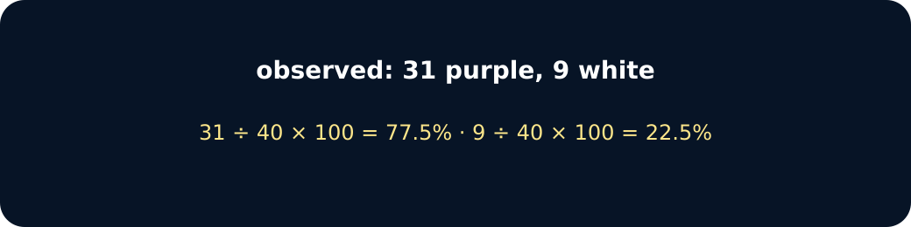
Observed
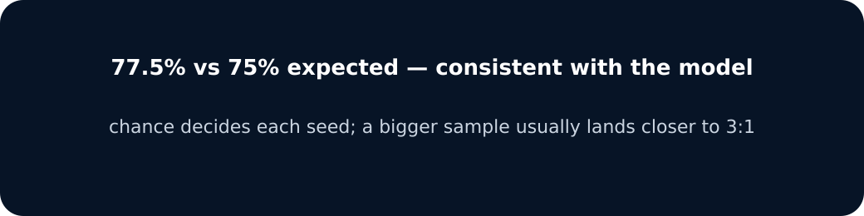
Compare

Exit · one next step
After the adult has listened, what will you keep, improve or check next?

