Genetic Conditions: Frame a Safe Research Question
  - LAUNCH · Science · 40 minutes
I can turn the SoW topic into a respectful research question, plan a school-approved source search, and separate biological explanation from personal or medical claims.
Name: __________________________ Date: ______________
You may write, type, say, sign, point or direct a partner. An adult can read the words and record your exact response. Keep the choice and explanation your own.

We do · make a choice and give a reason
Select the checks that make a source useful for this question, not merely easy to read.
Authority Who published the item, for what audience, and under what scientific or public-information responsibility?
Currency What date or review date is visible? A date helps locate the item; it does not make every claim correct.
Relevance Which exact part answers the bounded inheritance question? Do not collect an entire page when one defined idea is needed.
Boundary Does the source explain biology without inviting self-diagnosis, personal disclosure or unqualified advice?
A school-approved source set narrows access safely. The learner still makes the scientific choice, records why the source is relevant and keeps one uncertainty visible.
My choice and the evidence I used:

Resources and independent record

LAUNCH Science · Autumn · Week 14 · Introduce
SoW: LAUNCH Weekly - Autumn!C44 — “Research a genetic condition online; present.”
Learning objective: I can turn the SoW topic into a respectful research question, plan a school-approved source search, and separate biological explanation from personal or medical claims.

Success checks for today's activity — not assessment criteria
- Write a bounded question about inheritance, variation or evidence without asking for anyone's personal or family information.
- Plan to use at least two school-approved sources and record publisher, date and purpose.
- List what the final explanation must distinguish: established evidence, probability, lived-experience variation and uncertainty.

Supported
Choose a teacher-approved question frame and two prepared source cards; identify what each source can answer.

Standard
Refine a bounded question, plan two-source triangulation and identify one privacy or interpretation risk.

Stretch
Compare how question wording could bias the search, then design a neutral alternative and an uncertainty check.

Independent task · 16 minutes
Create a research brief for one teacher-approved genetic condition using no personal or family data. Record the question, keywords, two approved source types, the evidence categories required, a respectful-language check and one uncertainty that must remain visible.

Genetic Conditions: Frame a Safe Research Question · evidence record
Claim / decision | Source / date / locator | Learner contribution and meaning | Shared work / adult support | Limit / status

Reasoning or review

Honest gap / uncertainty

Next action, responsible role and report-back
Core teaching anchor: Edexcel GCSE Biology 1BI0 Foundation / Combined Science 1SC0 Foundation. IGCSE 4BI1/4CH1/4PH1 is optional stretch for eligible pupils only. No diagnosis or medical advice.

Genetic Conditions: Frame a Safe Research Question · learner review before confirmation
Read, point to or ask an adult to read each prompt exactly. Keep missing evidence, uncertainty and the privacy boundary visible.
Evidence link I am confirming
The question or claim, approved source locator and reason:
Limit or uncertainty I have kept visible
What the approved evidence does not show or cannot decide for an individual:
Audience influence and next check
What I revised or held, why, who owns the next action and when I will hear back.

Paper route · discuss the lesson choices
Use these choices with the matching teaching stage. Point to or number a choice, explain it, then revisit it after feedback. The original HTML keeps the live controls.
- How is the condition inherited, and what does that mean for probability in a Punnett square?
- Who in our class might have it?
- What do school-approved sources say the condition changes in the body, and how is that known?
- Is it their parents’ fault?
- Where do the sources agree and disagree, and what is still uncertain?
- respectful, answerable from biology
- about people, not biology — rewrite
Choice / card | My reason or evidence | My revision after feedback

Visual evidence from the lesson
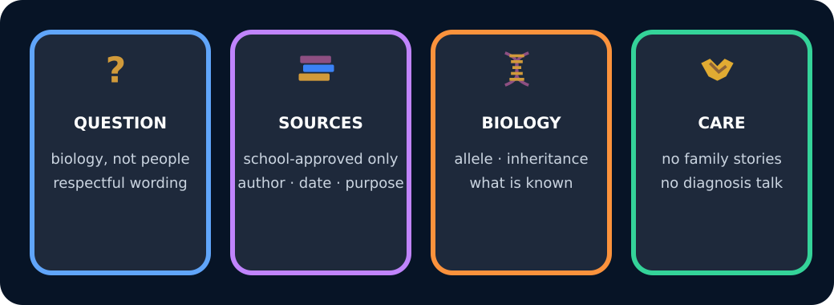
Four parts of a respectful research plan

Exit · one next step
After the adult has listened, what will you keep, improve or check next?

