Genetic Conditions: Triangulate Source Evidence
  - LAUNCH · Science · 40 minutes
I can compare school-approved sources, extract evidence relevant to my question, and record agreement, difference and uncertainty without copying or overclaiming.
Name: __________________________ Date: ______________
You may write, type, say, sign, point or direct a partner. An adult can read the words and record your exact response. Keep the choice and explanation your own.

We do · make a choice and give a reason
Classify each note, then decide how the classification changes the wording of the final claim.
Established evidence Both approved sources explain the same relevant biology and provide a traceable basis for the bounded statement.
Different emphasis One source may foreground inheritance while another foregrounds variation or lived experience. Record both without forcing sameness.
Different certainty Words such as may, can, often and is associated with carry different strength from always, proves or will.
Missing perspective A source set may omit detail, a population, a current review or lived-experience variation. Missing is a limit, not permission to invent.
My choice and the evidence I used:

Resources and independent record

LAUNCH Science · Autumn · Week 14 · Explore
SoW: LAUNCH Weekly - Autumn!C44 — “Research a genetic condition online; present.”
Learning objective: I can compare school-approved sources, extract evidence relevant to my question, and record agreement, difference and uncertainty without copying or overclaiming.

Success checks for today's activity — not assessment criteria
- Record each source's publisher, date, purpose and the exact idea used in my own notes.
- Identify at least one point of agreement and one difference in emphasis, scope or certainty.
- Write a bounded evidence statement and a limitation that the final presentation will preserve.

Supported
Use two prepared source cards and a match/difference table; explain one bounded finding with a prompt frame.

Standard
Triangulate two approved sources, paraphrase relevant evidence, record uncertainty and build a source trail.

Stretch
Evaluate source purpose, evidence type and missing perspective; qualify a claim and identify what additional evidence would be needed.

Independent task · 16 minutes
Complete a two-source evidence matrix for the teacher-approved condition. Record source identity, relevant evidence, agreement, difference, uncertainty and a respectful-language check. Write one bounded paragraph in your own words with both source locators.

Genetic Conditions: Triangulate Source Evidence · evidence record
Claim / decision | Source / date / locator | Learner contribution and meaning | Shared work / adult support | Limit / status

Reasoning or review

Honest gap / uncertainty

Next action, responsible role and report-back
Core teaching anchor: Edexcel GCSE Biology 1BI0 Foundation / Combined Science 1SC0 Foundation. IGCSE stretch remains optional for eligible pupils. No diagnosis, advice or personal disclosure.

Genetic Conditions: Triangulate Source Evidence · learner review before confirmation
Read, point to or ask an adult to read each prompt exactly. Keep missing evidence, uncertainty and the privacy boundary visible.
Evidence link I am confirming
The question or claim, approved source locator and reason:
Limit or uncertainty I have kept visible
What the approved evidence does not show or cannot decide for an individual:
Audience influence and next check
What I revised or held, why, who owns the next action and when I will hear back.

Paper route · discuss the lesson choices
Use these choices with the matching teaching stage. Point to or number a choice, explain it, then revisit it after feedback. The original HTML keeps the live controls.
- Source A and Source B both describe the same inheritance pattern
- Source A gives one frequency; Source B gives a different figure with a different date
- Neither source says how a proposed treatment performed in trials
- Both name the same gene
- One source is a charity page, the other a textbook: different purposes
- A statistic has no date or population attached
- agreement
- ↔ difference — record both
- uncertainty — keep visible
Choice / card | My reason or evidence | My revision after feedback

Visual evidence from the lesson
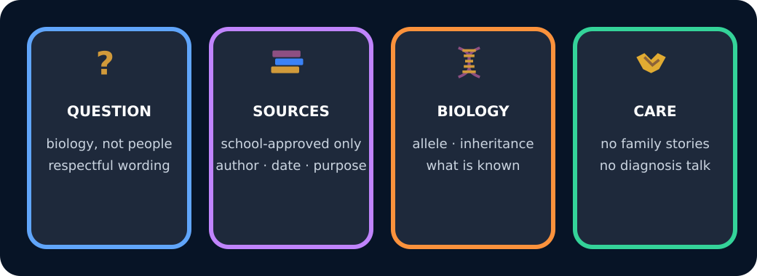
Four parts of a respectful research plan

Exit · one next step
After the adult has listened, what will you keep, improve or check next?

