Genetic Conditions: Present Evidence with Care
  - LAUNCH · Science · 40 minutes
I can present an evidence-led explanation of a teacher-approved genetic condition, credit sources, preserve uncertainty and respond to one audience question safely.
Name: __________________________ Date: ______________
You may write, type, say, sign, point or direct a partner. An adult can read the words and record your exact response. Keep the choice and explanation your own.

We do · make a choice and give a reason
Choose one question the evidence can answer and one that must be held for a qualified professional or a better source.
Answer Use the matrix when the question is within C44 and the approved evidence supports a bounded response.
Clarify Ask what the audience means when a word such as risk, cause or inherited is ambiguous.
Hold Say “The approved sources do not answer that” when evidence, scope or professional authority is absent.
Redirect Move personal health or safeguarding concerns to the school's approved support route, outside the presentation.
My choice and the evidence I used:

Resources and independent record

LAUNCH Science · Autumn · Week 14 · Do
SoW: LAUNCH Weekly - Autumn!C44 — “Research a genetic condition online; present.”
Learning objective: I can present an evidence-led explanation of a teacher-approved genetic condition, credit sources, preserve uncertainty and respond to one audience question safely.

Success checks for today's activity — not assessment criteria
- Explain the relevant inheritance idea using accurate, bounded language and a clear visual or verbal model.
- Credit at least two approved sources and distinguish evidence, probability, variation and uncertainty.
- Choose a private or small-audience presentation route, respond to one question, and record one justified revision or hold.

Supported
Use a four-panel frame, prepared vocabulary and a private explanation to a trusted adult or approved recording route.

Standard
Build an independent evidence-led presentation with two credited sources, one uncertainty and one response-led revision.

Stretch
Evaluate a misleading deterministic claim, explain why the evidence does not support it and adapt the presentation for a different audience.

Independent task · 16 minutes
Create and deliver the presentation through the agreed private or small-audience route. Include the question, inheritance explanation, two credited source findings, variation/uncertainty and the boundary. Record the audience question and your evidence-led revise/hold decision.

Genetic Conditions: Present Evidence with Care · evidence record
Claim / decision | Source / date / locator | Learner contribution and meaning | Shared work / adult support | Limit / status

Reasoning or review

Honest gap / uncertainty

Next action, responsible role and report-back
Core teaching anchor: Edexcel GCSE Biology 1BI0 Foundation / Combined Science 1SC0 Foundation. IGCSE 4BI1/4CH1/4PH1 is optional stretch for eligible pupils only. No diagnosis or medical advice.

Genetic Conditions: Present Evidence with Care · learner review before confirmation
Read, point to or ask an adult to read each prompt exactly. Keep missing evidence, uncertainty and the privacy boundary visible.
Evidence link I am confirming
The question or claim, approved source locator and reason:
Limit or uncertainty I have kept visible
What the approved evidence does not show or cannot decide for an individual:
Audience influence and next check
What I revised or held, why, who owns the next action and when I will hear back.

Paper route · discuss the lesson choices
Use these choices with the matching teaching stage. Point to or number a choice, explain it, then revisit it after feedback. The original HTML keeps the live controls.
- According to [source, date], the condition is inherited in this pattern…
- My cousin has it and…
- The two sources disagree on how common it is; the more recent gives…
- Everyone with the condition experiences…
- It is not yet known whether… — the sources say more research is needed
- This treatment cures it
- evidence-led, sourced, careful
- rewrite — personal, absolute or unsourced
Choice / card | My reason or evidence | My revision after feedback

Visual evidence from the lesson
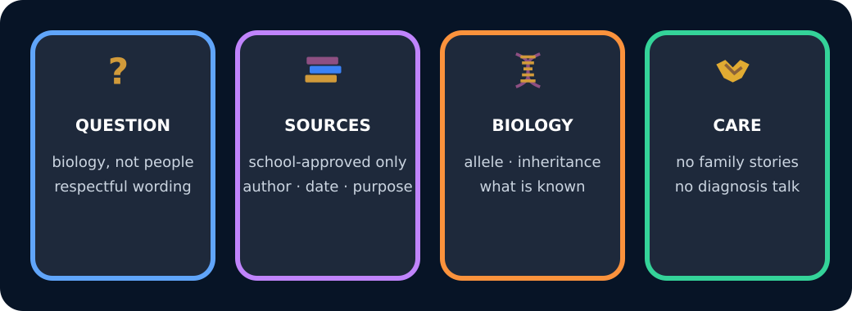
Four parts of a respectful research plan

Exit · one next step
After the adult has listened, what will you keep, improve or check next?

