Enzyme Action: Preparing the pH Investigation
  - LAUNCH · Science · 40 minutes
I can explain enzyme specificity and denaturation, then identify the variables and evidence needed to investigate the effect of pH on amylase safely.
Name: __________________________ Date: ______________
You may write, type, say, sign, point or direct a partner. An adult can read the words and record your exact response. Keep the choice and explanation your own.

Words for this lesson
Word | Meaning
specificity | one substrate fits
denature | active site changes shape
variable | what changes or is measured

First idea
Three amylase mixtures contain the same starch and are kept at the same temperature. Which first prediction is scientifically testable?
A. Amylase will always work equally fast because enzymes never change.
B. There may be an optimum pH where starch disappears in the shortest time.
C. The buffer with the brightest label will make the reaction fastest.
My first idea and reason:

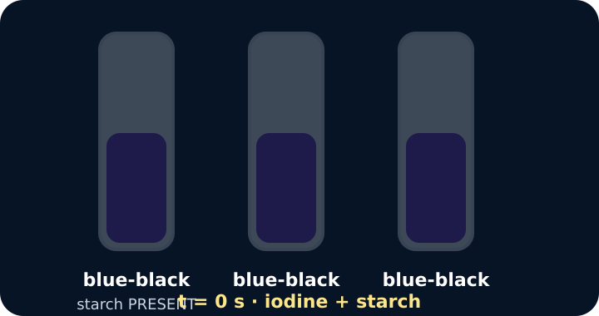
Three tubes all blue-black with iodine at the start

We do · choose, explain, check
Which statement best explains enzyme specificity?
A. Every enzyme binds every substrate if enough time passes.
B. An enzyme's active site has a complementary shape to its particular substrate.
C. The substrate permanently changes the enzyme into a product.
My choice: ______ Evidence or reason:

Variables and validity planning console
Route each planning card to independent variable, dependent evidence or control/validity before writing the method.
Read or hear one card. Choose a group. Give the evidence. A partner checks your reason before you move on. Point or write card numbers; cutting is optional.
Group | Card numbers and evidence
INDEPENDENT VARIABLE
DEPENDENT EVIDENCE
CONTROL / VALIDITY

Activity cards
1 · Buffer pH | 2 · Endpoint time
Use labelled buffers so mixtures differ in pH according to the centre-approved method. | Record the time until a sample no longer makes iodine turn blue-black.

3 · Constant temperature | 4 · Equal volumes
Keep every reaction at the same approved temperature throughout the comparison. | Use the same approved volume and concentration of amylase and starch in every trial.

5 · Sampling interval | 6 · No-amylase control
Sample every fixed number of seconds using the interval in the centre method. | A separate starch mixture contains no active amylase and should remain starch-positive.

State the predicted causal chain: changing pH may change active-site shape, which changes endpoint time and calculated rate.

Your lesson record
Produce a safe, ordered CP 1.10 planning record that another trained person could follow using the centre-approved Pearson method and local risk assessment.

Model helps us see
Use the model to connect active-site shape, substrate binding and a measurable endpoint. Record the sentence: pH may affect active-site shape, so we measure the time until starch is no longer detected.

Model does not show
Card shapes do not show molecular movement, collisions, bonds or gradual changes in protein structure. A neat lock-and-key picture is a simplified representation, not a literal rigid lock.

Supported
Complete a labelled IV/DV/CV table and order six picture-method cards; finish one because sentence about keeping temperature constant.
Use the word bank and sentence stem: We change __. We measure __. We keep __ the same because __.

Standard
Write an ordered method outline, identify variables and control sample, and design a table for pH, endpoint time and rate.
Use numbered steps and the command-word frame: EXPLAIN = point + scientific reason.

Stretch
Justify the controls and sampling interval, predict the rate pattern, and identify one source of uncertainty before practical work begins.
Distinguish validity, precision and safety; do not invent an unsupported concentration or heating method.

Evidence target
A pupil-owned prediction, IV/DV/CV table, ordered method outline, results-table headings and one justified safety/control decision.

Exit, Audience and evidence · W8L1
Supported: Complete: amylase acts on __. We change __ and measure __.

Standard: Explain why temperature and volumes must be controlled when investigating pH and amylase.
Stretch: Justify the no-amylase control and distinguish it from a control variable.

What I said, and what it changed
________________________________________________

Next I will ______.

Adult witness note
What was observed, and with what level of independence?

My evidence and explanation

What does this evidence not show?

Visual reference cards
These are diagrams or model views from the uploaded lesson. Use their labels and the card descriptions; they are not photographs of your own results.
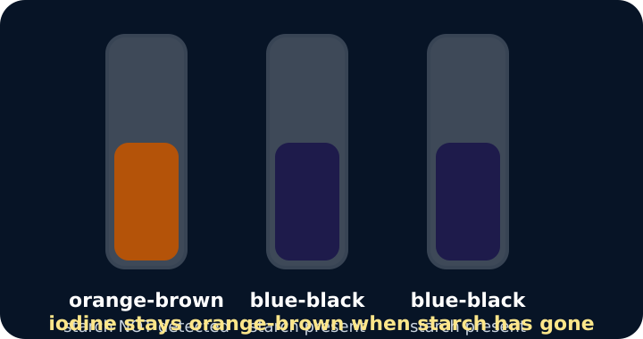
One tube orange-brown, two still blue-black
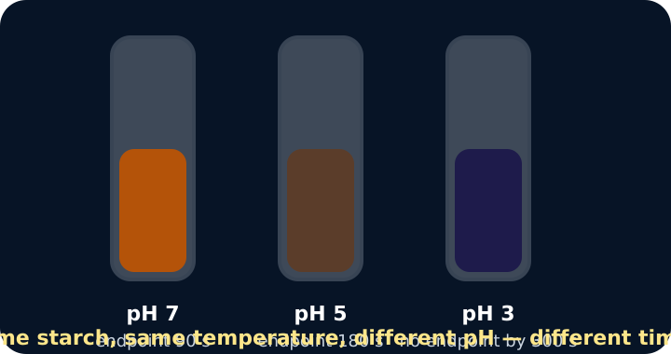
Three tubes at different pH reaching the endpoint at different times
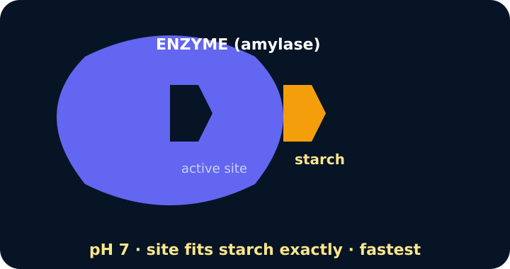
Enzyme active site model at the chosen pH

Exit · one next step
After the adult has listened, what will you keep, improve or check next?

