Amylase and pH: Continuous-Sampling Investigation
  - LAUNCH · Science · 40 minutes
I can follow the centre-approved Pearson method to investigate how pH affects amylase activity, recording safe continuous-sampling evidence accurately.
Name: __________________________ Date: ______________
You may write, type, say, sign, point or direct a partner. An adult can read the words and record your exact response. Keep the choice and explanation your own.

Words for this lesson
Word | Meaning
continuous sampling | test small samples over time
endpoint | the stopping observation
validity | tests the intended question

First idea
A group starts the reaction and only then begins adding iodine to the spotting tile. What is your first judgement?
A. The method is fine because the reaction can wait while the tile is prepared.
B. Pause and reset: prepare the iodine wells first so sampling can begin at the agreed time.
C. Add extra amylase to make up for the delay.
My first idea and reason:

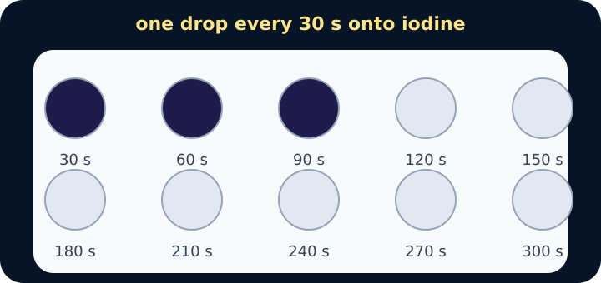
Spotting tile with three blue-black drops

We do · choose, explain, check
At 60 s the iodine well is blue-black; at 90 s it remains orange-brown. What endpoint time should be recorded with this sampling interval?
A. 60 s, because starch was definitely present then.
B. 90 s, the first sampled time at which starch was not detected, with interval uncertainty acknowledged.
C. 75 s exactly, because the colour must have changed at the midpoint.
My choice: ______ Evidence or reason:

Method-decision checkpoint
Before or during the physical practical, classify each situation as continue, stop/check, or record-and-repeat.
Read or hear one card. Choose a group. Give the evidence. A partner checks your reason before you move on. Point or write card numbers; cutting is optional.
Group | Card numbers and evidence
CONTINUE AS AUTHORISED
STOP AND CHECK ADULT
RECORD, THEN REPEAT IF AUTHORISED

Activity cards
1 · Ready tile | 2 · Iodine spill
Goggles are on, iodine wells and labels are ready, roles are agreed and the teacher has authorised the setup. | Iodine is spilled on the bench or skin.

3 · Unlabelled buffer | 4 · Missed interval
A buffer container has no clear pH label. | The 60 s sample was missed but the reaction and later observations are otherwise intact.

5 · Borderline colour | 6 · Clean fixed sample
A well looks purple-brown and the agreed endpoint cannot be judged confidently. | A clean transfer is made at the agreed interval to the next labelled iodine well.

7 · Temperature outside range
The monitored temperature is outside the tolerance in the centre method.

Name the condition that allowed continuation or forced a stop/repeat, and link it to safety, validity or honest evidence.

Your lesson record
Carry out the assigned part of the centre-approved amylase-pH investigation and preserve a complete raw evidence record.

Model helps us see
The tile timeline makes starch disappearance visible as a sequence of tested samples and supports a defensible endpoint decision.

Model does not show
The iodine colour is a threshold judgement, not a continuous measure of starch concentration. Sampling intervals limit time precision, and the classroom method does not show molecular collisions or active-site shape directly.

Supported
Complete one clearly labelled reaction timeline with an adult-authorised role; circle the first orange-brown endpoint and state whether starch is detected.
Use the colour key, pre-labelled time row and exact scribing/pointing route. Keep the same scientific endpoint.

Standard
Run or record assigned pH trials, identify endpoint times and annotate one control-variable or uncertainty check.
Use the prepared raw table. Write what was observed before writing what it means.

Stretch
Preserve full sampling evidence, estimate the maximum endpoint-time uncertainty from the interval and justify whether a repeat is needed.
Separate an ambiguous endpoint, missed sample and anomalous result; do not imply greater precision than the method provides.

Evidence target
A dated raw table with pH, each sampled colour, first observed endpoint time, anomalies/uncertainty and the pupil's own method note. The page itself makes no CP-completion claim.

Exit, Audience and evidence · W8L2
Supported: Point or complete: blue-black means starch __; orange-brown means starch __.

Standard: State the endpoint for one trial and explain why a shorter time indicates greater amylase activity.
Stretch: Quantify the endpoint uncertainty created by the sampling interval and propose one authorised improvement.

What I said, and what it changed
________________________________________________

Next I will ______.

Adult witness note
What was observed, and with what level of independence?

My evidence and explanation

What does this evidence not show?

Amylase observation record
Use only the method, timings and substances authorised by your teacher. Write actual observations; leave missed samples visibly marked. This blank sheet is not a practical completion certificate.
pH: ____ Trial: ____ Temperature: ____ Sampling interval: ____
Sample time / s | Observed colour | Starch detected? | Method note / missed sample

First observed endpoint / s: ____ What limits its precision?

Visual reference cards
These are diagrams or model views from the uploaded lesson. Use their labels and the card descriptions; they are not photographs of your own results.
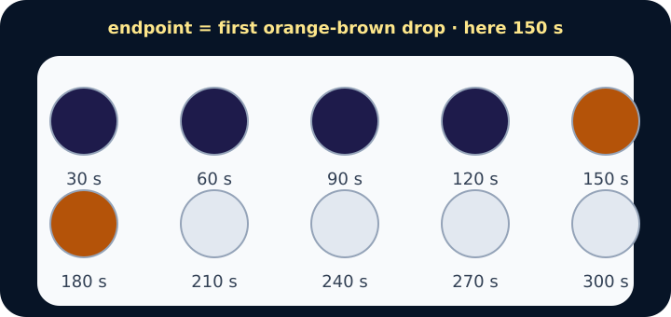
Tile showing the change from blue-black to orange-brown at 150 s
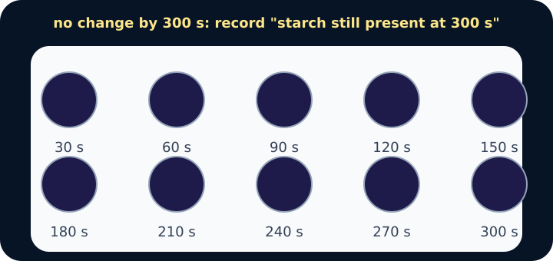
Tile with all ten drops blue-black
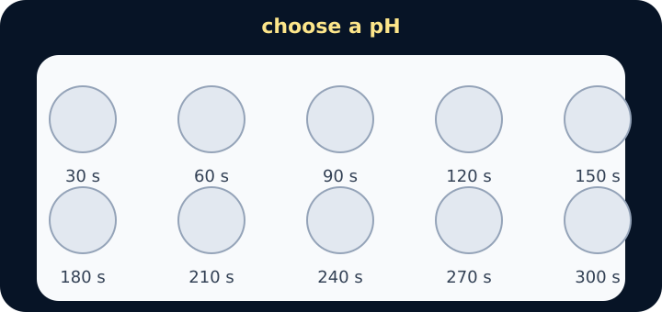
Spotting tile filling with iodine drops

Exit · one next step
After the adult has listened, what will you keep, improve or check next?

