Amylase Rate, Graph and Topic 1 Consolidation
  - LAUNCH · Science · 40 minutes
I can calculate amylase rate from endpoint time, plot and interpret the pH pattern, evaluate the method, and apply Topic 1 knowledge to exam-style evidence.
Name: __________________________ Date: ______________
You may write, type, say, sign, point or direct a partner. An adult can read the words and record your exact response. Keep the choice and explanation your own.

Words for this lesson
Word | Meaning
reciprocal | one divided by
optimum | highest measured activity
evaluate | weigh evidence and judge

First idea
Two trials reached the endpoint in 50 s and 200 s. Which interpretation should you test against the full dataset?
A. The 200 s trial was faster because its time number is larger.
B. The 50 s trial was faster and should have the larger value when rate = 1/time.
C. Both rates are identical because both reached an endpoint.
My first idea and reason:

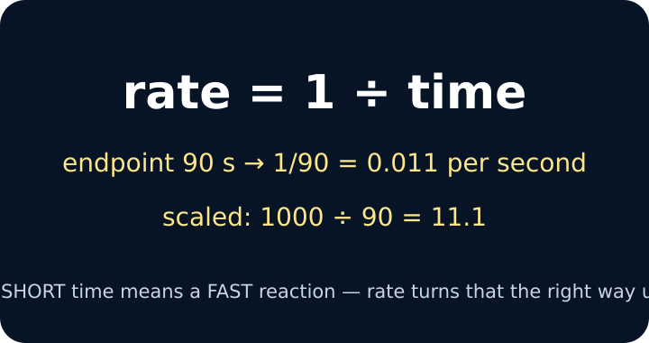
Rate equals one divided by time

We do · choose, explain, check
A trial at pH 6 reaches the endpoint in 125 s. What is its rate to three significant figures?
A. 125 s⁻¹
B. 0.00800 s⁻¹
C. 0.125 s⁻¹
My choice: ______ Evidence or reason:

Calculation, graph and evaluation triage
Route each data statement to calculation check, pattern/conclusion or evaluation before writing the full response.
Read or hear one card. Choose a group. Give the evidence. A partner checks your reason before you move on. Point or write card numbers; cutting is optional.
Group | Card numbers and evidence
CALCULATION CHECK
PATTERN / CONCLUSION
EVALUATION

Activity cards
1 · Reciprocal value | 2 · Direction check
Endpoint 100 s gives 1/100 = 0.0100 s⁻¹. | The shortest time should correspond to the largest reciprocal rate.

3 · Highest tested rate | 4 · Rise then fall
The largest mean rate occurs at pH 7 among the tested values. | Rate rises towards the peak and falls on either side in this dataset.

5 · Subjective endpoint | 6 · Shorter interval
Different observers may judge a borderline iodine colour differently. | A shorter fixed sampling interval could narrow the endpoint-time window if the authorised method allows it.

7 · Preserve anomaly
One repeat is far from the others; keep it visible, check the method and justify any treatment.

State one result, one explanation and one method judgement, making clear which claim comes from data and which comes from biological knowledge.

Your lesson record
Complete a GCSE-style CP analysis: rate table, pH-rate graph, evidence-led conclusion, method evaluation and a compact Topic 1 transfer check.

Model helps us see
A reciprocal-rate table and graph translate time evidence into a pattern in enzyme activity. Use observed points first, then add the active-site explanation.

Model does not show
A smooth curve can hide repeats, anomalies and uncertainty. The graph covers only tested pH values and does not by itself prove the molecular mechanism or an exact optimum between points.

Supported
Calculate three rates from a worked equation, plot supplied coordinates, choose the tested optimum and complete one limitation-improvement pair.
Use a calculator sequence, partially labelled axes and stems: The fastest was __ because __. A limitation was __, so improve by __.

Standard
Calculate the full rate column, plot the graph, describe and explain the pattern, then evaluate the endpoint method and answer one Topic 1 exam question.
Follow CALCULATE → DESCRIBE → EXPLAIN → EVALUATE; keep each command-word response distinct.

Stretch
Analyse repeats and uncertainty, justify the tested optimum, evaluate whether the conclusion is valid and transfer enzyme/transport knowledge to an unfamiliar context.
Quantify where possible; distinguish accuracy, precision, repeatability and validity without claiming more than the evidence supports.

Evidence target
Shown rate working, an accurately labelled graph or equivalent data interpretation, a bounded conclusion, a strength-limitation-improvement chain and one Topic 1 transfer response.

Exit, Audience and evidence · W8L3
Supported: A trial takes 100 s. Calculate rate = 1/time and choose the unit.

Standard: Use one graph feature to explain how pH affected amylase, then name one justified method improvement.
Stretch: Evaluate the claim that the graph proves an exact optimum pH, using tested range, repeats and endpoint uncertainty.

What I said, and what it changed
________________________________________________

Next I will ______.

Adult witness note
What was observed, and with what level of independence?

My evidence and explanation

What does this evidence not show?

Visual reference cards
These are diagrams or model views from the uploaded lesson. Use their labels and the card descriptions; they are not photographs of your own results.
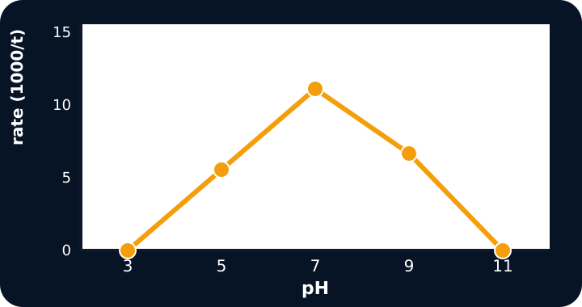
A pH against rate line graph peaking at pH 7
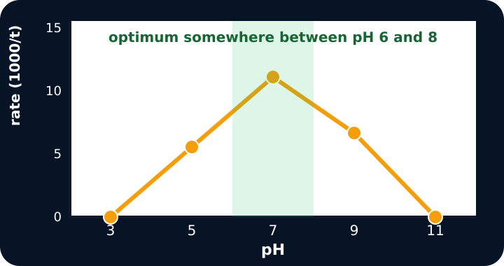
The same graph with a shaded optimum band

Live graph of pH against rate

Exit · one next step
After the adult has listened, what will you keep, improve or check next?

