Cell Cycle: Copy, Check, Divide
  - LAUNCH · Science · 40 minutes
I can describe the cell cycle, distinguishing interphase from mitosis and cytokinesis, and sequence prophase, metaphase, anaphase and telophase using chromosome evidence.
Name: __________________________ Date: ______________
You may write, type, say, sign, point or direct a partner. An adult can read the words and record your exact response. Keep the choice and explanation your own.

Words for this lesson
Word | Meaning
interphase | prepare and copy
mitosis | divide the nucleus
cytokinesis | split the cell

First idea
A cell has grown and copied its DNA, but the chromosome copies have not yet separated. Which part of the cycle is it completing?
A. Interphase, which prepares the cell for nuclear division.
B. Cytokinesis, because the cytoplasm has already formed two cells.
C. The end of the cycle, because DNA copying alone makes two daughter cells.
My first idea and reason:

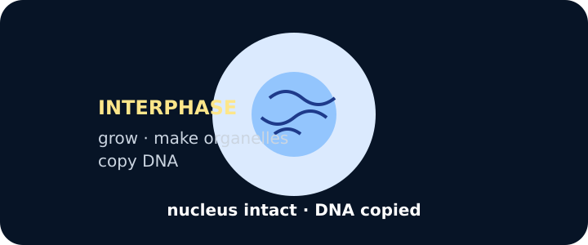
Interphase cell with intact nucleus

We do · choose, explain, check
Which event belongs to interphase rather than mitosis?
A. Copied chromosomes align across the middle of the cell.
B. The cell replicates its DNA before nuclear division.
C. Sister chromosome copies move to opposite ends of the cell.
My choice: ______ Evidence or reason:

Cell-cycle event routing console
Route each event to preparation before nuclear division, nuclear division, or cell split/outcome, then build one defensible sequence.
Read or hear one card. Choose a group. Give the evidence. A partner checks your reason before you move on. Point or write card numbers; cutting is optional.
Group | Card numbers and evidence
INTERPHASE · PREPARE
MITOSIS · NUCLEAR DIVISION
CYTOKINESIS · CELL SPLIT

Activity cards
1 · Cell growth | 2 · DNA replication
The cell grows and increases the number of subcellular structures. | Each chromosome's DNA is copied before nuclear division.

3 · Chromosomes condense | 4 · Chromosomes align
Copied chromosomes become shorter, thicker and more visible in prophase. | Copied chromosomes arrange near the equator of the cell in metaphase.

5 · Sister chromatids separate | 6 · Two nuclei reform
Copied chromosome halves move towards opposite poles in anaphase. | Nuclear envelopes form around the two chromosome groups during telophase.

7 · Cytoplasm divides
The membrane and cytoplasm separate the parent cell into two daughter cells.

Describe the complete cycle using interphase, one visible clue for each mitotic stage, and cytokinesis.

Your lesson record
Create an evidence-labelled cell-cycle sequence and answer GCSE DESCRIBE and EXPLAIN questions that distinguish interphase, mitosis and cytokinesis.

Model helps us see
Use the chain PREPARE → ALIGN → SEPARATE → REFORM → SPLIT, then replace each everyday word with the formal stage and its chromosome evidence.

Model does not show
Stage cards freeze a continuous, three-dimensional process into neat snapshots. Chromosomes, spindle fibres, cell size and timing are not to scale, and checkpoints and molecular controls are mostly omitted.

Supported
Order six labelled picture cards, match prepare/divide/split, and complete a stem explaining when DNA is copied.
Use: During interphase __. During mitosis __. During cytokinesis __.

Standard
Sequence interphase, four named mitotic stages and cytokinesis, annotate visible evidence, then explain why DNA replication must precede mitosis.
Use DESCRIBE for the ordered changes and EXPLAIN for cause plus biological reason.

Stretch
Evaluate an incorrect cell-cycle model, repair chromosome-number reasoning and explain why stage boundaries can be uncertain in a snapshot.
Distinguish observation, stage inference and model limitation; include the caveat that mutation or segregation error can disrupt the usual outcome.

Evidence target
A complete ordered cycle, at least four stage-evidence links, a correct distinction between DNA replication and chromosome separation, and one pupil-owned explanation.

Exit, Audience and evidence · W9L1
Supported: Complete: DNA is copied during __, chromosome copies separate during __, and the cytoplasm divides during __.

Standard: Describe the cell cycle from interphase to two daughter cells using at least four formal stage terms.
Stretch: Explain why DNA amount increases before division without each daughter cell retaining twice the parent chromosome number.

What I said, and what it changed
________________________________________________

Next I will ______.

Adult witness note
What was observed, and with what level of independence?

My evidence and explanation

What does this evidence not show?

Visual reference cards
These are diagrams or model views from the uploaded lesson. Use their labels and the card descriptions; they are not photographs of your own results.
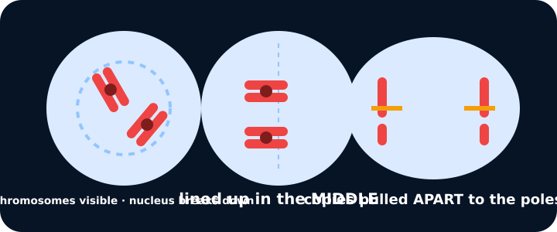
Prophase, metaphase, anaphase
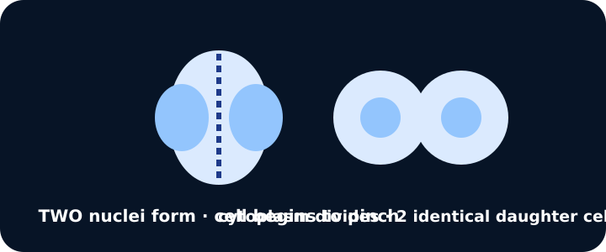
Telophase then cytokinesis

Exit · one next step
After the adult has listened, what will you keep, improve or check next?

