Card 1 Model story A
All people and job stories are made up. Pictures show types of work. Use the words as well.
Picture | Story card
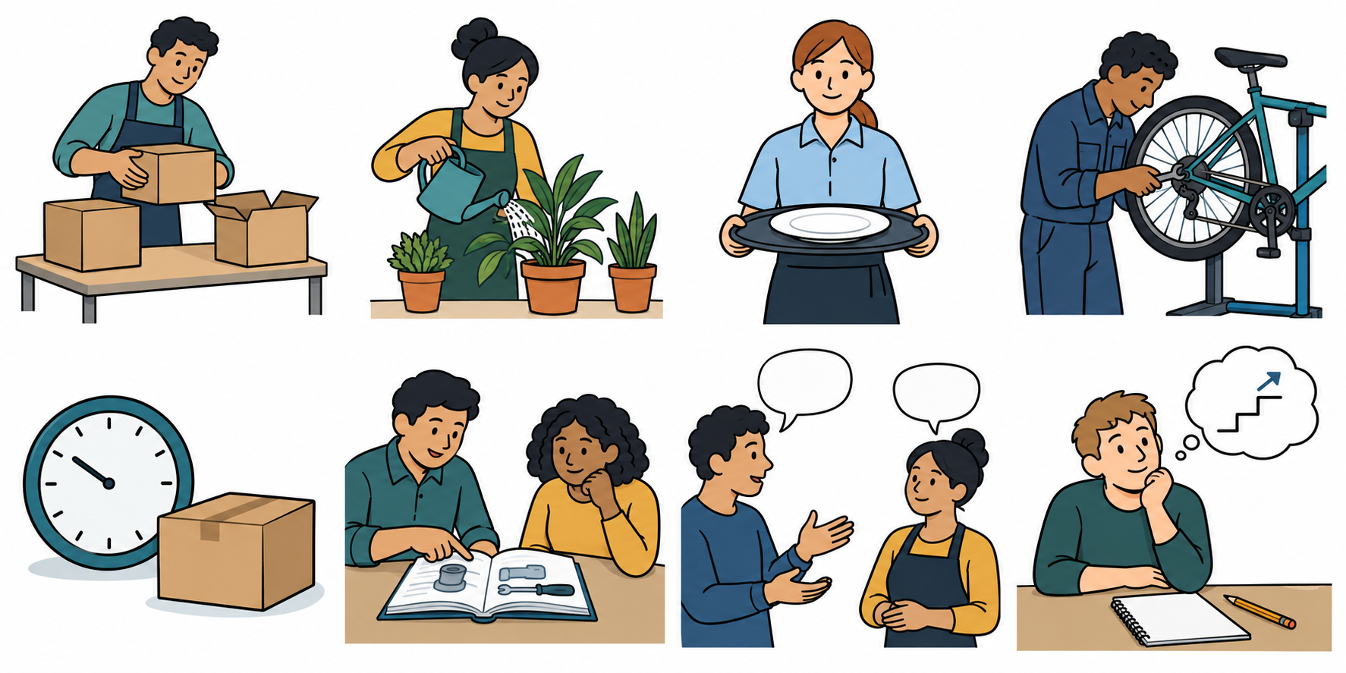 | J First, a person packs boxes.
 | K The job ends.
 | L They learn to tend plants.
 | M Later, they tend plants in a new job.

Our model
Order: J K L M. The change is K. They adapt at L by learning a new skill. A new job does not mean they failed.
One way to cope: ask for help with a next step.
Words: first, next, then, last, learn, help. Start: “They learn to ... .”

Card 2 Sort story B
This story is made up. The cards are mixed up. Point, move the cards or use the letters in your book.
Picture | Story card
 | P Their shift times change.
 | Q Later, they pack boxes in a new job.
 | R First, they serve food.
 | S They learn to pack boxes.

Sort and talk in private
Which comes first? What changed? Where did they learn a new skill? Choose one way to cope: ask for help or make one small plan.
Use A as a model. Words: first, next, then, last. Start: “The change is ... . They learn to ... .”

Card 3 Your story C
This story is made up. Choose all four cards or two at a time. Use your book, an aid, Type instead or a scribe.
Picture | Story card
 | T The job ends.
 | U Later, they mend bikes in a new job.
 | V First, they tend plants.
 | W They learn to mend bikes.

Your task
Put the letters in order. Point to the change and the new skill. Give one way to cope. Use A as a model.
Words: first, next, then, last, learn, help. Start: “They learn to ... . They could ask ... .”

Card 4 Ways to cope
A work plan can change. A person may need help. These pictures and ideas are made up.
Picture | A useful step
 | Ask for help. An adult can help plan a next step.
 | Make one small plan. Choose one step to try.
 | Agree a short pause. Then plan a step with help.
Choose one useful step for the story person. There may be more than one good answer. No need to share your own story.

Words and model
help · plan · pause · next step
Start: “They could ... .” Model: “They could ask for help.”

Help in private
Point to HELP, write a request or ask for a private talk. Use a trusted adult or the school’s help route. If one adult is busy, ask another. You may pass, pause and return with support.

