Card 1 Bike repair apprentice
This profile is made up for practice. It is not a real job advert. The needs shown are for this card only.
Picture | Role and sector
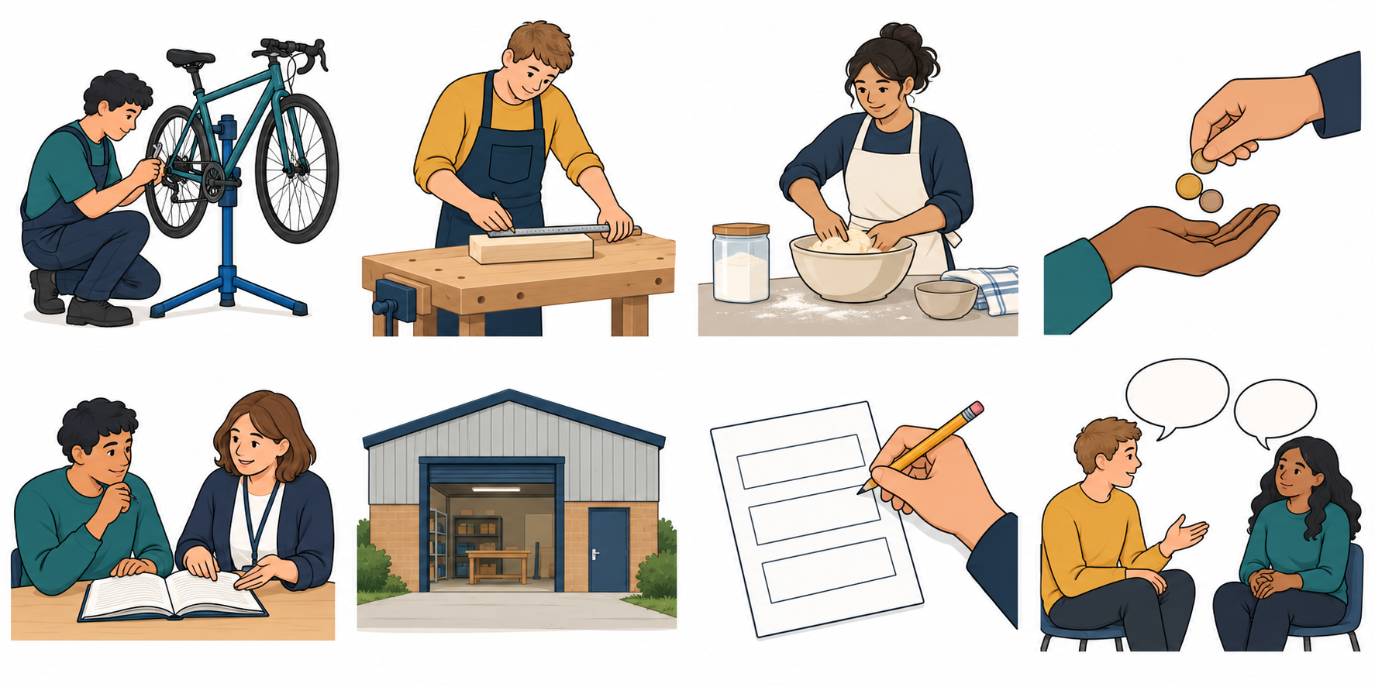 | A Bike repair apprentice. Sector: Bike repair.
Label | Profile detail
Pay | Paid to help check and mend bikes.
Training | Planned lessons and practice with a trainer.
Employer | A small bike repair workshop.
Entry need | Read a short safety note.
To apply | Complete a short form about a skill to learn.

Our model
A earns pay for work and learns through training. A would need to read a short safety note. Find that in Entry need.
The employer gives the job. The trainer helps learning. Use both Pay and Training to explain earn and learn.
You may point, use your book, type or use a scribe. This is a reading task; do not do the trade work.

Card 2 Woodwork apprentice
This profile is made up for practice. It is not a real job advert. The needs shown are for this card only.
Picture | Role and sector
 | B Woodwork apprentice. Sector: Woodwork.
Label | Profile detail
Pay | Paid to help measure and smooth wood.
Training | Planned lessons and practice with a trainer.
Employer | A small wood workshop.
Entry need | Measure a short length with a ruler.
To apply | Give one example of following an instruction.

Your fact card
Find pay, training, employer and entry need. Explain earn and learn. Choose one need from Entry need or To apply.
Use A as a model. Start: “For this made-up role, I would need ... .” The sector is woodwork.
You may point, use your book, type or use a scribe. This is a reading task; do not do the trade work.

Card 3 Bakery apprentice
This profile is made up for practice. It is not a real job advert. The needs shown are for this card only.
Picture | Role and sector
 | C Bakery apprentice. Sector: Food making.
Label | Profile detail
Pay | Paid to help weigh and mix food.
Training | Planned lessons and practice in a training kitchen.
Employer | A small bakery.
Entry need | Follow a short list of steps.
To apply | Complete a short form about a skill to practise.

Your fact card
Find pay, training, employer and entry need. Explain earn and learn. Choose one need from Entry need or To apply.
Use A as a model. Start: “For this made-up role, I would need ... .” The sector is food making.
You may point, use your book, type or use a scribe. This is a reading task; do not do the trade work.

Card 4 Earn learn and apply
Use the words and pictures. All pictures and practice roles are made up.
Picture | Meaning
 | Earn: get pay for work.
 | Learn: gain skills through training.
 | Apply: ask to be considered for a place.

Myth or fact
1 An apprenticeship includes paid work and training.
2 An apprentice does paid work but has no training.
3 All three practice profiles ask for the same entry skill.
Choose myth or fact in private. Use a clue from a card. You may pass.

Start and help
“An apprentice earns ... and learns ... .” “One need is ... .”
For private help, point to HELP or ask a trusted adult. Use the school’s help route. If one adult is busy, ask another. You may pass, pause and return with help.

