Choice cards
Pink Supported sheet
Make a choice and say why.

Which job
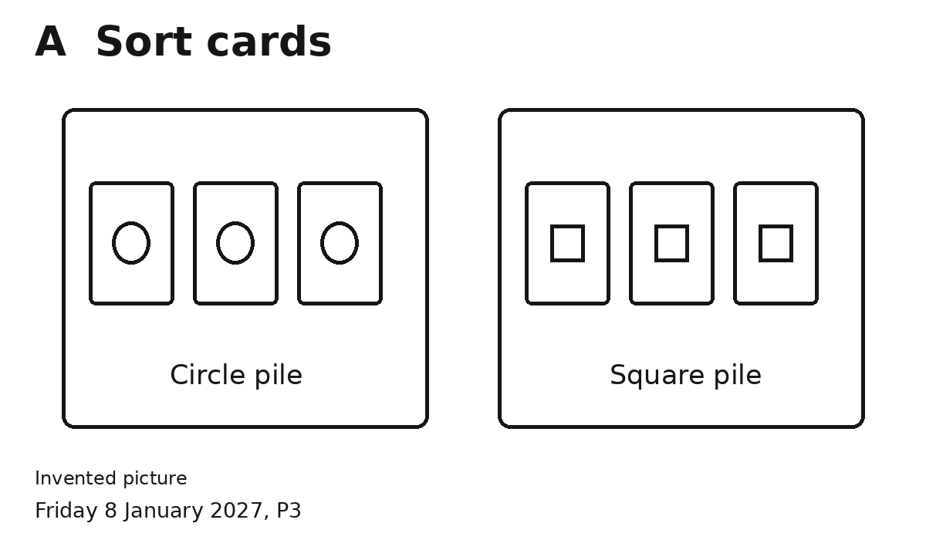
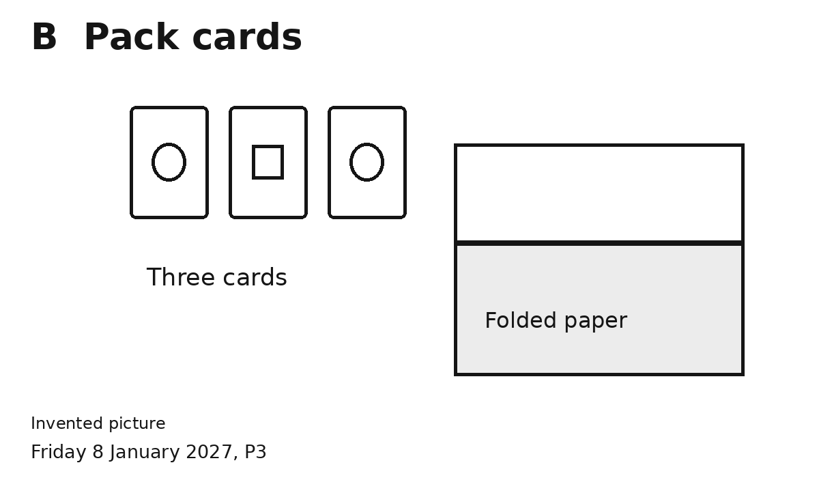
Pick A or B.
I chose ... because ...

Which tool
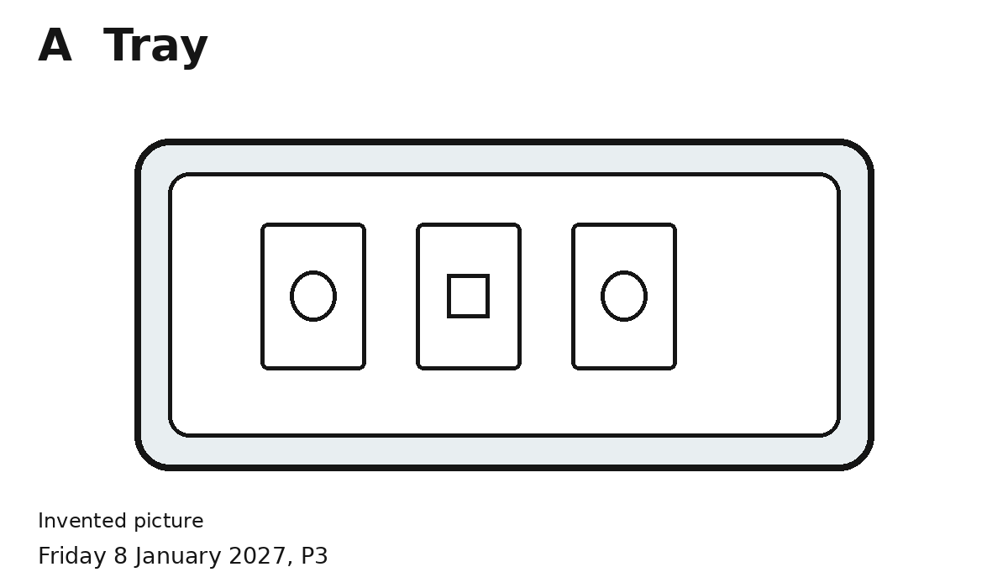
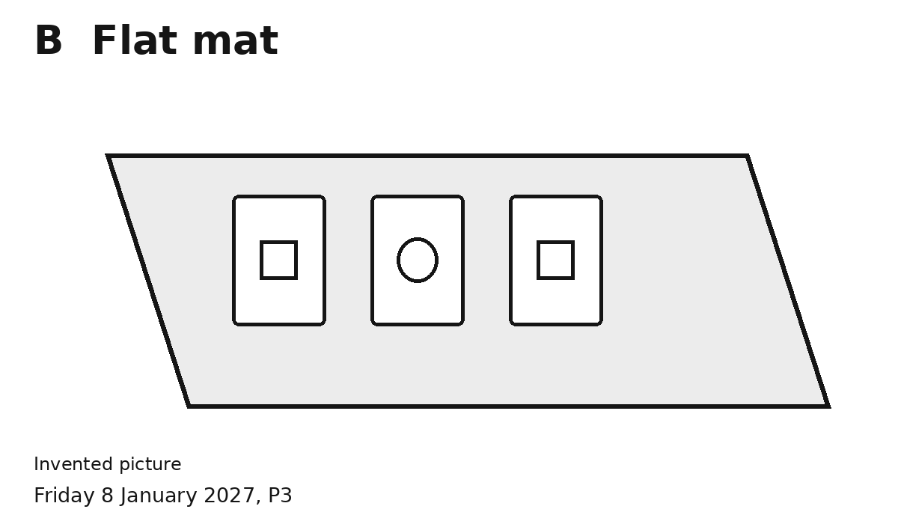
Pick A or B.
I chose ... because ...

What comes first
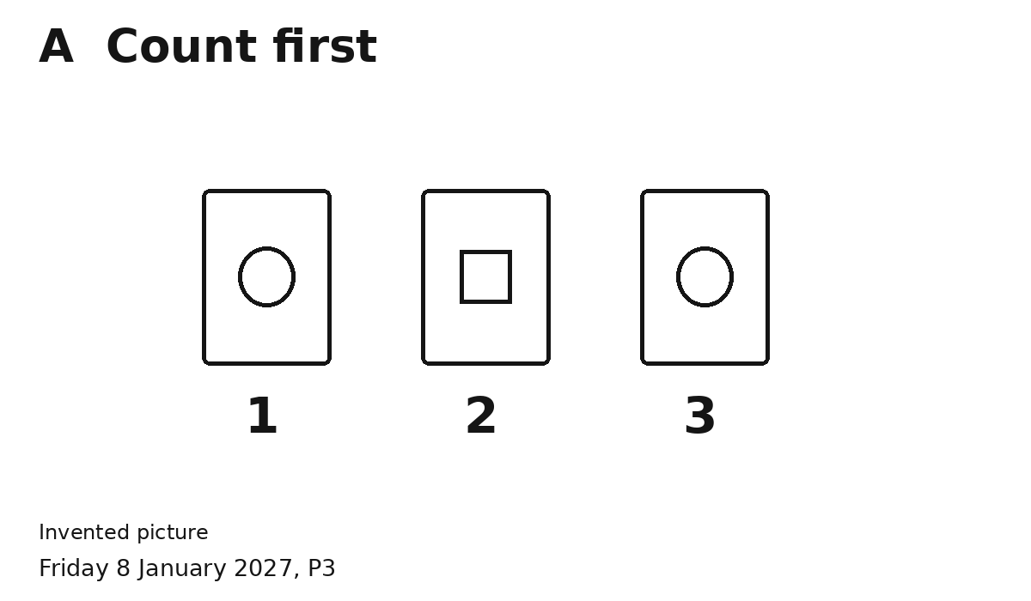
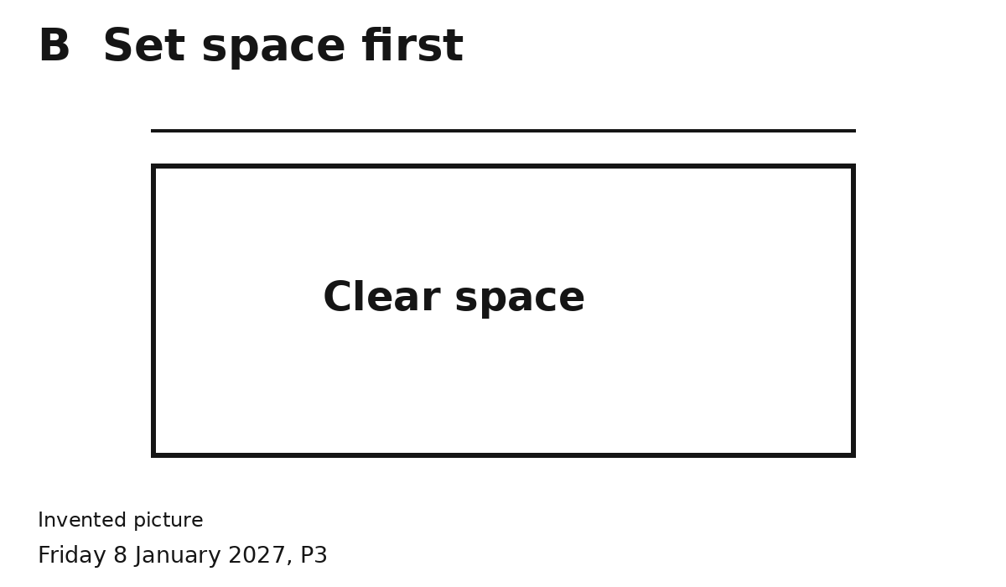
Pick A or B.
I chose ... because ...

