Job cards
Pink Supported sheet
Make a choice and say why.

A Sort cards
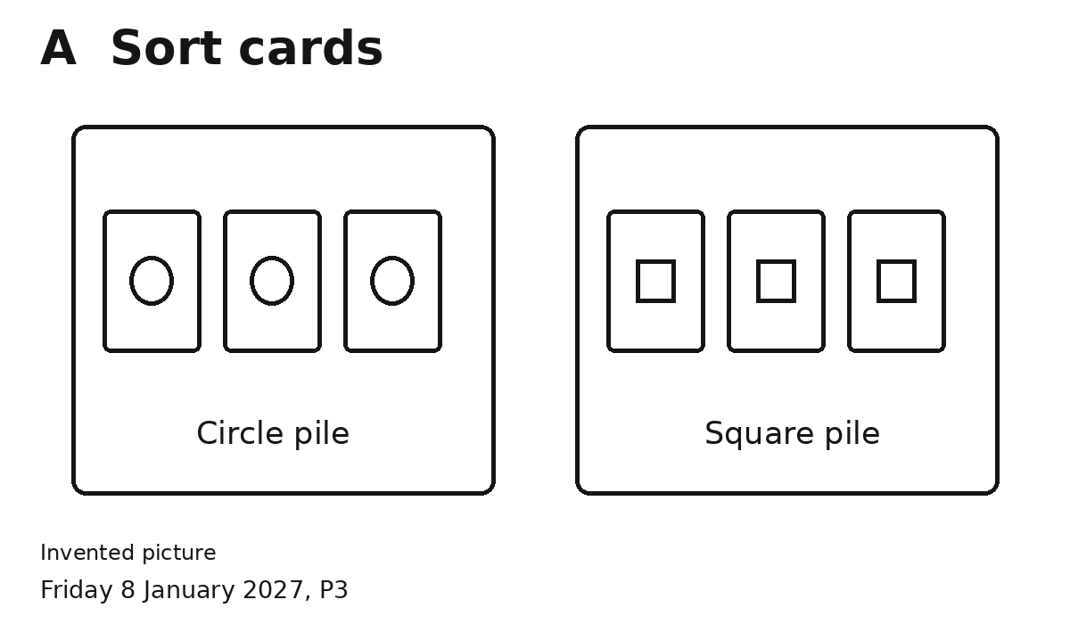
1 Put the same shapes together.
2 Check with an adult.
I chose this job because ...

B Pack cards
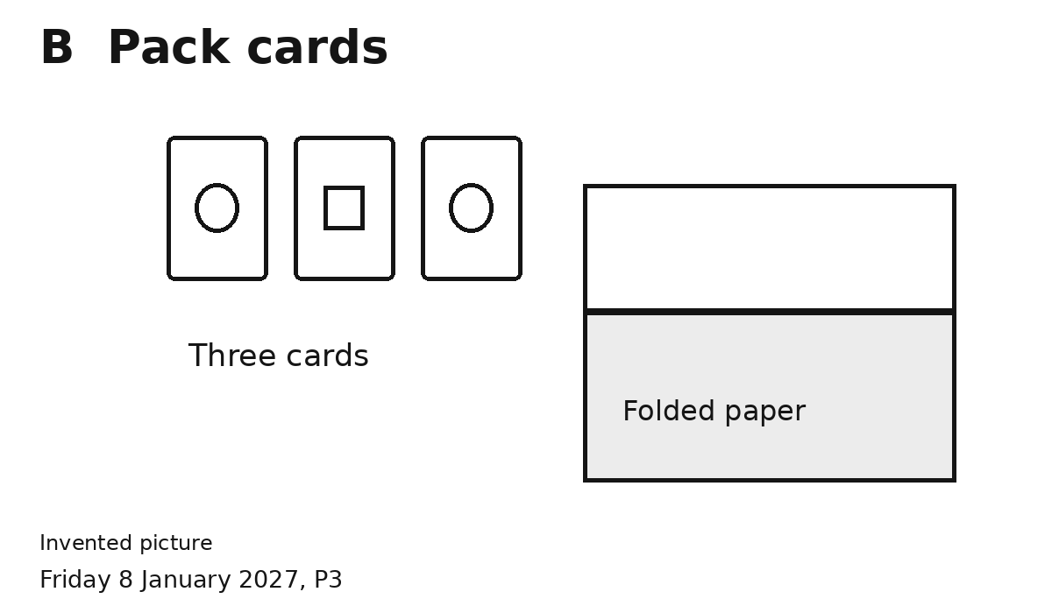
1 Put three cards in the fold.
2 Check with an adult.
I chose this job because ...
Ask for help or a break.

