Help with my choice
White Standard sheet
Make a choice and say why.

My reason
I chose ... because ...
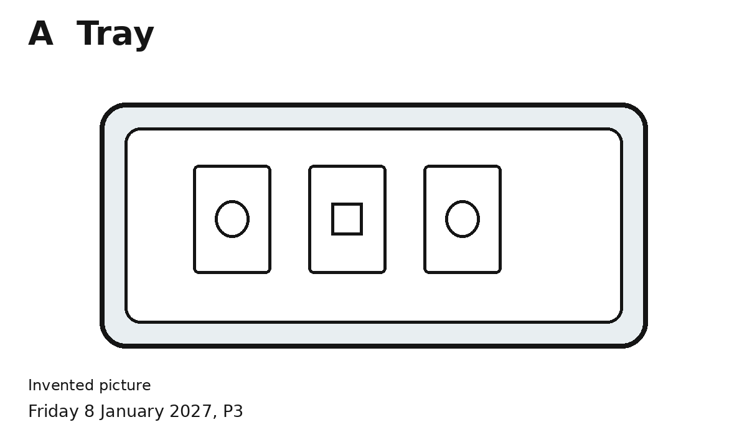
It keeps my cards in one spot.
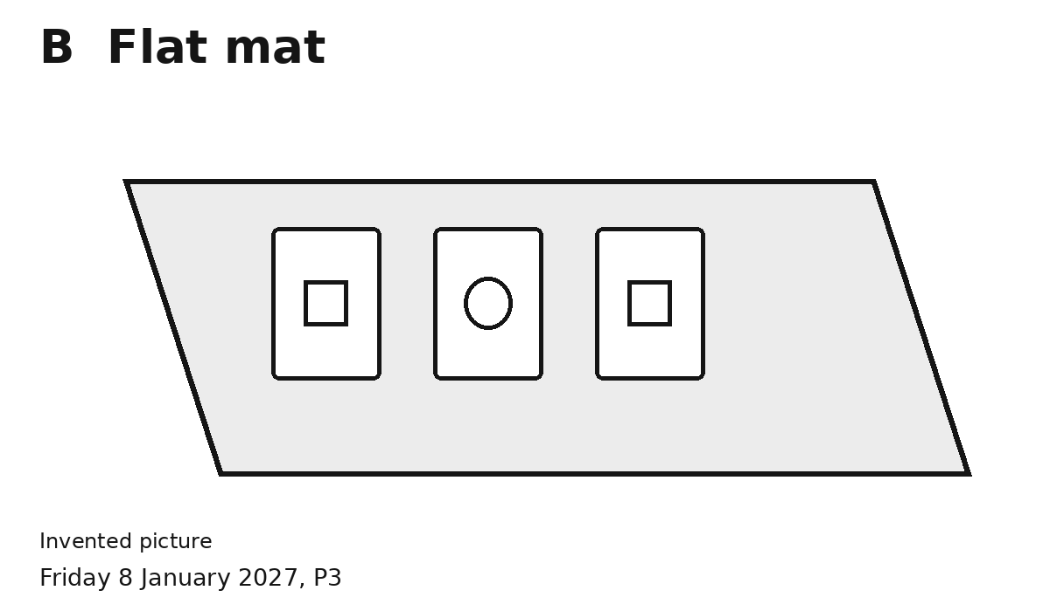
I can see the cards.
I like a tidy pile.
It helps me count.
I can use my own reason.

Help and break cards

HELP
Please show me one step.
I can point to this word.

BREAK
I need a short pause.
Tell or show an adult. Agree a quiet spot.
When I am ready, I can make one choice with an adult.

