Our packing job card
Pink Supported sheet
Work with a partner to complete a task.
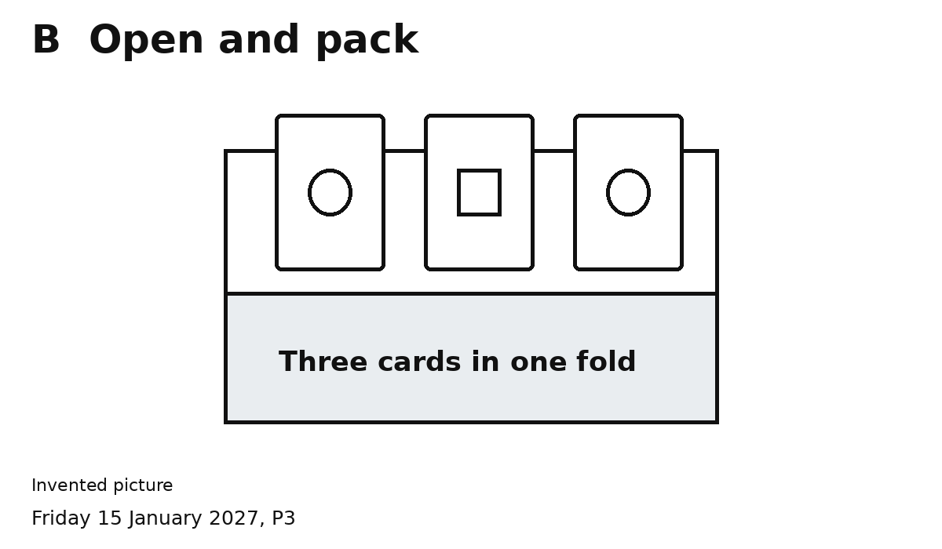
One pack. Three cards. Two people.
Pass cards in the shared space.
1 Do the part on your role card.
2 Check three cards together.
We can help each other.

