Our packing job card
White Standard sheet
Work with a partner to complete a task.
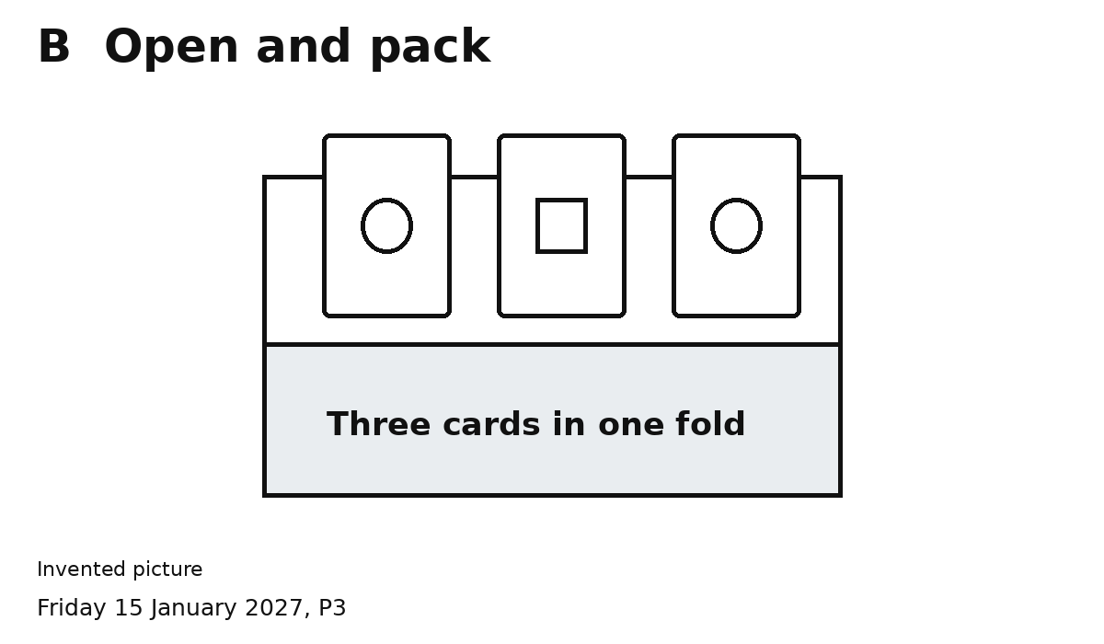
One pack. Three cards. Two people.
Pass cards in the shared space.
1 A counts three cards and passes them.
2 B opens the fold and puts them in.
3 Both open it and count three cards.
4 Both close the fold. The job is done.
We can help each other.

