Our shared packer job
Pink Supported sheet
Take turns and share a role.
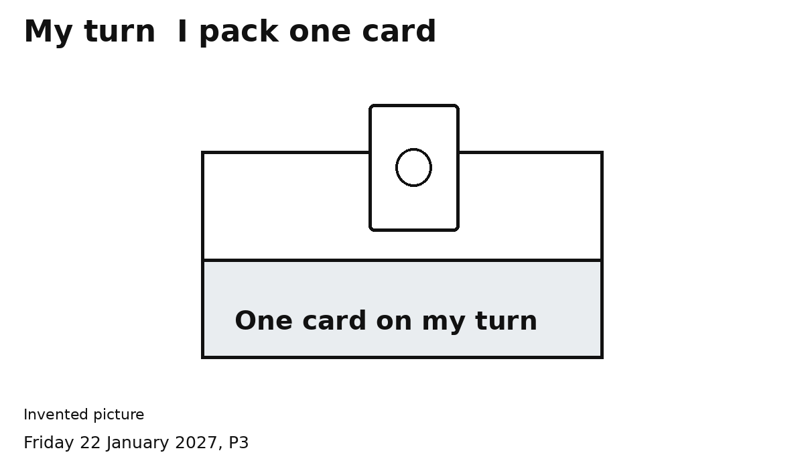
One role. Two turns. Two cards.
1 Pack one card on your turn.
2 Let your partner pack one card.
Check two cards together.
Keep hands clear for the swap.

