Our workplace problem cards
White Standard sheet
Solve a simple everyday problem.

A missing card
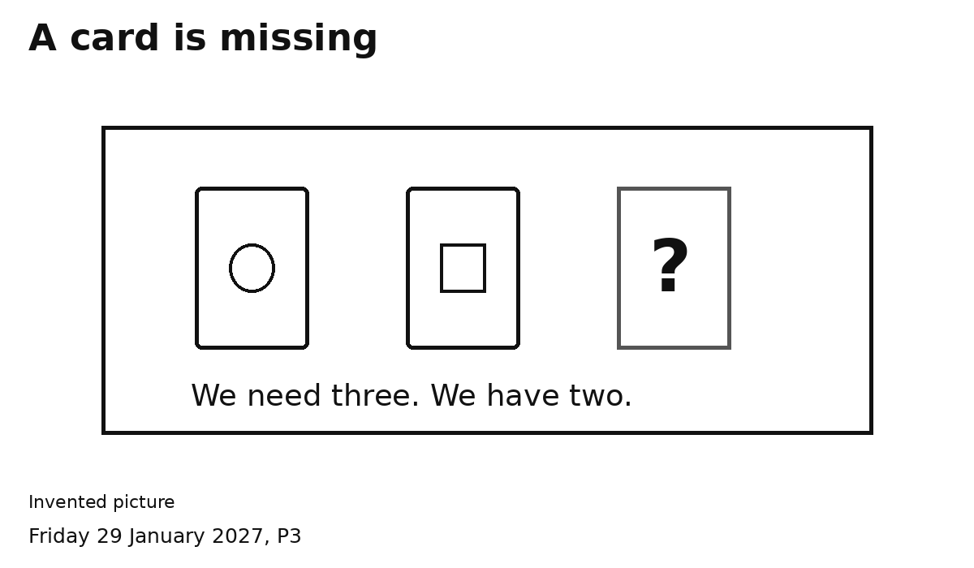
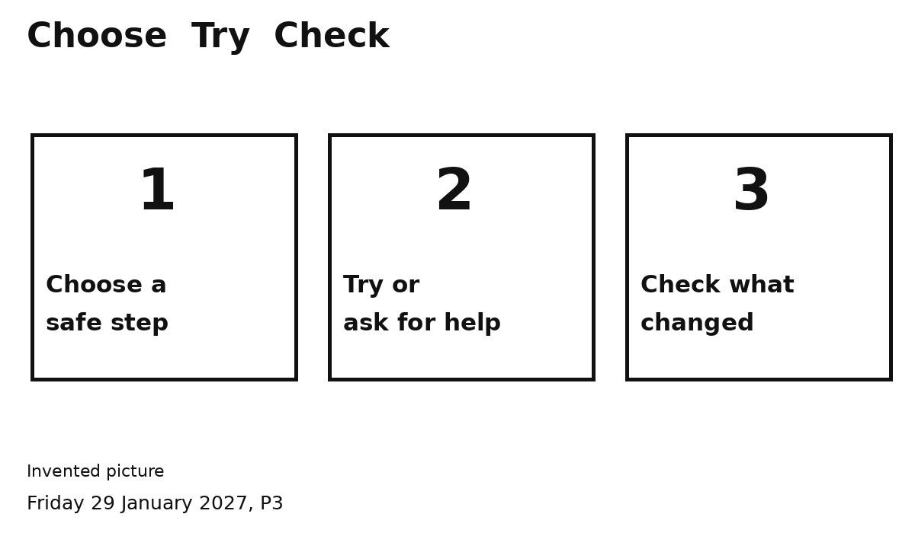
1 We need three cards. We have two.
2 Check the nearby tray or ask an adult for one.
3 Count again. Have we got three?

A picture spill
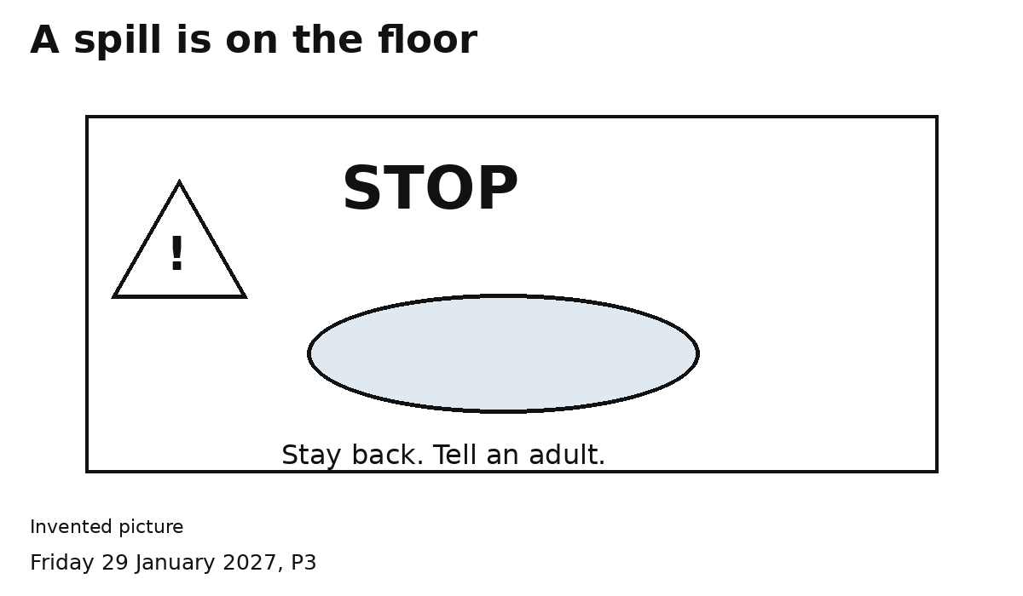
1 STOP. Stay back.
2 Tell an adult about the spill.
3 Check the adult knows. Keep clear.
This is a pretend spill. An adult deals with it.

A pretend customer waiting
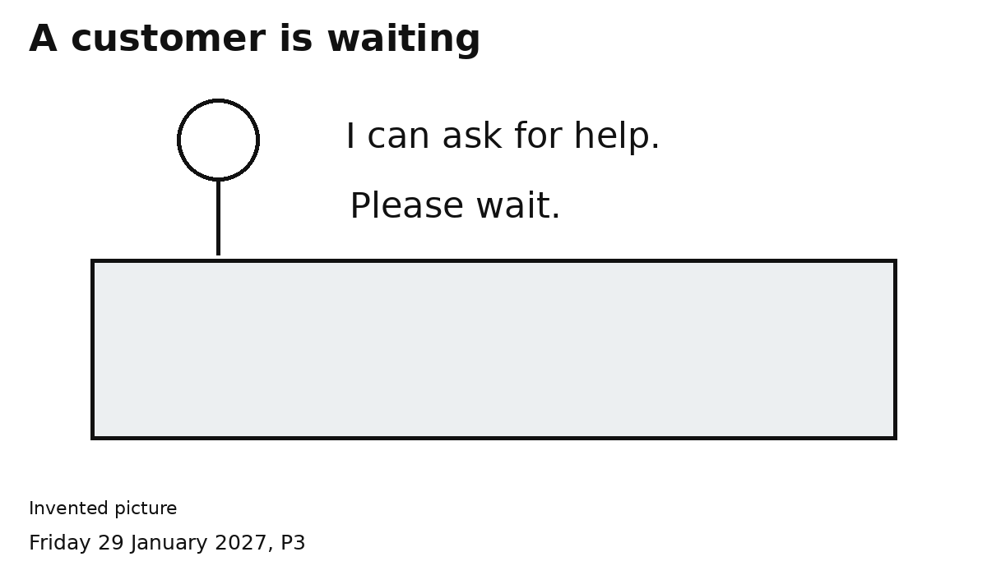
1 Say or show: Please wait.
2 Ask an adult for help.
3 Check the adult knows who is waiting.
The customer is pretend. We ask for help.

