Our everyday problem task
White Standard sheet
Solve a simple everyday problem.
We help in a small packing room. It is made up.
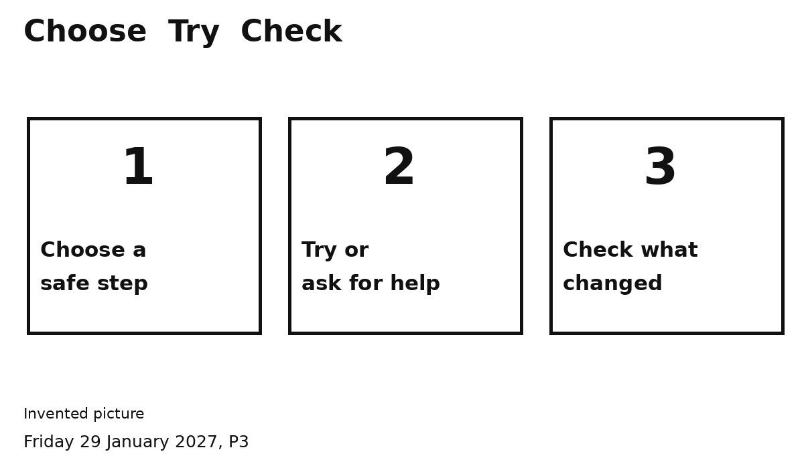
Pick one problem to try.
1 Look at the problem picture.
2 Pick a safe step.
3 Try it or ask for help.
4 Check what changed.
Asking an adult can help solve it.
You can point or speak. Ask for help.

