Four picture and word instructions
Pink Supported sheet
Follow instructions in a practical task.
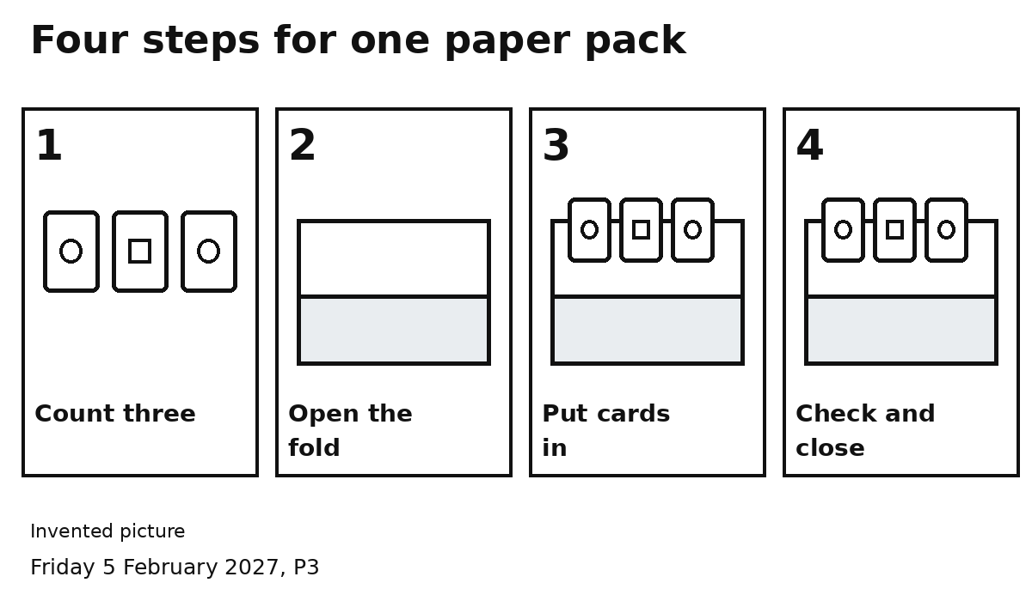

Steps 1 and 2
Count three cards. Open the fold.

Steps 3 and 4
Put three cards in. Check three. Close the fold.
Look at one number at a time.
Finish it. Then go to the next number.

