Four picture and word instructions
White Standard sheet
Follow instructions in a practical task.
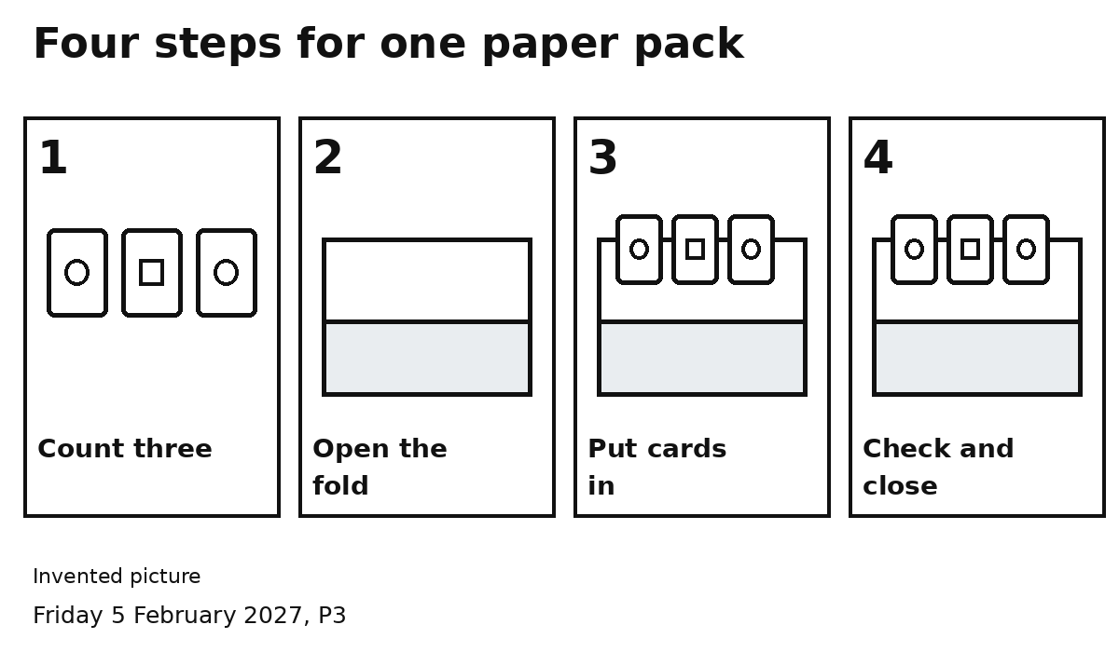
1 Count three cards.
2 Open the folded sheet.
3 Put three cards inside.
4 Check three cards. Close the fold.
Look at one number at a time.
Finish it. Then go to the next number.

