How our team worked
Pink Supported sheet
Reflect on how our team worked.
We help in a small packing room. It is made up.
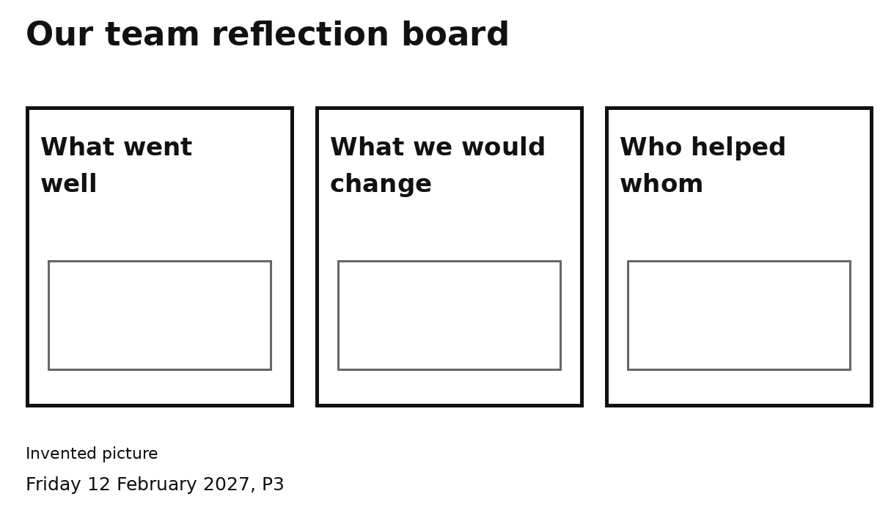
1 Pick one picture or heading.
2 Show or tell one idea.
One idea is enough.
You can point, speak or ask an adult to write.

