My week record
7 January 2027 | P3
Pink paper | You can point, write or ask an adult to write.
My code ____ Date ____
Sequence events in my own week.
In your book: put three things you did in order. Use safe things you wish to share.

Words
first, next, last
read, drew, played, walked, rested, packed

Start
First I __ on __.
Next I __ on __.
Last I __ on __.

Model
This is made up.
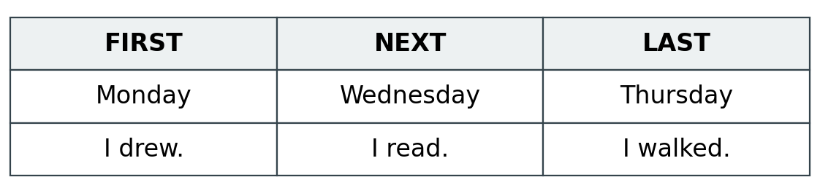
Use the day strip. You can point or move cards. An adult can write what you show or say.

Finish
Keep your own three things in your book. Show one part to an adult in a quiet way.

My week record continued
7 January 2027 | P3
Pink paper | You can point, write or ask an adult to write.

Adult record
Pupil number: ____ Actual date ____ HUM-BUILD-S1-W01-E1
Book/photo reference ____
Record kind: own week / model practice / part complete
Actual days/events and observed order:
1 ______________________________________________
2 ______________________________________________
3 ______________________________________________
Order check: sound / needs a change / not yet clear
Time words shown by: words / pointing / card order / scribed line
Actual prompts and aid ____________________________
Who chose each event and day? ____________________
Adult-supplied content, if any ______________________
Adult reply and one NS ___________________________
Pupil’s own response or change ____________________
Unfinished day/event check ________________________
Actual review and banking ________________________
Use roles and codes only. Do not add names or places. Model practice does not prove the own-week outcome. Record R after reply, NS and own response; E after actual banking.

