Object picture cards
14 January 2027 | P3
Pink paper | You can point, write or ask an adult to write.
Generic teaching pictures. Left: kettle. Middle: phone. Right: school bag.
Top row: then, an older design.
Bottom row: now, a more recent design.
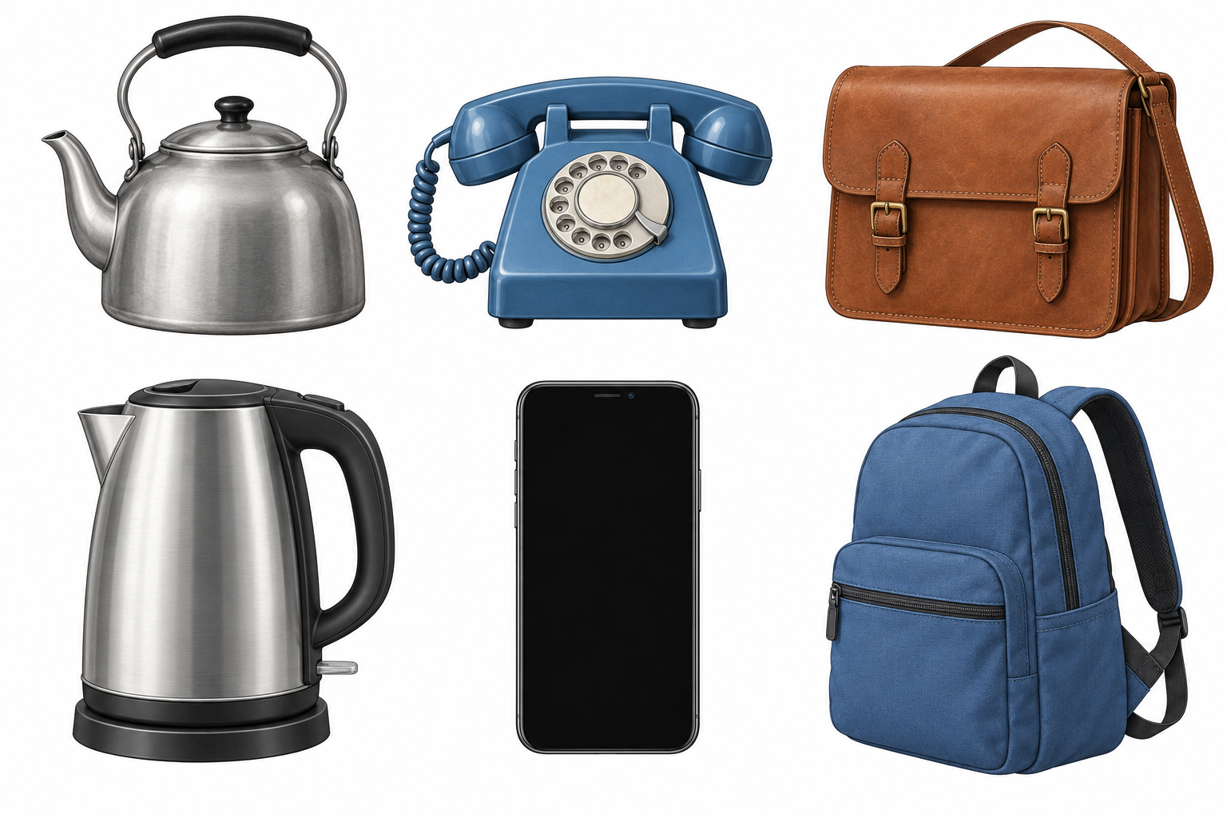
Words: kettle, phone, bag, both.
Start: Both are __. Model: Both are kettles.

Finish
Point to one pair. Both styles may still be used now.

Object picture cards continued
14 January 2027 | P3
Pink paper | You can point, write or ask an adult to write.

Clues for a comparison
These labels tell us about the pictures. Use both in a pair.
Pair | Shared use | Then clue | Now clue
Kettle | Heat water | Handle on top | Handle at side
Phone | Talk to someone | Round dial | Flat screen
School bag | Carry things | Flap and buckles | Zip

Words
both, same, different, handle, dial, screen, buckles, zip

Start
Both __. Then __. Now __.

Model
Part | Model
Same use | Both bags carry things.
Then | The bag has buckles.
Now | The bag has a zip.
The pictures do not tell us the exact age or weight. Old does not mean broken. New does not mean best.

Finish
Use one shared use and one paired difference. An adult can read with you.

