Object story cards
21 January 2027 | P3
White paper | You can point, write or ask an adult to write.
Two made-up stories. These pictures are mixed up.
Top: A sewn, B whole, C torn.
Bottom: D paint, E chips, F bare wood.
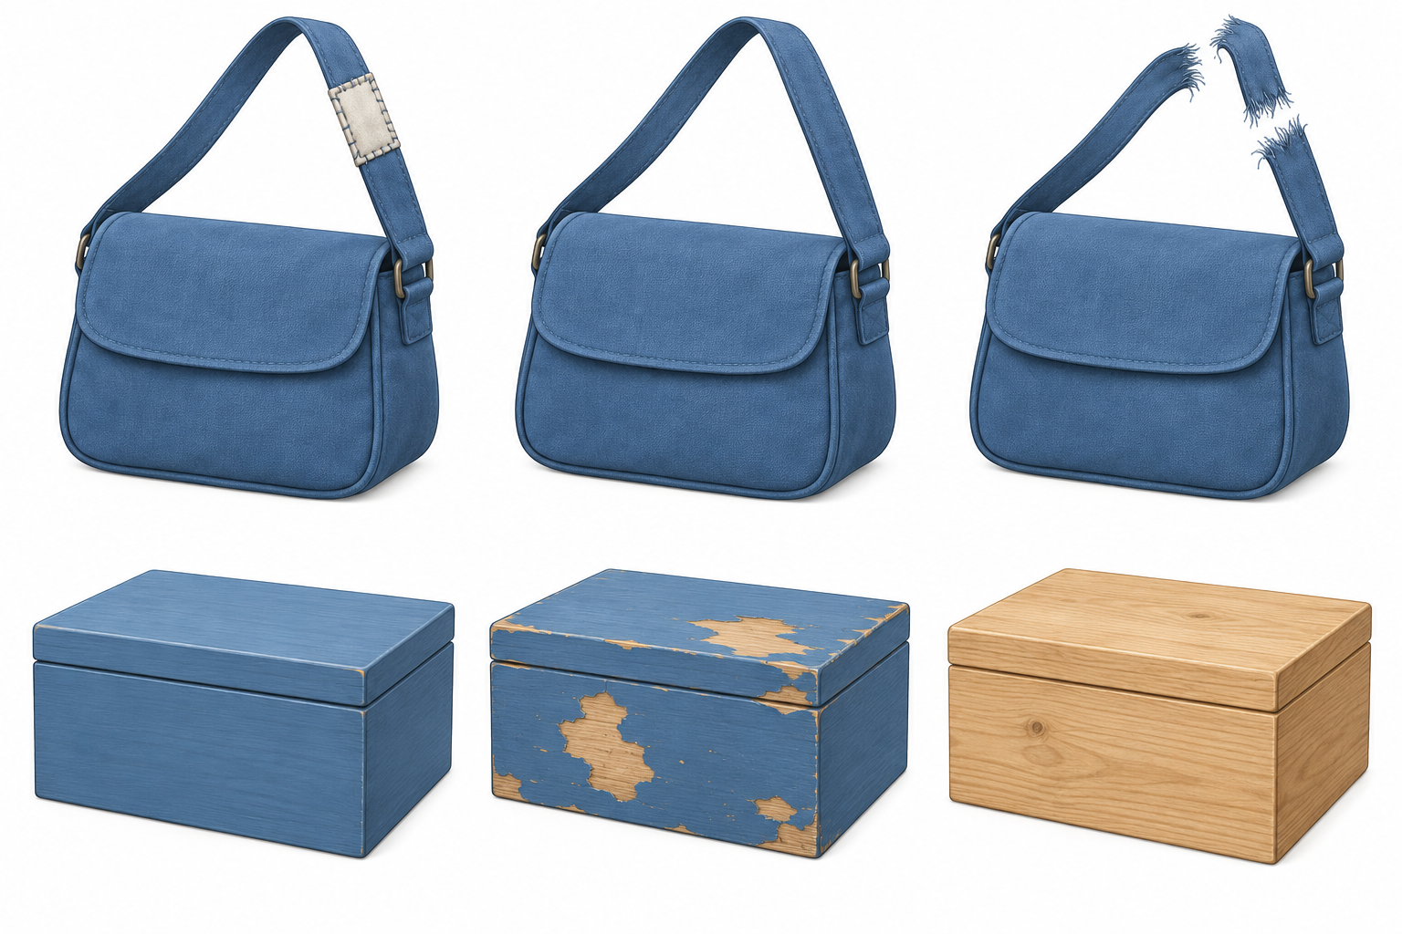
Words: bag, whole, torn. Start: This strap is __.
Model: This strap is whole. It is B.

Finish
Find whole and torn straps. Show an adult quietly.

Object story cards continued
21 January 2027 | P3
White paper | You can point, write or ask an adult to write.

The bag story
At first the bag has a whole strap. Later the strap tears. At the end someone sews the strap.

The box story
At first the box is bare wood. Later someone paints it. At the end the paint has chips from use.

Words
first, next, last, whole, torn, sewn, bare, paint, chips

Start
First __. Next __. Last __.

Bag model
First | Next | Last
B · Whole strap | C · Torn strap | A · Sewn strap
Use the story clues. Colour does not tell the order.
These are made-up stories with no product dates.

Finish
Place three pictures from one story on a line. Keep one time phrase. An adult can read the clues.

