Object story cards
4 February 2027 | P3
White paper | You can point, write or ask an adult to write.
Made-up objects and stories from Week 3.
Top, left to right: A sewn, B whole, C torn.
Bottom, left to right: D paint, E chips, F bare wood.
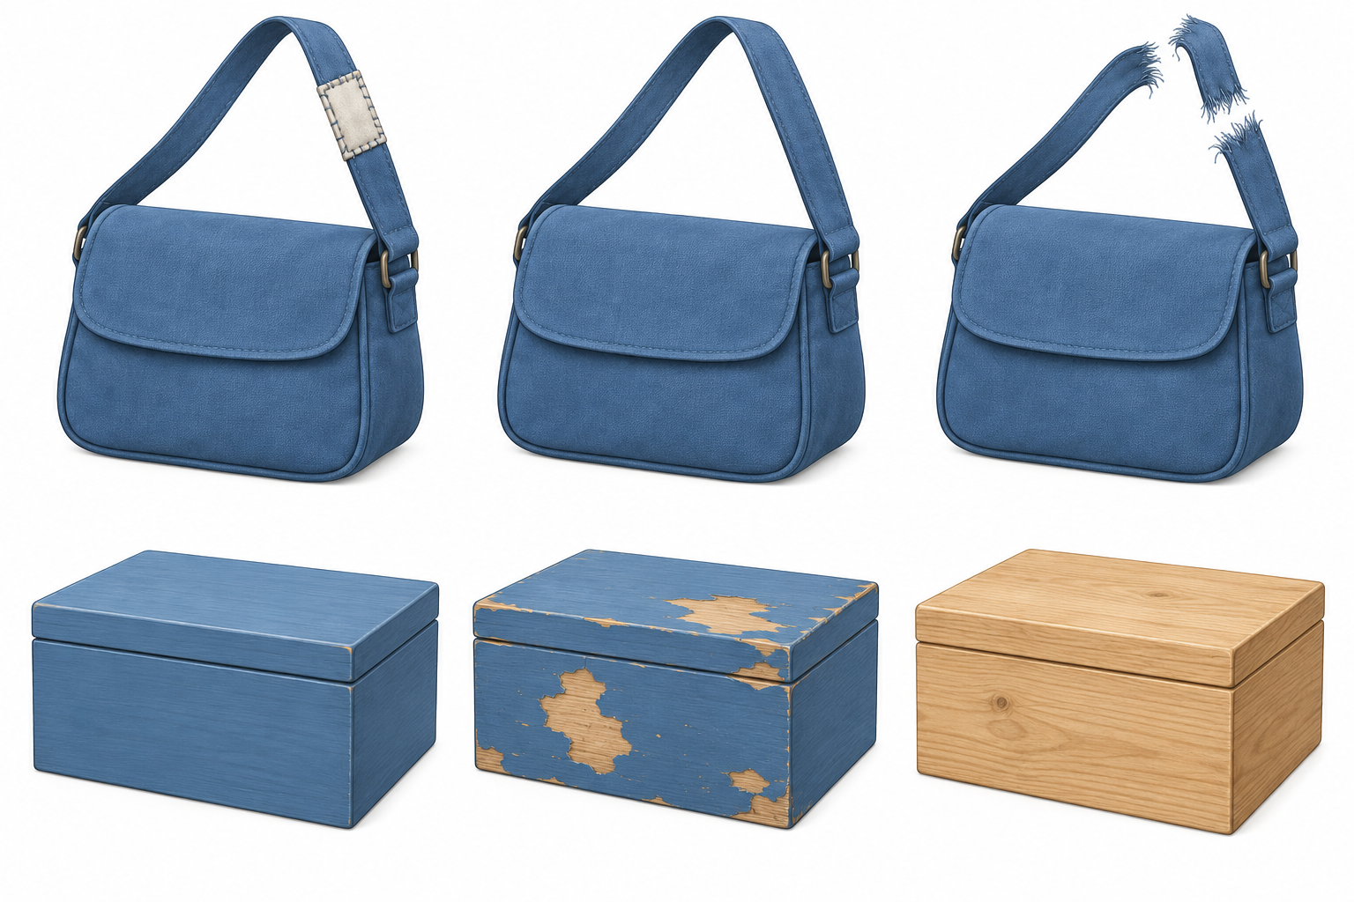
Words: strap, torn, sewn. Start: The strap was __.
Model: The strap was torn.

Finish
Point to one clue. Find torn and sewn straps.

Object story cards continued
4 February 2027 | P3
White paper | You can point, write or ask an adult to write.

Story clues
These stories are made up. The pictures are mixed up.
Story | First | Next | Last
Bag | B whole strap | C strap tears | A strap sewn
Box | F bare wood | D painted | E chips from use
Someone sews the strap. Someone paints the box.
We do not know who, where, the date or why.

Words
who, what, when, where, why, how, strap, box

Start
What happened to __? Who __?

Model
Ask | Reply from the story
What happened to the strap? | The strap tore.

Finish
Choose a clue to ask about. Use a stem from the help cards. An adult can read with you.

