Science · LAUNCH · Autumn 2 · Week 4 · SCI-LAUNCH-A2-W04 · Date __________
DNA, genes and chromosomes
Today I can… I can label DNA, a gene and a chromosome in a simple model. I can explain that a gene is a section of DNA with a protein instruction. I can distinguish one chromosome from the genome.
Feedback: □ VF □ WS □ I □ NS □ E □ R □ [//] □ [?] __________
Lesson strips
DNA, genes and chromosomes
Today I can… I can label DNA, a gene and a chromosome in a simple model. I can explain that a gene is a section of DNA with a protein instruction. I can distinguish one chromosome from the genome.
Feedback: □ VF □ WS □ I □ NS □ E □ R □ [//] □ [?] __________
DNA, genes and chromosomes
Today I can… I can label DNA, a gene and a chromosome in a simple model. I can explain that a gene is a section of DNA with a protein instruction. I can distinguish one chromosome from the genome.
Feedback: □ VF □ WS □ I □ NS □ E □ R □ [//] □ [?] __________
DNA, genes and chromosomes
Today I can… I can label DNA, a gene and a chromosome in a simple model. I can explain that a gene is a section of DNA with a protein instruction. I can distinguish one chromosome from the genome.
Feedback: □ VF □ WS □ I □ NS □ E □ R □ [//] □ [?] __________

Science · LAUNCH · Autumn 2 · Week 4 · SCI-LAUNCH-A2-W04 · Date __________
DNA, genes and chromosomes
Today I can… I can label DNA, a gene and a chromosome in a simple model. I can explain that a gene is a section of DNA with a protein instruction. I can distinguish one chromosome from the genome.
Feedback: □ VF □ WS □ I □ NS □ E □ R □ [//] □ [?] __________
Arrival · Supported
Look at this week’s string-and-clip DNA model. Point to one detail you notice.
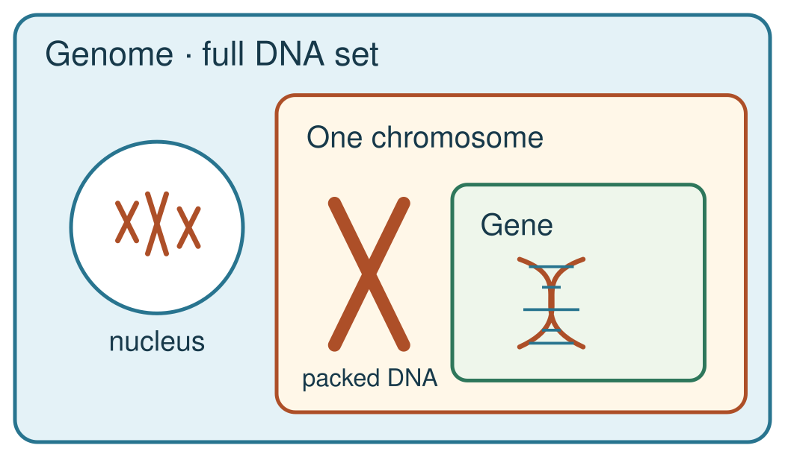
The genome is the full DNA set; a chromosome carries part of it; a gene is a section of DNA on a chromosome. Nested view; not to scale.

Science · LAUNCH · Autumn 2 · Week 4 · SCI-LAUNCH-A2-W04 · Date __________
DNA, genes and chromosomes
Today I can… I can label DNA, a gene and a chromosome in a simple model. I can explain that a gene is a section of DNA with a protein instruction. I can distinguish one chromosome from the genome.
Feedback: □ VF □ WS □ I □ NS □ E □ R □ [//] □ [?] __________
Exit ticket · Supported
1. What does your model show, and why?
Show what you know with a model and explain one reason.
My learning: I am learning to show how a gene is part of DNA and how DNA is packed into chromosomes.
How I know: I can show a gene within DNA, DNA packaged in a chromosome, and the genome as all DNA.
2. What feedback did you hear, and what is your next step?
My feedback was … Name what you heard at Review.
Next I need to … Use “section of DNA” and “codes for a protein” precisely in one sentence.
Check today’s success:
I can label DNA, a gene and a chromosome in a simple model.
I can explain that a gene is a section of DNA with a protein instruction.
I can distinguish one chromosome from the genome.
Your teacher hears your answer and uses it to choose our next model, prompt or example.

Science · LAUNCH · Autumn 2 · Week 4 · SCI-LAUNCH-A2-W04 · Date __________
DNA, genes and chromosomes
Today I can… I can label DNA, a gene and a chromosome in a simple model. I can explain that a gene is a section of DNA with a protein instruction. I can distinguish one chromosome from the genome.
Feedback: □ VF □ WS □ I □ NS □ E □ R □ [//] □ [?] __________
Arrival · Independent
Look at this week’s string-and-clip DNA model. Point to one detail you notice.
The genome is the full DNA set; a chromosome carries part of it; a gene is a section of DNA on a chromosome. Nested view; not to scale.

Science · LAUNCH · Autumn 2 · Week 4 · SCI-LAUNCH-A2-W04 · Date __________
DNA, genes and chromosomes
Today I can… I can label DNA, a gene and a chromosome in a simple model. I can explain that a gene is a section of DNA with a protein instruction. I can distinguish one chromosome from the genome.
Feedback: □ VF □ WS □ I □ NS □ E □ R □ [//] □ [?] __________
Exit ticket · Independent
1. What does your model show, and why?
Show what you know with a model and explain one reason.
My learning: I am learning to show how a gene is part of DNA and how DNA is packed into chromosomes.
How I know: I can show a gene within DNA, DNA packaged in a chromosome, and the genome as all DNA.
2. What feedback did you hear, and what is your next step?
My feedback was … Name what you heard at Review.
Next I need to … Use “section of DNA” and “codes for a protein” precisely in one sentence.
Check today’s success:
I can label DNA, a gene and a chromosome in a simple model.
I can explain that a gene is a section of DNA with a protein instruction.
I can distinguish one chromosome from the genome.
Your teacher hears your answer and uses it to choose our next model, prompt or example.

Science · LAUNCH · Autumn 2 · Week 4 · SCI-LAUNCH-A2-W04 · Date __________
DNA, genes and chromosomes
Today I can… I can label DNA, a gene and a chromosome in a simple model. I can explain that a gene is a section of DNA with a protein instruction. I can distinguish one chromosome from the genome.
Feedback: □ VF □ WS □ I □ NS □ E □ R □ [//] □ [?] __________
Arrival · Aspire
Look at this week’s string-and-clip DNA model. Point to one detail you notice.
The genome is the full DNA set; a chromosome carries part of it; a gene is a section of DNA on a chromosome. Nested view; not to scale.

Science · LAUNCH · Autumn 2 · Week 4 · SCI-LAUNCH-A2-W04 · Date __________
DNA, genes and chromosomes
Today I can… I can label DNA, a gene and a chromosome in a simple model. I can explain that a gene is a section of DNA with a protein instruction. I can distinguish one chromosome from the genome.
Feedback: □ VF □ WS □ I □ NS □ E □ R □ [//] □ [?] __________
Exit ticket · Aspire
1. What does your model show, and why?
Show what you know with a model and explain one reason.
My learning: I am learning to show how a gene is part of DNA and how DNA is packed into chromosomes.
How I know: I can show a gene within DNA, DNA packaged in a chromosome, and the genome as all DNA.
2. What feedback did you hear, and what is your next step?
My feedback was … Name what you heard at Review.
Next I need to … Use “section of DNA” and “codes for a protein” precisely in one sentence.
Check today’s success:
I can label DNA, a gene and a chromosome in a simple model.
I can explain that a gene is a section of DNA with a protein instruction.
I can distinguish one chromosome from the genome.
Your teacher hears your answer and uses it to choose our next model, prompt or example.

Science · LAUNCH · Autumn 2 · Week 4 · SCI-LAUNCH-A2-W04 · Date __________
DNA, genes and chromosomes
Today I can… I can label DNA, a gene and a chromosome in a simple model. I can explain that a gene is a section of DNA with a protein instruction. I can distinguish one chromosome from the genome.
Feedback: □ VF □ WS □ I □ NS □ E □ R □ [//] □ [?] __________
Starter
Recall three ideas from earlier lessons. Show one answer at a time.
1. What is one reason a claim of a new stem-cell treatment needs evidence?
2. Which structure carries the matching chromosome sets after mitosis?
3. Where are chromosomes found in a eukaryotic animal cell?
Today I can:
I can label DNA, a gene and a chromosome in a simple model.
I can explain that a gene is a section of DNA with a protein instruction.
I can distinguish one chromosome from the genome.

Science · LAUNCH · Autumn 2 · Week 4 · SCI-LAUNCH-A2-W04 · Date __________
DNA, genes and chromosomes
Today I can… I can label DNA, a gene and a chromosome in a simple model. I can explain that a gene is a section of DNA with a protein instruction. I can distinguish one chromosome from the genome.
Feedback: □ VF □ WS □ I □ NS □ E □ R □ [//] □ [?] __________
I do · words
Watch the full model. Point to the step that answers today’s question.
Word | Meaning | Example
DNA | the molecule that stores genetic instructions | DNA contains the instructions for making proteins.
gene | a section of DNA that codes for a specific protein | The coloured section of the model stands for one gene.
chromosome | a long DNA molecule packaged with proteins in a cell | A chromosome contains many DNA sections, including genes.
genome | the entire DNA of an organism | The genome includes all of the organism’s chromosomes and other DNA.

Science · LAUNCH · Autumn 2 · Week 4 · SCI-LAUNCH-A2-W04 · Date __________
DNA, genes and chromosomes
Today I can… I can label DNA, a gene and a chromosome in a simple model. I can explain that a gene is a section of DNA with a protein instruction. I can distinguish one chromosome from the genome.
Feedback: □ VF □ WS □ I □ NS □ E □ R □ [//] □ [?] __________
I do · full model
Full model: Mark a short section of a DNA cord as a gene. Coil the cord as one chromosome; place it inside a border for the genome. Name the section, molecule, package and complete DNA set.
The genome is the full DNA set; a chromosome carries part of it; a gene is a section of DNA on a chromosome. Nested view; not to scale.
Show me: is a gene a section of DNA, or is all DNA inside one gene?

Science · LAUNCH · Autumn 2 · Week 4 · SCI-LAUNCH-A2-W04 · Date __________
DNA, genes and chromosomes
Today I can… I can label DNA, a gene and a chromosome in a simple model. I can explain that a gene is a section of DNA with a protein instruction. I can distinguish one chromosome from the genome.
Feedback: □ VF □ WS □ I □ NS □ E □ R □ [//] □ [?] __________
We do · missing step
Complete the missing step in the part-done model. Speak, then match the cards.
One-minute reset: use the agreed move, then return to one step.
Part-done model: DNA cord → a short marked ________ codes for a protein → chromosome package → the genome contains all DNA.
Speak first: “A gene is part of …; a chromosome contains …”
Work as a pair. One explains a label. One asks which part it names. Swap roles. Each keeps their own response.

Science · LAUNCH · Autumn 2 · Week 4 · SCI-LAUNCH-A2-W04 · Date __________
DNA, genes and chromosomes
Today I can… I can label DNA, a gene and a chromosome in a simple model. I can explain that a gene is a section of DNA with a protein instruction. I can distinguish one chromosome from the genome.
Feedback: □ VF □ WS □ I □ NS □ E □ R □ [//] □ [?] __________
We do · match the labels
Select where each label belongs in the string model and explain one mismatch.
Word bank, in source order: DNA / chromosome / gene / genome.
Clue | Your match
short coloured DNA section | Choose from the word bank.
whole genetic molecule | Choose from the word bank.
long DNA package | Choose from the word bank.
all of the organism’s DNA | Choose from the word bank.

Science · LAUNCH · Autumn 2 · Week 4 · SCI-LAUNCH-A2-W04 · Date __________
DNA, genes and chromosomes
Today I can… I can label DNA, a gene and a chromosome in a simple model. I can explain that a gene is a section of DNA with a protein instruction. I can distinguish one chromosome from the genome.
Feedback: □ VF □ WS □ I □ NS □ E □ R □ [//] □ [?] __________
We do · choose a route
Supported: Use the full cord model. Place the gene label on the short marked section.
Independent: Explain how the short DNA section relates to one gene and the larger package.
Aspire: Explain why “one chromosome = one gene” misrepresents scale and role.

Science · LAUNCH · Autumn 2 · Week 4 · SCI-LAUNCH-A2-W04 · Date __________
DNA, genes and chromosomes
Today I can… I can label DNA, a gene and a chromosome in a simple model. I can explain that a gene is a section of DNA with a protein instruction. I can distinguish one chromosome from the genome.
Feedback: □ VF □ WS □ I □ NS □ E □ R □ [//] □ [?] __________
We do 2 · hinge
Choose one hinge answer. Both learners show their answer at the same time.
A new diagram marks a short DNA region carrying instructions for one protein. Which label belongs to that region?
A. A genome containing the whole cell.
B. A gene within the DNA molecule.
C. A complete cell containing no DNA.
D. A chromosome containing the whole genome.
Show one answer to the adult. Point or use a card, too. Then explain to your partner. You may pass on speaking.

Science · LAUNCH · Autumn 2 · Week 4 · SCI-LAUNCH-A2-W04 · Date __________
DNA, genes and chromosomes
Today I can… I can label DNA, a gene and a chromosome in a simple model. I can explain that a gene is a section of DNA with a protein instruction. I can distinguish one chromosome from the genome.
Feedback: □ VF □ WS □ I □ NS □ E □ R □ [//] □ [?] __________
Independent · compare the models
Check these two models. One has a false label. Choose the accurate model and explain one reason.
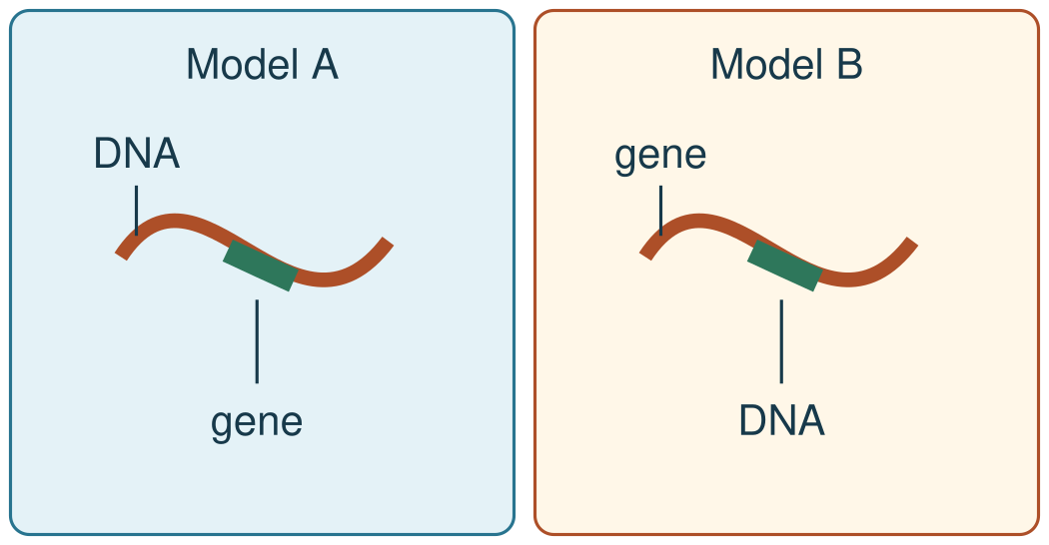
Both pictures are models to check, not real cells. Sizes are not to scale.
Talk before write: “Move this label because …”

Science · LAUNCH · Autumn 2 · Week 4 · SCI-LAUNCH-A2-W04 · Date __________
DNA, genes and chromosomes
Today I can… I can label DNA, a gene and a chromosome in a simple model. I can explain that a gene is a section of DNA with a protein instruction. I can distinguish one chromosome from the genome.
Feedback: □ VF □ WS □ I □ NS □ E □ R □ [//] □ [?] __________
Independent · Supported
Two diagrams label a gene differently. Choose the accurate model and explain one reason.
One-minute reset: use the agreed move, then return to one step.
Talk before write: “Move this label because …”
You can plan in any language. Point, sign, speak, draw, type, write, use an exact scribe or a staff-captured photo.
Label a gene, DNA, chromosome and genome on the model.
This short marked section is a …; the long package is a …
Choose one route. Use the full 8 minutes for your own task.
I · S · C □

Science · LAUNCH · Autumn 2 · Week 4 · SCI-LAUNCH-A2-W04 · Date __________
DNA, genes and chromosomes
Today I can… I can label DNA, a gene and a chromosome in a simple model. I can explain that a gene is a section of DNA with a protein instruction. I can distinguish one chromosome from the genome.
Feedback: □ VF □ WS □ I □ NS □ E □ R □ [//] □ [?] __________
Independent · Independent
Two diagrams label a gene differently. Choose the accurate model and explain one reason.
One-minute reset: use the agreed move, then return to one step.
Talk before write: “Move this label because …”
You can plan in any language. Point, sign, speak, draw, type, write, use an exact scribe or a staff-captured photo.
Explain why a gene is a DNA section, not another material.
A gene is part of … and codes for …
Choose one route. Use the full 8 minutes for your own task.
I · S · C □

Science · LAUNCH · Autumn 2 · Week 4 · SCI-LAUNCH-A2-W04 · Date __________
DNA, genes and chromosomes
Today I can… I can label DNA, a gene and a chromosome in a simple model. I can explain that a gene is a section of DNA with a protein instruction. I can distinguish one chromosome from the genome.
Feedback: □ VF □ WS □ I □ NS □ E □ R □ [//] □ [?] __________
Independent · Aspire
Two diagrams label a gene differently. Choose the accurate model and explain one reason.
One-minute reset: use the agreed move, then return to one step.
Talk before write: “Move this label because …”
You can plan in any language. Point, sign, speak, draw, type, write, use an exact scribe or a staff-captured photo.
Correct a faulty gene label and explain the protein instruction.
The faulty label is …; it should be … because …
Choose one route. Use the full 8 minutes for your own task.
I · S · C □

Science · LAUNCH · Autumn 2 · Week 4 · SCI-LAUNCH-A2-W04 · Date __________
DNA, genes and chromosomes
Today I can… I can label DNA, a gene and a chromosome in a simple model. I can explain that a gene is a section of DNA with a protein instruction. I can distinguish one chromosome from the genome.
Feedback: □ VF □ WS □ I □ NS □ E □ R □ [//] □ [?] __________
Independent · Go deeper
What distinctions disappear if the whole genome is called one gene?
Two-diagram audit: Repair two faulty diagrams: DNA inside a gene, and one chromosome as the entire genome. Justify both.
You can plan in any language. Point, sign, speak, draw, type, write, use an exact scribe or a staff-captured photo.
Choose one route. Use the full 8 minutes for your own task.
I · S · C □

Science · LAUNCH · Autumn 2 · Week 4 · SCI-LAUNCH-A2-W04 · Date __________
DNA, genes and chromosomes
Today I can… I can label DNA, a gene and a chromosome in a simple model. I can explain that a gene is a section of DNA with a protein instruction. I can distinguish one chromosome from the genome.
Feedback: □ VF □ WS □ I □ NS □ E □ R □ [//] □ [?] __________
Independent · prepared model
This is model rehearsal, not a core practical.
Kit: Short DNA cord, large blunt clips, genome and chromosome frames, tray.
Mark one gene with a blunt clip and nest the cord model in its frames.
Risk: A clip could pinch a finger, and a loose cord could catch.
Safe: Use large blunt clips and short cord on a tray. Keep the cord away from necks.

Science · LAUNCH · Autumn 2 · Week 4 · SCI-LAUNCH-A2-W04 · Date __________
DNA, genes and chromosomes
Today I can… I can label DNA, a gene and a chromosome in a simple model. I can explain that a gene is a section of DNA with a protein instruction. I can distinguish one chromosome from the genome.
Feedback: □ VF □ WS □ I □ NS □ E □ R □ [//] □ [?] __________
Review and improve
Tell your partner what you changed after feedback. Mark a real edit // and read it back when asked ?.
One-minute reset: use the agreed move, then return to one step.
My feedback was … Name the actual point an adult or partner noticed. Make one true self-edit //. Ask “Read this back to me” ? if that helps.

Science · LAUNCH · Autumn 2 · Week 4 · SCI-LAUNCH-A2-W04 · Date __________
DNA, genes and chromosomes
Today I can… I can label DNA, a gene and a chromosome in a simple model. I can explain that a gene is a section of DNA with a protein instruction. I can distinguish one chromosome from the genome.
Feedback: □ VF □ WS □ I □ NS □ E □ R □ [//] □ [?] __________
Knowledge organiser · model
I am learning to show how a gene is part of DNA and how DNA is packed into chromosomes.
The genome is the full DNA set; a chromosome carries part of it; a gene is a section of DNA on a chromosome. Nested view; not to scale.
Picture colours: blue genome frame, orange chromosome and DNA cord, green gene frame. Colours mark parts of the model; they are not real cell colours.
A gene is a DNA section with a protein instruction. One chromosome is not the whole genome.

Science · LAUNCH · Autumn 2 · Week 4 · SCI-LAUNCH-A2-W04 · Date __________
DNA, genes and chromosomes
Today I can… I can label DNA, a gene and a chromosome in a simple model. I can explain that a gene is a section of DNA with a protein instruction. I can distinguish one chromosome from the genome.
Feedback: □ VF □ WS □ I □ NS □ E □ R □ [//] □ [?] __________
Knowledge organiser · words
Word | Meaning
DNA | the molecule that stores genetic instructions
gene | a section of DNA that codes for a specific protein
chromosome | a long DNA molecule packaged with proteins in a cell
genome | the entire DNA of an organism
Mark a short DNA section as a gene. Pack the DNA cord as a chromosome. The genome is the whole DNA set, including other DNA.
No model shows the real sizes or all of a real cell. You may use words in any language to plan your explanation.

Science · LAUNCH · Autumn 2 · Week 4 · SCI-LAUNCH-A2-W04 · Date __________
DNA, genes and chromosomes
Today I can… I can label DNA, a gene and a chromosome in a simple model. I can explain that a gene is a section of DNA with a protein instruction. I can distinguish one chromosome from the genome.
Feedback: □ VF □ WS □ I □ NS □ E □ R □ [//] □ [?] __________
Word page
Word | Meaning | Example
DNA | the molecule that stores genetic instructions | DNA contains the instructions for making proteins.
gene | a section of DNA that codes for a specific protein | The coloured section of the model stands for one gene.
chromosome | a long DNA molecule packaged with proteins in a cell | A chromosome contains many DNA sections, including genes.
genome | the entire DNA of an organism | The genome includes all of the organism’s chromosomes and other DNA.
My language: use words or notes that help you understand. Keep the science meaning.

Science · LAUNCH · Autumn 2 · Week 4 · SCI-LAUNCH-A2-W04 · Date __________
DNA, genes and chromosomes
Today I can… I can label DNA, a gene and a chromosome in a simple model. I can explain that a gene is a section of DNA with a protein instruction. I can distinguish one chromosome from the genome.
Feedback: □ VF □ WS □ I □ NS □ E □ R □ [//] □ [?] __________
Cards · match and explain
Word bank: DNA / chromosome / gene / genome.
Clue card
short coloured DNA section
whole genetic molecule
long DNA package
all of the organism’s DNA
Match each label and explain one mismatch.

Science · LAUNCH · Autumn 2 · Week 4 · SCI-LAUNCH-A2-W04 · Date __________
DNA, genes and chromosomes
Today I can… I can label DNA, a gene and a chromosome in a simple model. I can explain that a gene is a section of DNA with a protein instruction. I can distinguish one chromosome from the genome.
Feedback: □ VF □ WS □ I □ NS □ E □ R □ [//] □ [?] __________
Two-diagram audit · repair the faults
Both diagrams below contain a false label. Repair each one and justify both changes.
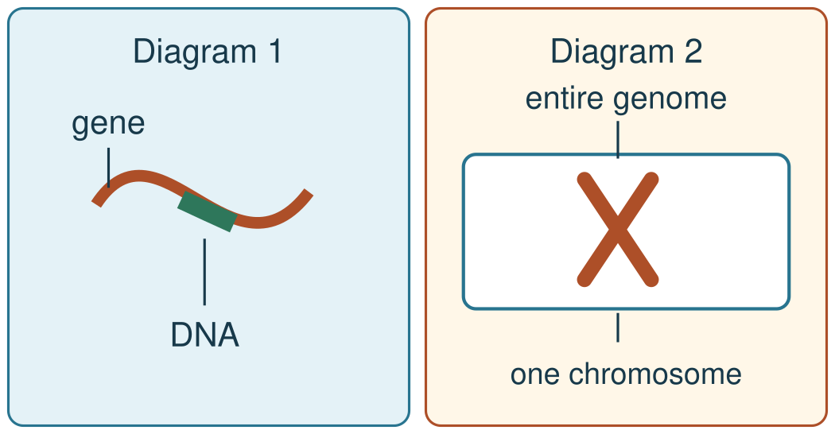
These are deliberately faulty challenge models. They are not teaching facts. Sizes are not to scale.

Science · LAUNCH · Autumn 2 · Week 4 · SCI-LAUNCH-A2-W04 · Date __________
DNA, genes and chromosomes
Today I can… I can label DNA, a gene and a chromosome in a simple model. I can explain that a gene is a section of DNA with a protein instruction. I can distinguish one chromosome from the genome.
Feedback: □ VF □ WS □ I □ NS □ E □ R □ [//] □ [?] __________
Staff answers · model and retrieval
Source authority and prior learning
Recommended generic S4: Describe DNA, genes & chromosomes. Exact goal and criteria above are unchanged. Source: Launch/Autumn_2_2026-27/SCI_LAUNCH_A2_W04/SCI_LAUNCH_A2_W04.html; revision c4ca8ffab98e6186a9ef2fed3921644b177f0d6d. Workbook: _authoring/science_2026-27/_toolchain/scheme_references/LAUNCH_SOW.xlsx; LAUNCH Weekly - Autumn B42 Aut2·W4, C42 Describe DNA, genes & chromosomes.
Starter keys in order: (1) To check whether it benefits people and what risks it has [Autumn 2 Week 3]. (2) Each new daughter-cell nucleus [Autumn 2 Week 1]. (3) In the nucleus [Autumn 1 Week 1]. “Last term” refers to the workbook Autumn 1 block. Confirm actual taught coverage rather than inventing a prior lesson.
Full model, check and fade
Mark a short section of a DNA cord as a gene. Coil the cord as one chromosome; place it inside a border for the genome. Name the section, molecule, package and complete DNA set.
Show-me answer: A gene is a section of DNA. Hear both responses through pointing, board or card and re-model the named step if insecure. The clip is a marker; the DNA section beneath it is the gene and codes for a specific protein. A chromosome is a long DNA molecule packaged with proteins; the genome is all an organism’s DNA, including other DNA.
The nested diagram and string are simplified, not to scale. The genome border is the full DNA set, not a whole-cell label. No personal medical claim is made. Full model → missing gene label at We do → no filled answer at Independent. Next lesson hide the genome label and reconstruct the whole-set meaning before genetic-cross work.
Misconceptions
Chromosome = gene: uncoil the cord, point to one marked DNA section, then to the whole DNA package. Gene = protein or separate cell: the clip marks DNA beneath; that section codes for a protein. Do not say that the clip itself is a gene.
A genomics laboratory scientist compares gene sections and chromosome changes when interpreting a test. This career example is not a medical claim about a learner.

Science · LAUNCH · Autumn 2 · Week 4 · SCI-LAUNCH-A2-W04 · Date __________
DNA, genes and chromosomes
Today I can… I can label DNA, a gene and a chromosome in a simple model. I can explain that a gene is a section of DNA with a protein instruction. I can distinguish one chromosome from the genome.
Feedback: □ VF □ WS □ I □ NS □ E □ R □ [//] □ [?] __________
Staff answers · shared work and hinge
Missing step: gene; the short marked DNA section codes for a specific protein. Leave the pupil blank unfilled. Speaking frame: “A gene is part of …; a chromosome contains …”
Match keys in source card order: short coloured DNA section → gene; whole genetic molecule → DNA; long DNA package → chromosome; all of the organism’s DNA → genome. Option order remains DNA / chromosome / gene / genome. Explain one mismatch and allow retry; do not store answers in HTML.
We do Supported/F: place gene on the short marked part of the full cord. Independent/M: explain how this short section relates to one gene and the larger package. Aspire/H: one chromosome = one gene confuses scale and role. These are alternative support routes, not extra consecutive tasks.
Four-option hinge
Correct B, the second option: A gene within the DNA molecule. A treats a short DNA region as the whole genome. C labels a DNA region as a whole cell and overlooks DNA. D calls a gene a chromosome and confuses one chromosome with all DNA. Keep source question and option order. There is no separate three-choice step check in this source.
Pair adaptation of the source class threshold: hear BOTH learners’ own choices and reasons. Continue to transfer when both are secure. If either is unsure, re-model their named step and ask the parallel hinge while the other continues. Do not use a literal three-in-four pupil count or infer a grade.
Parallel hinge: “A second diagram outlines an organism’s complete DNA set. Which label fits: gene or genome?” Answer: genome; it includes all its DNA.
Independent keys
Comparison Model A is accurate: gene marks the short DNA section. Model B reverses gene and DNA; correct the labels and justify with section/whole molecule. Supported labels gene, DNA, chromosome, genome. Independent explains gene is DNA, not another material. Aspire corrects the gene label and names its protein instruction. Go deeper keeps gene section, DNA molecule, chromosome package and entire DNA set distinct. Two-diagram audit: (1) gene is part of DNA, not DNA inside a gene; (2) one chromosome is part of the genome, not the entire genome. Justify both.

Science · LAUNCH · Autumn 2 · Week 4 · SCI-LAUNCH-A2-W04 · Date __________
DNA, genes and chromosomes
Today I can… I can label DNA, a gene and a chromosome in a simple model. I can explain that a gene is a section of DNA with a protein instruction. I can distinguish one chromosome from the genome.
Feedback: □ VF □ WS □ I □ NS □ E □ R □ [//] □ [?] __________
Staff answers · invitations, prompts and evidence
Optional invitation bank · pass is valid
Route | Invitation | Expected answer
Supported | What is a gene part of? | DNA.
Supported | What is the name for all an organism’s DNA? | The genome.
Independent | How does a chromosome relate to genes? | A long packaged DNA molecule with gene sections.
Independent | What does the gene section code for in this specification? | A specific protein.
Aspire | Why is the whole chromosome not correctly labelled as one gene? | A gene is only a DNA section, with a coding function.
Aspire | What is lost when genome means one chromosome? | Genome is the entire DNA, not one package.
Use invitations privately without cold calling. Each learner may plan in any language and point, sign, speak, draw, type, write, use AAC, an exact scribe or staff-captured photo. No required personal or family disclosure.
Held five-step prompt ladder · staff only
1. Point to the relevant place / instruction.
2. Ask one short question: "What is it asking you to find?"
3. Rephrase the instruction in simpler language.
4. Provide a scaffold or limited choice.
5. Model the first step only, then return the task to the pupil.
First wait five seconds for an independent label. Source cue examples within the ladder: point to the marked string; ask “Is this marker the entire string or part of it?”; model the DNA label on one string while the learner labels the coloured part; complete one label only if needed, then offer a fresh diagram alone. No physical prompting. Record the deepest step separately from the pupil I · S · C box.
Stage scripts: I do “Point to the short marked section, then trace the whole DNA string.” We do “Where is the missing label on this model? What size is it?” Independent “Show the incorrect label first. What does the short section stand for?”

Science · LAUNCH · Autumn 2 · Week 4 · SCI-LAUNCH-A2-W04 · Date __________
DNA, genes and chromosomes
Today I can… I can label DNA, a gene and a chromosome in a simple model. I can explain that a gene is a section of DNA with a protein instruction. I can distinguish one chromosome from the genome.
Feedback: □ VF □ WS □ I □ NS □ E □ R □ [//] □ [?] __________
Staff answers · access, marking and targets
Access and regulation
Cognition: enlarged full cord beside an unlabelled model; fade only the gene marker. Communication: rehearse “part of” with a partner; allow point/sign/AAC labelled explanation. Regulation: private heads-up before faulty-model critique, pause choice and one-label return. Sensory/physical: high-contrast cord, easy-grip clip or digital labelled image/speech-to-text. Language: the same four cards with meanings/examples and any-language planning; keep Independent/Aspire science demand. EAL is language, not SEN.
Check in before hinge, the top rung and Independent. Allow space and one return step; resume at the last completed step with one small choice and private correction. No evidence during distress. Use actual staffing; one learner explains while the other asks/locates, then swap. Keep separate individual work.
Mark actual evidence
Use VF · WS · I · NS(+) · E · R · // · ? only when they occur. R requires the next-step response heard and judged next lesson; it is never automatic. Hear actual Review feedback, invite a real self-edit // or requested read-back ?, and hear the Exit model/reason and precise next sentence. Record hinge split, misconception, actual code and deepest prompt separately.
Book-first: use the exercise book or agreed response mode; do not require writing on these resource pages. Evidence is an observation/result table OR labelled explanation, Review edit and Exit alongside the original. Do not invent a result table for this modelling lesson. Label spoken/practical/photo evidence SCI-LAUNCH-A2-W04 on [SYS]; no pupil data in HTML and no pupil phones needed.
Individual targets
Missing gene: sequencing, attention and independence plus actual prompt. Hinge: agreed response mode/turn-taking without mandatory speech. Arrival/pause: private engagement. Independent: accessible input and target-related independence, not diagnosis. Record actual four-word first-language rehearsal. Link E to each learner’s own education/support/health/care/personal targets on [SYS]. Follow the individual behaviour/support plan where it differs.

Science · LAUNCH · Autumn 2 · Week 4 · SCI-LAUNCH-A2-W04 · Date __________
DNA, genes and chromosomes
Today I can… I can label DNA, a gene and a chromosome in a simple model. I can explain that a gene is a section of DNA with a protein instruction. I can distinguish one chromosome from the genome.
Feedback: □ VF □ WS □ I □ NS □ E □ R □ [//] □ [?] __________
Staff answers · safety, mapping and handoff
Optional prepared-model rehearsal
Kit: short DNA cord, large blunt clips, genome/chromosome frames, tray. Mark one gene with a blunt clip and nest the cord in its frames. Risk: clip pinch and loose cord catch. Use large blunt clips, short cord on a tray, away from necks. Mandatory controls: short length only, counted out and back in, adult-supervised, removed at once if a learner is dysregulated. Confirm actual kit and school risk assessment. Offer a digital labelled picture and no forced handling. This is not a core practical.
Mapping and scheme context
[AWARD] [QUAL] Foundation Biology/Combined Science Paper 1: shared points 3.5 (genome/gene) and 3.13 (chromosome/gene). No Biology-only or higher-tier point is assumed; workbook approach is not an extra specification point. Scheme evidence: [AWARD] [QUAL] foundation topic tests and science units; formative topic quizzes/practical write-ups; summative Topics 1–3 assessment in December.
Evaluation and next lesson
Date taught __________ Delivered as planned __________ Criteria met __________ Adaptations and reasons __________ Change/coverage impact __________ Evidence banked __________. Printed Date and Version stay blank. Record response mode, independence and deepest prompt in handoff.
If behind, retain accurate-model choice plus reason, individual evidence and safety. After a secure hinge shorten repeated oral rehearsal. If necessary merge Exit reflection into Autumn 2 Week 5 Arrival, recording reason and coverage impact. Do not replace individual work with group output. Pass checked understanding and unresolved errors to the next starter.
Next weekly line: Complete a genetic cross (digital Punnett square). Hide the genome label for the next model and reconstruct the whole-set meaning first.
Source resets: one minute inside We do 7, Independent 8 and Review 4. Stage budget: Arrival 5, Starter 3, I do 5, We do 7, We do 2 5, Independent 8, Review 4, Exit 3 = 40 minutes. Optional resources and alternative route views add no minutes.

Science · LAUNCH · Autumn 2 · Week 4 · SCI-LAUNCH-A2-W04 · Date __________
DNA, genes and chromosomes
Today I can… I can label DNA, a gene and a chromosome in a simple model. I can explain that a gene is a section of DNA with a protein instruction. I can distinguish one chromosome from the genome.
Feedback: □ VF □ WS □ I □ NS □ E □ R □ [//] □ [?] __________
TA brief · before and during
Read the exact goal and criteria. Two learners: one explains a label, one asks which part it names; swap, keeping each response. Actual staffing determines who supports; no pupil phones, public cold calling, required speech or personal/family disclosure. Book-first or agreed response mode.
Prepare enlarged full model beside unlabelled model, four word cards, blank response books and chosen input. Cognition: fade gene only. Communication: rehearse “part of”, point/sign/AAC. Sensory: high contrast/easy grip/digital picture/speech typing. Language: meanings/examples and any-language planning; keep the science demand, EAL is not SEN.
Optional kit: short cord, large blunt clips, genome/chromosome frames and tray. Clip pinch/cord catch: large blunt clips, short cord on tray away from necks. Short length only, counted out and back in, adult-supervised and removed immediately if dysregulated. Confirm school risk assessment. Offer picture alternative; no forced handling.
Arrival 5 private predictable notice. Starter 3: hear both attempts. I do 5: short DNA section → gene, packaged DNA → chromosome, all DNA → genome. Clip marks DNA; it is not the gene itself. Source models are not to scale and make no personal medical claim.
We do 7: missing label gene, match keys gene / DNA / chromosome / genome in card order; option order DNA / chromosome / gene / genome. Reset minute is inside 7. We do 2 5: correct B/second, gene within DNA. Hear both own reasons; teacher re-models an unsure learner and asks parallel genome hinge while the other continues.
Independent 8: accurate Model A plus reason and ONE chosen route. Questioner/explainer swap; no filled answer. Source two-diagram audit repairs DNA-inside-gene and one-chromosome-entire-genome. Reset minute inside 8. Review 4 includes reset, actual feedback, true edit // and requested read-back ?. Exit 3 hears each model/reason and precise sentence.

Science · LAUNCH · Autumn 2 · Week 4 · SCI-LAUNCH-A2-W04 · Date __________
DNA, genes and chromosomes
Today I can… I can label DNA, a gene and a chromosome in a simple model. I can explain that a gene is a section of DNA with a protein instruction. I can distinguish one chromosome from the genome.
Feedback: □ VF □ WS □ I □ NS □ E □ R □ [//] □ [?] __________
TA brief · prompts, regulation and handoff
Held five-step prompt ladder · staff only
1. Point to the relevant place / instruction.
2. Ask one short question: "What is it asking you to find?"
3. Rephrase the instruction in simpler language.
4. Provide a scaffold or limited choice.
5. Model the first step only, then return the task to the pupil.
Wait five seconds first. Source cues: point at marked string; “Is this marker the entire string or part of it?”; model DNA on one string, learner labels coloured part; if needed complete one label together then fresh diagram alone. No physical prompts. I do: point short section, trace whole string. We do: where/what size is missing label? Independent: show incorrect label then name the short section.
Check in privately before hinge/top rung/Independent. Give heads-up for faulty-model critique, pause/space/one-label return and private correction. Follow each individual behaviour/support plan. Re-enter last completed step with one small choice. No evidence during distress.
Use actual VF · WS · I · NS(+) · E · R · // · ? only. R is next lesson’s judged response, never automatic. Record deepest prompt separately from I · S · C, valid mode and what was independent. Evidence is labelled explanation or observation/result table, Review edit and Exit beside original work; no invented data table. Use current SCI-LAUNCH-A2-W04 for spoken/practical/photo evidence on [SYS]. No pupil data in HTML.
Targets: missing-step sequencing/attention/independence; agreed hinge mode/turn-taking without mandatory speech; Arrival/pause engagement; accessible Independent input and independence; four-word language rehearsal. Link actual E evidence to personal education/support/health/care/personal targets on [SYS], not diagnosis.
Handoff: criteria met, hinge split/misconception, actual code, deepest prompt, response mode, independence, adaptation/reason, coverage change and banked evidence. Next hide genome label and reconstruct whole DNA meaning before “Complete a genetic cross (digital Punnett square).” If behind preserve individual accurate-model choice/reason/safety; teacher may shorten secure rehearsal or move Exit reflection to Week 5 Arrival with a record. Date/Version __________.

