 | Science · LAUNCH · Autumn 2 · Week 4  SCI-LAUNCH-A2-W04-L3 · Date __________

Knowledge organiser · extraction steps
Today I can
Explain release, filtering and precipitation steps.
Record an observation without claiming purity.
State one practical limit or useful comparison.

Extraction means separating material from cells. A membrane is a boundary around a cell or an organelle.
Mashing breaks up soft fruit tissue. Detergent helps disrupt cell and nuclear membranes. This releases a mixture of cell contents.
Salt assists extraction and precipitation. Filtering removes larger pieces of tissue. The liquid that passes through is the filtrate.
Cold ethanol helps DNA precipitate. A precipitate is material that comes out of a solution. The trained adult handles and layers the ethanol.
Use only the approved method. No tasting or direct pupil contact with chemicals. A supplied-observation route is an equal choice.
Keep each role clear. Say what each step does. Use one step at a time.
I · S · C □

Science · LAUNCH · Autumn 2 · Week 4
SCI-LAUNCH-A2-W04-L3 · Date __________

Knowledge organiser · observation and limits
Today I can
Explain release, filtering and precipitation steps.
Record an observation without claiming purity.
State one practical limit or useful comparison.

An observation records what was seen. Say where the material was and what it looked like.
White strands may be consistent with a DNA-containing precipitate. This uses method knowledge as well as sight. It is an interpretation.
A crude extract is a mixture that has not been purified. Visible material may include other substances. Appearance alone does not establish purity.
A water comparison helps test whether strands appeared in every tube. It does not identify every substance in the fruit sample.
Do not use visible amount as a true measure of DNA yield. Keep fruit mass, volumes, mixing and timing fair. An appropriate DNA measurement is needed for true yield.
Fruit-cell chromosomes contain DNA and genes. This extraction cannot show an individual gene, base sequence or double helix to the naked eye.
I · S · C □

Science · LAUNCH · Autumn 2 · Week 4
SCI-LAUNCH-A2-W04-L3 · Date __________

Word help · extraction and evidence
Today I can
Explain release, filtering and precipitation steps.
Record an observation without claiming purity.
State one practical limit or useful comparison.

Extraction: separating material from cells. Extract: remove from a mixture.
Membrane: a boundary around a cell or an organelle. Detergent: helps disrupt membranes and release cell contents.
Filter: separates larger debris from liquid. Filtrate: the liquid that passes through the filter.
Precipitate: material that comes out of a solution. Crude extract: a mixture that has not been purified.
Observation: what you saw. Interpretation: what the evidence may mean, using what you know.
Purity: whether other substances are present. Yield: how much of a substance is obtained. Visible amount alone does not measure true DNA yield.
DNA carries genetic information. A gene is a section of DNA. Chromosomes contain long DNA molecules. The extraction does not show a single gene or its base sequence.
I · S · C □

Science · LAUNCH · Autumn 2 · Week 4
SCI-LAUNCH-A2-W04-L3 · Date __________

Arrival · Supported · four clues
Today I can
Explain release, filtering and precipitation steps.
Record an observation without claiming purity.
State one practical limit or useful comparison.

Use your book. Point, speak, sign, draw, write or direct an adult. An adult may read or scribe your exact words.
1. Release: What does detergent help to disrupt?
Help: Read or point first. Cell and nuclear boundaries.
2. Filter: What does filtering remove?
Help: Read or point first. Large tissue pieces or individual genes?
3. Observe: Is “white strands appeared” an observation or a purity test?
Help: Read or point first. It describes what was seen.
4. Safety: Who handles and layers the cold ethanol in this route?
Help: Read or point first. Use the adult-directed method.
I · S · C □

Science · LAUNCH · Autumn 2 · Week 4
SCI-LAUNCH-A2-W04-L3 · Date __________

Arrival · Independent · four clues
Today I can
Explain release, filtering and precipitation steps.
Record an observation without claiming purity.
State one practical limit or useful comparison.

Use your book. Point, speak, sign, draw, write or direct an adult. An adult may read or scribe your exact words.
1. Release: What does detergent help to disrupt?
Help: Cell and nuclear boundaries.
2. Filter: What does filtering remove?
Help: Large tissue pieces or individual genes?
3. Observe: Is “white strands appeared” an observation or a purity test?
Help: It describes what was seen.
4. Safety: Who handles and layers the cold ethanol in this route?
Help: Use the adult-directed method.
I · S · C □

Science · LAUNCH · Autumn 2 · Week 4
SCI-LAUNCH-A2-W04-L3 · Date __________

Arrival · Aspire · four clues
Today I can
Explain release, filtering and precipitation steps.
Record an observation without claiming purity.
State one practical limit or useful comparison.

Use your book. Point, speak, sign, draw, write or direct an adult. An adult may read or scribe your exact words.
1. Release: What does detergent help to disrupt?
Help: Cell and nuclear boundaries.
2. Filter: What does filtering remove?
Help: Large tissue pieces or individual genes?
3. Observe: Is “white strands appeared” an observation or a purity test?
Help: It describes what was seen.
4. Safety: Who handles and layers the cold ethanol in this route? Give a reason.
Help: Use the adult-directed method.
I · S · C □

Science · LAUNCH · Autumn 2 · Week 4
SCI-LAUNCH-A2-W04-L3 · Date __________

Starter · choose a first idea
Today I can
Explain release, filtering and precipitation steps.
Record an observation without claiming purity.
State one practical limit or useful comparison.

Use your book. Point, speak, sign, draw, write or direct an adult. An adult may read or scribe your exact words.
White, stringy material appears. Which statement is most careful?
1. I can see one gene.
2. A crude DNA-containing extract may have formed.
3. This proves the sample is pure DNA.
Think first. Give one choice and a reason before checking the evidence. Keep the first idea so you can review it later.
I · S · C □

Science · LAUNCH · Autumn 2 · Week 4
SCI-LAUNCH-A2-W04-L3 · Date __________

Model 1 · Break up the tissue
Today I can
Explain release, filtering and precipitation steps.
Record an observation without claiming purity.
State one practical limit or useful comparison.

Gently mash soft fruit in a sealed bag with the centre-approved extraction solution. Use gentle pressure. An adult prepares the fruit and controls materials. No tasting.
This breaks up tissue and exposes cells. The picture is a simplified model, not a photo of your own result.
Start with soft tissue. Keep the bag sealed. Use gentle pressure. This is an adult-led method. You may direct the adult.
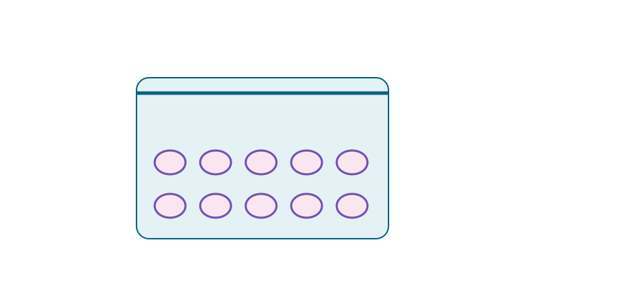 | Mash: break up tissue  Sealed bag • soft  fruit • gentle  pressure  Adult preparation • no tasting
I · S · C □

Science · LAUNCH · Autumn 2 · Week 4
SCI-LAUNCH-A2-W04-L3 · Date __________

Model 2 · Release the contents
Today I can
Explain release, filtering and precipitation steps.
Record an observation without claiming purity.
State one practical limit or useful comparison.

Detergent helps disrupt membranes. Salt assists the extraction and precipitation process.
The membranes around the cell and nucleus are boundaries. Releasing cell contents gives a mixture, not a purified DNA sample.
A membrane is a boundary. It keeps some contents inside. Breaking that boundary lets contents out. The contents still form a mixture.
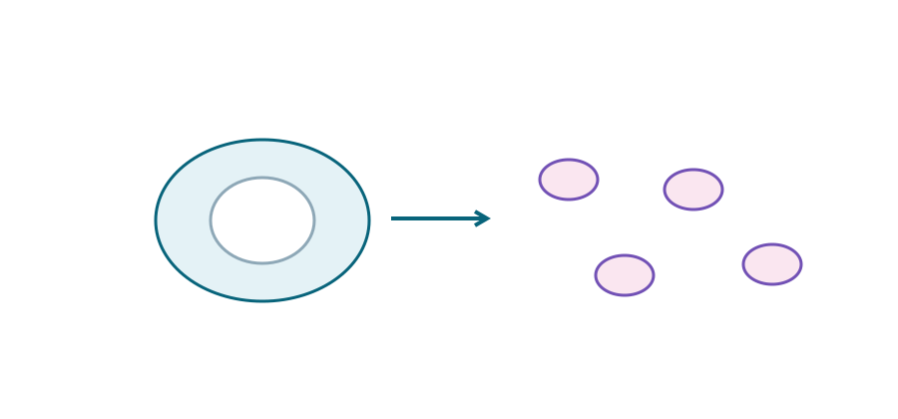 | Detergent: disrupt membranes  Membranes around cell and  nucleus  Released cell contents: a  mixture
I · S · C □

Science · LAUNCH · Autumn 2 · Week 4
SCI-LAUNCH-A2-W04-L3 · Date __________

Model 3 · Remove large debris
Today I can
Explain release, filtering and precipitation steps.
Record an observation without claiming purity.
State one practical limit or useful comparison.

Filter the mixture. The liquid contains dissolved and suspended material released from the fruit.
Filtering removes large tissue debris. It does not remove every dissolved substance. The liquid that passes through is the filtrate.
A filter traps large bits. Liquid goes through. Some small or dissolved material may go through too. Clear does not mean pure.
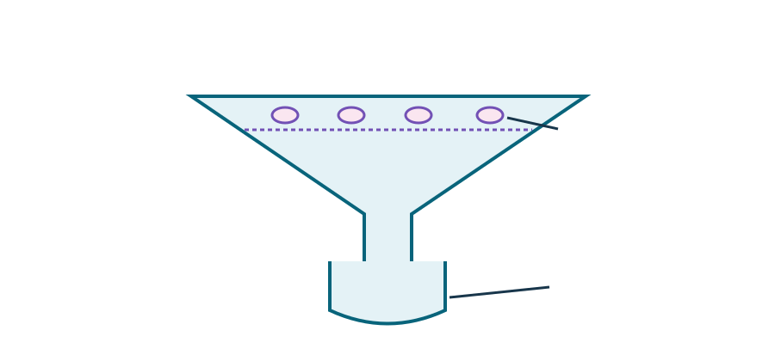 | Filter: remove large debris  Large debris  Filtrate
I · S · C □

Science · LAUNCH · Autumn 2 · Week 4
SCI-LAUNCH-A2-W04-L3 · Date __________

Model 4 · Observe the interface
Today I can
Explain release, filtering and precipitation steps.
Record an observation without claiming purity.
State one practical limit or useful comparison.

An adult carefully layers cold ethanol. White, stringy material may appear; it is a crude DNA-containing extract.
Observe the boundary between liquids. Appearance alone does not establish DNA purity. Other material may remain. No flames, sparks or heat.
Look where the two liquids meet. Say what you see. Keep the claim small. White strands can be a mix of substances.
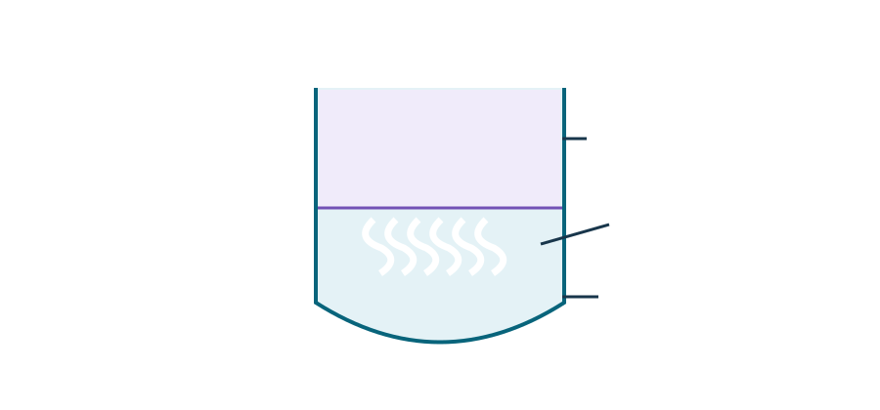 | Ethanol: observe a crude precipitate  Cold ethanol  White strands  Fruit filtrate  Adult handles  ethanol. No  flames or heat.  Appearance alone does not establish DNA purity.
I · S · C □

Science · LAUNCH · Autumn 2 · Week 4
SCI-LAUNCH-A2-W04-L3 · Date __________

Sort · six extraction and evidence cards
Today I can
Explain release, filtering and precipitation steps.
Record an observation without claiming purity.
State one practical limit or useful comparison.

Use your book. Point, speak, sign, draw, write or direct an adult. An adult may read or scribe your exact words.
Choose a card, then a group. Explain one placement using its clue. Take turns as chooser and reason-questioner.
The groups are Release contents / Separate material / Observe and evaluate.
1. Mash soft fruit
2. Add approved detergent–salt solution
3. Filter the mixture
4. Adult layers cold ethanol
5. Record white stringy material
6. Name one contamination limit
Point, use keys, move a card or direct an adult. Swap roles after three cards. Each learner keeps one own reason.
I · S · C □

Science · LAUNCH · Autumn 2 · Week 4
SCI-LAUNCH-A2-W04-L3 · Date __________

Sort · card clues and a choice of help
Today I can
Explain release, filtering and precipitation steps.
Record an observation without claiming purity.
State one practical limit or useful comparison.

1. Mash soft fruit: Break up tissue and expose cells.
2. Add approved detergent–salt solution: Disrupt membranes and assist extraction.
3. Filter the mixture: Remove larger tissue debris.
4. Adult layers cold ethanol: Help DNA precipitate from solution.
5. Record white stringy material: State the appearance without claiming purity.
6. Name one contamination limit: Crude extract may contain other material.
Would a small change help? Ask the lesson teacher for clearer labels, fewer cards, reading help, an adult-directed model or more thinking time.
The teacher will explain what can change, try it and check its effect. Ask privately or pass. No extra form is needed.
I · S · C □

Science · LAUNCH · Autumn 2 · Week 4
SCI-LAUNCH-A2-W04-L3 · Date __________

Worked example · a clear liquid
Today I can
Explain release, filtering and precipitation steps.
Record an observation without claiming purity.
State one practical limit or useful comparison.

After filtering, a liquid looks clear. Does that prove it contains only DNA?
1. The observation is appearance: the liquid looks clear.
2. Filtering removed large debris, not every dissolved substance.
3. Other molecules may remain even when they are not visible.
4. Therefore a clear filtrate is not evidence of pure DNA.
Use what the method can show. A clear look alone cannot identify all the substances present.
Look at the liquid first. Say what you saw. Then say what that can show. The look alone cannot tell us what every substance is.
I · S · C □

Science · LAUNCH · Autumn 2 · Week 4
SCI-LAUNCH-A2-W04-L3 · Date __________

Practical or supplied evidence · safe access
Today I can
Explain release, filtering and precipitation steps.
Record an observation without claiming purity.
State one practical limit or useful comparison.

Use only the teacher-approved method. A trained adult handles all liquids and layers cold ethanol. You may direct an adult or use the supplied observations instead.
Teacher or technician approves the method, concentrations, quantities, eye protection and disposal. Use adult-prepared soft fruit, sealed bags and a tray.
Check allergies privately. No public disclosure is needed. No tasting, human samples or mouth pipetting. No direct pupil contact with chemicals.
Keep ethanol away from flames, sparks and heat. Follow local chemical risk controls. Wash hands. Staff clear spills and dispose of materials as approved.
Observation, adult-directed demonstration and supplied-data routes are equal choices. Do not treat the supplied records as your own practical observations.
You can use the paper route. You do not need to touch the kit. Direct the adult if you wish. The science task stays the same.
I · S · C □

Science · LAUNCH · Autumn 2 · Week 4
SCI-LAUNCH-A2-W04-L3 · Date __________

Supplied observations · keep the evidence route clear
Today I can
Explain release, filtering and precipitation steps.
Record an observation without claiming purity.
State one practical limit or useful comparison.

Use your book. Point, speak, sign, draw, write or direct an adult. An adult may read or scribe your exact words.
These observations are fictional teaching records. They are not results from your classroom. Use them if a practical or demonstration is not suitable.
Fruit extract: white stringy material at the liquid boundary after layering ethanol.
Water comparison: no visible strands after layering ethanol.
Limit: no chemical purity test was performed.
The observation is consistent with a DNA-containing precipitate from the fruit extract. The water comparison helps show that strands did not simply appear in every tube.
It does not identify all substances or prove purity. Record an actual demonstration only if you observed it. Keep supplied and observed evidence distinct.
A record tells us what was seen. A claim says what it may mean. Keep them apart. The sample has a clear limit.
I · S · C □

Science · LAUNCH · Autumn 2 · Week 4
SCI-LAUNCH-A2-W04-L3 · Date __________

Evidence record · observation, meaning and limit
Today I can
Explain release, filtering and precipitation steps.
Record an observation without claiming purity.
State one practical limit or useful comparison.

Use your book. Point, speak, sign, draw, write or direct an adult. An adult may read or scribe your exact words.
Label the evidence route: classroom observation, adult demonstration or supplied fictional record.
Record the ordered method. Say what mashing, detergent, salt, filtering and adult-controlled ethanol each do.
Write “I observed…” for what you saw. For supplied evidence, use “The supplied record states…”. Describe colour, location and texture.
Then give a cautious interpretation: “This is consistent with a crude DNA-containing extract.” Do not call it pure DNA.
Name one limit and a useful comparison or improvement. A water comparison does not identify every component.
Connect the material to fruit-cell DNA, chromosomes and genes. The extraction does not reveal individual genes or a base sequence. Keep the evidence and its limit together.
Use three short parts. First say what you saw. Next say what it may mean. Then say what it cannot show.
I · S · C □

Science · LAUNCH · Autumn 2 · Week 4
SCI-LAUNCH-A2-W04-L3 · Date __________

DNA, genes and chromosomes · recap and connection
Today I can
Explain release, filtering and precipitation steps.
Record an observation without claiming purity.
State one practical limit or useful comparison.

Use this recap if it helps. Do not assume a previous lesson was completed. Describe complementary base pairing. State the chromosome–DNA–gene relationship.
DNA carries genetic information. A gene is a section of DNA. A chromosome contains a long DNA molecule. DNA bases pair in a model; this practical cannot show those pairs.
The extracted DNA came from fruit-cell chromosomes and contains many genes. It does not reveal an individual gene or the base sequence.
Explain what filtration separates. Why is an observation different from identifying every component?
Keep a precise method, an observation and one evaluation point. A diagram is simplified and not to scale. It is not a photograph of your own result.
I · S · C □

Science · LAUNCH · Autumn 2 · Week 4
SCI-LAUNCH-A2-W04-L3 · Date __________

Reference cards · observation, inference or limit
Today I can
Explain release, filtering and precipitation steps.
Record an observation without claiming purity.
State one practical limit or useful comparison.

Use your book. Point, speak, sign, draw, write or direct an adult. An adult may read or scribe your exact words.
Use within the evidence discussion if needed. Classify a statement, then explain the clue. This is not another practical.
1. White strands: white stringy material appeared at the liquid boundary.
2. DNA-containing material: the method and expected chemistry support that the precipitate contains DNA.
3. Purity unknown: the white material may contain substances other than DNA.
Groups: Direct observation / Scientific inference / Method limitation. Say what was seen, what is inferred and what cannot be concluded.
Take turns to choose, justify and check. You may direct a partner to move a card. Cutting is optional.
I · S · C □

Science · LAUNCH · Autumn 2 · Week 4
SCI-LAUNCH-A2-W04-L3 · Date __________

Independent task · Supported
Today I can
Explain release, filtering and precipitation steps.
Record an observation without claiming purity.
State one practical limit or useful comparison.

Use your book. Point, speak, sign, draw, write or direct an adult. An adult may read or scribe your exact words.
Choose one route. Use the whole shared 14 minutes for your task, feedback and one improvement. Do not complete all three routes.
1. Explain: Link mashing, detergent, filtering and ethanol to their roles.
Help: Use the step cards: mash / detergent / filter / cold ethanol. Match each step to its stated purpose.
2. Record: Write an observation and a cautious interpretation using your evidence route.
Help: Choose actual demonstration or supplied observations. Complete: I observed ___; this may indicate ___.
3. Evaluate: Give one limitation and one useful comparison or improvement.
Help: Complete: the appearance supports a crude extract, but does not prove ___. One useful extra check would be ___.
Label classroom or supplied evidence. Adult handles all materials. Use paper, cards, point or exact scribing. Keep your own explanation and its limit.
I · S · C □

Science · LAUNCH · Autumn 2 · Week 4
SCI-LAUNCH-A2-W04-L3 · Date __________

Independent task · Independent
Today I can
Explain release, filtering and precipitation steps.
Record an observation without claiming purity.
State one practical limit or useful comparison.

Use your book. Point, speak, sign, draw, write or direct an adult. An adult may read or scribe your exact words.
Choose one route. Use the whole shared 14 minutes for your task, feedback and one improvement. Do not complete all three routes.
1. Explain: Link mashing, detergent, filtering and ethanol to their roles.
Help: Use release, remove debris and precipitate.
2. Record: Write an observation and a cautious interpretation using your evidence route.
Help: Start “I observed…” or “The supplied record states…”.
3. Evaluate: Give one limitation and one useful comparison or improvement.
Help: Purity, equal fruit mass, same volumes or a water comparison.
Label classroom or supplied evidence. Adult handles all materials. Use paper, cards, point or exact scribing. Keep your own explanation and its limit.
I · S · C □

Science · LAUNCH · Autumn 2 · Week 4
SCI-LAUNCH-A2-W04-L3 · Date __________

Independent task · Aspire
Today I can
Explain release, filtering and precipitation steps.
Record an observation without claiming purity.
State one practical limit or useful comparison.

Use your book. Point, speak, sign, draw, write or direct an adult. An adult may read or scribe your exact words.
Choose one route. Use the whole shared 14 minutes for your task, feedback and one improvement. Do not complete all three routes.
1. Explain: Link mashing, detergent, filtering and ethanol to their roles.
Help: Use release, remove debris and precipitate.
2. Record: Write an observation and a cautious interpretation using your evidence route.
Help: Start “I observed…” or “The supplied record states…”.
3. Fair comparison: Two groups get different amounts of visible material. Why is this not automatically a fair comparison of DNA yield?
Help: Think fruit mass, volumes, mixing, timing and purity.
Label classroom or supplied evidence. Adult handles all materials. Use paper, cards, point or exact scribing. Keep your own explanation and its limit.
I · S · C □

Science · LAUNCH · Autumn 2 · Week 4
SCI-LAUNCH-A2-W04-L3 · Date __________

Review · real audience and one next move
Today I can
Explain release, filtering and precipitation steps.
Record an observation without claiming purity.
State one practical limit or useful comparison.

Use your book. Point, speak, sign, draw, write or direct an adult. An adult may read or scribe your exact words.
Show one useful science explanation to the adult. Keep your words and evidence route exact. The adult names back the science they heard or saw.
Check the method role, the observation, the interpretation and the limit. Change one overclaim or clarify one missing link.
Choose a named next move: secure / mixed / misconception / access / method or evidence. Say “Next I will ___.” Try the change on your existing work.
Keep what you said and what changed after the adult listened. No extra participation form is needed. Review happens within the 14-minute independent block.
I · S · C □

Science · LAUNCH · Autumn 2 · Week 4
SCI-LAUNCH-A2-W04-L3 · Date __________

Exit · Supported · two checks
Today I can
Explain release, filtering and precipitation steps.
Record an observation without claiming purity.
State one practical limit or useful comparison.

Use your book. Point, speak, sign, draw, write or direct an adult. An adult may read or scribe your exact words.
Answer both small checks. Use your own explanation and the model or evidence.
1. Role: Why is detergent used in fruit-DNA extraction?
Help: Use: my answer is ___ because ___. Point to a model or card first. Think membranes and released contents.
2. Limit: Why should the visible material not be called pure DNA?
Help: Use: the evidence shows ___, but cannot yet show ___. Consider what else may be present.
I · S · C □

Science · LAUNCH · Autumn 2 · Week 4
SCI-LAUNCH-A2-W04-L3 · Date __________

Exit · Independent · two checks
Today I can
Explain release, filtering and precipitation steps.
Record an observation without claiming purity.
State one practical limit or useful comparison.

Use your book. Point, speak, sign, draw, write or direct an adult. An adult may read or scribe your exact words.
Answer both small checks. Use your own explanation and the model or evidence.
1. Role: Why is detergent used in fruit-DNA extraction?
Help: Think membranes and released contents.
2. Limit: Why should the visible material not be called pure DNA?
Help: Consider what else may be present.
I · S · C □

Science · LAUNCH · Autumn 2 · Week 4
SCI-LAUNCH-A2-W04-L3 · Date __________

Exit · Aspire · two checks
Today I can
Explain release, filtering and precipitation steps.
Record an observation without claiming purity.
State one practical limit or useful comparison.

Use your book. Point, speak, sign, draw, write or direct an adult. An adult may read or scribe your exact words.
Answer both small checks. Use your own explanation and the model or evidence.
1. Role: Why is detergent used in fruit-DNA extraction?
Help: Think membranes and released contents.
2. Fair comparison: Two groups get different amounts of visible material. Why is this not automatically a fair comparison of DNA yield?
Help: Think fruit mass, volumes, mixing, timing and purity.
I · S · C □

Science · LAUNCH · Autumn 2 · Week 4
SCI-LAUNCH-A2-W04-L3 · Date __________

Staff answers · Supported
Arrival:1 membranes;2 larger tissue debris;3 an observation;4 trained adult following local risk assessment. Aspire gives a valid reason using model/evidence.
Explain: mashing breaks tissue; detergent disrupts membranes; salt assists extraction/precipitation; filtering removes large debris; cold ethanol helps DNA precipitate. Adult controls the ethanol and all liquids.
Record: supplied record states white strands appeared at the boundary; consistent with a crude DNA-containing extract. Do not rewrite supplied data as the pupil’s own observed result.
Evaluate: appearance does not show purity. Keep conditions consistent and use a useful comparison. A water comparison does not chemically identify DNA. Exit2: other cell material may remain; appearance alone does not establish purity.
Exit1: detergent helps disrupt membranes, releasing cell contents including DNA. For all routes, record own reasoning, one valid limit and one next step; do not infer independence from clicks or completion.

Science · LAUNCH · Autumn 2 · Week 4
SCI-LAUNCH-A2-W04-L3 · Date __________

Staff answers · Independent
Arrival:1 membranes;2 larger tissue debris;3 an observation;4 trained adult following local risk assessment. Aspire gives a valid reason using model/evidence.
Explain: mashing breaks tissue; detergent disrupts membranes; salt assists extraction/precipitation; filtering removes large debris; cold ethanol helps DNA precipitate. Adult controls the ethanol and all liquids.
Record: supplied record states white strands appeared at the boundary; consistent with a crude DNA-containing extract. Do not rewrite supplied data as the pupil’s own observed result.
Evaluate: appearance does not show purity. Keep conditions consistent and use a useful comparison. A water comparison does not chemically identify DNA. Exit2: other cell material may remain; appearance alone does not establish purity.
Exit1: detergent helps disrupt membranes, releasing cell contents including DNA. For all routes, record own reasoning, one valid limit and one next step; do not infer independence from clicks or completion.

Science · LAUNCH · Autumn 2 · Week 4
SCI-LAUNCH-A2-W04-L3 · Date __________

Staff answers · Aspire
Arrival:1 membranes;2 larger tissue debris;3 an observation;4 trained adult following local risk assessment. Aspire gives a valid reason using model/evidence.
Explain: mashing breaks tissue; detergent disrupts membranes; salt assists extraction/precipitation; filtering removes large debris; cold ethanol helps DNA precipitate. Adult controls the ethanol and all liquids.
Record: supplied record states white strands appeared at the boundary; consistent with a crude DNA-containing extract. Do not rewrite supplied data as the pupil’s own observed result.
Evaluate/Exit2: different fruit masses, volumes, mixing, timing or contaminants can alter visible material. Keep conditions fair and use an appropriate DNA measurement before comparing true yield.
Exit1: detergent helps disrupt membranes, releasing cell contents including DNA. For all routes, record own reasoning, one valid limit and one next step; do not infer independence from clicks or completion.

Science · LAUNCH · Autumn 2 · Week 4
SCI-LAUNCH-A2-W04-L3 · Date __________

Staff answers · models, cards and evidence
Starter: second option, a crude DNA-containing extract may have formed. First and third overclaim visible genes/purity.
Six sorter placements, in order: release/release/separate/separate/judge/judge. Each exact card clue is on the pupil clue page. All six are distinct steps in the method/evidence reasoning.
Four worked steps: clear is appearance; filtering removed large debris, not all dissolved material; invisible other molecules may remain; clear filtrate does not prove pure DNA.
Fictional table: fruit extract white strands at boundary; water no visible strands; no chemical purity test. Water comparison counters strands in every tube; it does not identify all substances or establish true DNA yield.
Reference cards: white strands=direct observation; DNA-containing material=scientific inference based on method knowledge; purity unknown=method limitation. Preserve the distinction and pupil reason.
DNA recap: chromosomes contain long DNA molecules; genes are sections of DNA. Extracted material came from fruit-cell chromosomes and contains many genes. This method does not show individual genes, base sequence/base pairs or naked-eye double helix.

Science · LAUNCH · Autumn 2 · Week 4
SCI-LAUNCH-A2-W04-L3 · Date __________

Staff guidance · method, evidence and identity
Teacher/technician chooses physical adult demonstration, pupil-directed adult handling or supplied-observation route. Label the fruit-DNA activity non-core. Approve local method, chemical concentrations/quantities, PPE and disposal. Adult prepares fruit/solutions and handles all liquids; no pupil direct contact. Do not add quantities or procedural steps from this resource.
Local chemical risk assessment applies. Ethanol is flammable: adult controlled, away from flames/sparks/heat. Check allergy privately; no tasting, mouth pipetting or human samples. Sealed soft-fruit bag/tray; wash hands; staff clear spills and dispose as approved.
Secure→fade content prompts/transfer a limit; mixed→point to deciding evidence and invite revision; misconception→contrast observation with purity claim and recheck; access→change format/mode/adult role while keeping goal; method/evidence→keep gap visible, name approved check/source needed.
Current main DOM+lesson-data stage clock4/3/4/4/3/4/14/4 governs40min. Legacy config.timings3minArrival/15minIndependent and alternate I-can objective are stale. Body/main wrongly W8L1/Introduce; corrected to W12L3/Do, taught Autumn2Week4. Stale amylase pH/iodine print residue and W8L2next-link excluded by recorded correction.
Existing six W12L3 hub members examined: old17slide deck and teacher/pupil notes are not current-DOM-equivalent. Reissue/restructure source content, metadata/credit and standard member routes in CHECKS. Workbook LAUNCH Weekly - Autumn B42Aut2·W4 C42 exact: Describe DNA, genes & chromosomes.
Source Launch/W8-W13_2026-27/SCI_L_W12L3_Fruit_DNA_Evidence_Do.html @ c4ca8ffab98e6186a9ef2fed3921644b177f0d6d. Original source unchanged. No awarding/qualification external link reproduced.

Science · LAUNCH · Autumn 2 · Week 4
SCI-LAUNCH-A2-W04-L3 · Date __________

TA brief · access, safety and pair roles
Two learners switch card chooser and reason-questioner after three cards, then speaker and listener. Each chooses a route and keeps own evidence, explanation and both exit answers.
Read or scribe exact pupil words. Point/say/sign/draw/write/type/adult-directed handling are valid; allow thinking time/private ask/pass. No cold calling, speed ranking, forced contact or public allergy disclosure.
Adult controls all liquids and ethanol. No pupil touching or tasting; no flames/sparks/heat; no human samples/mouth pipetting. Follow local approved method/PPE/disposal. Supplied records and observation are equal alternatives.
Prepare cards/organiser/books, pencils and source model views. If practical route is authorised: adult-prepared fruit/solutions, sealed bag, filter/mesh, clear tube, cold ethanol/tray under staff control. Otherwise use fictional table and picture sequence.
Teacher hears optional help request, says what can change, tries it and checks effect. Each pupil’s final response has a real adult audience and one named next teaching move. No extra pupil form.

Science · LAUNCH · Autumn 2 · Week 4
SCI-LAUNCH-A2-W04-L3 · Date __________

TA brief · held five-step prompt record
Use the least prompt that gives access, then fade. Keep this adult record separate from pupil I · S · C □ marking.
1. Point to the relevant place / instruction.
2. Ask one short question: "What is it asking you to find?"
3. Rephrase the instruction in simpler language.
4. Provide a scaffold or limited choice.
5. Model the first step only, then return the task to the pupil.
Record pupil/date/task, response mode, prompt step1–5 or none, exact response, support faded and next teaching step. Do not infer marking codes from clicks, saved answers or completed boxes.

