Source A · NHS public information
Paraphrase accurately and label the source.
Compare agreement and differences in emphasis.
Remove or qualify unsupported individual predictions.

Cystic fibrosis is inherited. Altered gene copies from both parents cause thick, sticky mucus. This can affect the lungs and digestion. Treatments can help ease symptoms. Care depends on the person.
This source gives a public overview. It does not tell us one person’s exact symptoms or future.
Publisher: NHS. Title: Cystic fibrosis. Use the Causes, Symptoms and Treatments sections.
Source A full page: ask an adult to use the link in the page tools or staff notes.
Accessed 24 October 2026. Page reviewed 28 February 2025. This is a classroom paraphrase, not a quotation. The full page can be opened by the teacher.

Source B · NHS Genomics Education
Paraphrase accurately and label the source.
Compare agreement and differences in emphasis.
Remove or qualify unsupported individual predictions.

Cystic fibrosis usually involves harmful variants in both copies of CFTR. This is an autosomal recessive condition. A carrier has one changed copy in this model. The effects can vary.
Two carrier parents: each pregnancy | Model chance
Child has the condition | 1 in 4 = 25%
Child is a carrier | 2 in 4 = 50%
Child inherits neither changed copy | 1 in 4 = 25%

These chances apply each time. They do not predict a set family count or the severity of one person’s symptoms.
NHS Genomics Education Programme. Page: Cystic fibrosis. Read Genomics, then Inheritance and genomic counselling. Use these parts to check the gene and how changed copies pass to a child.
Source B full page: ask an adult to use the link in the page tools or staff notes.
Checked 24 October 2026. This card uses our own words. It is not a quote. We have not given a review date for this source.

Sources · purpose and limits
Paraphrase accurately and label the source.
Compare agreement and differences in emphasis.
Remove or qualify unsupported individual predictions.

Both sources are NHS sources. They have different readers and are not wholly independent publishers.
Source A | Source B
Public information about effects and care | More detail about genes and inheritance

Both support inherited cause. More detail does not by itself mean a conflict. Check the actual claim, source section, date and purpose.
Read the source, cover it, explain the meaning in your own words, then check it. Keep the source label beside each claim.
Use fictional cases. Do not ask for family details or predict a person’s future. Inheritance and infection precautions are separate matters.

Arrival · Supported
Paraphrase accurately and label the source.
Compare agreement and differences in emphasis.
Remove or qualify unsupported individual predictions.

Four checks. Point, speak, sign, draw, write or direct an adult. An adult may read or scribe your exact words. Choose one route; do not complete all three.
1. Attribution
What should you record beside a source claim?
Help: Read or point first. Who says it and where it can be found.
2. Paraphrase
Does paraphrase mean changing just one word?
Help: Read or point first. Explain the meaning in your own wording.
3. Model
Two parents are carriers. What is the chance that their child has CF each time?
Help: Read or point first. Use the one-in-four model.
4. Limit
Does the one-in-four chance tell us how severe one person’s symptoms will be?
Help: Read or point first. Inheritance and severity are different questions.
My response: ____________________

Independent · Supported
Paraphrase accurately and label the source.
Compare agreement and differences in emphasis.
Remove or qualify unsupported individual predictions.

Point, speak, sign, draw, write or direct an adult. An adult may read or scribe your exact words. Choose one route; do not complete all three.
1. Trace
Complete the claim–evidence ledger for all three claims.
Help: For each claim, choose A / B / not established. Copy only a brief supporting idea into the ledger.
2. Paraphrase
Write two accurate source-linked sentences in your own words.
Help: Say the source idea aloud, cover it, then explain the meaning. Add Source A or Source B.
3. Compare
Explain one agreement and one difference in emphasis between the sources.
Help: Use: both sources say ___. Source A emphasises ___; Source B gives more detail about ___.
My response: ____________________
One partner explains. The other asks for the clue. Swap roles. Keep your own first answer, feedback and next step.
Use one route for the full 10 minutes. Keep your own record and response.

Exit · Supported
Paraphrase accurately and label the source.
Compare agreement and differences in emphasis.
Remove or qualify unsupported individual predictions.

1. Trace
What makes a claim traceable?
Help: Use: my answer is ___ because ___. Point to a model or card first. The next reader can find the source and the line that supports the claim.
2. Compare
Source B gives more detail than Source A. Must this mean they disagree?
Help: Use: both ___; a difference is ___. Check what each source says. More words do not prove that the claims clash.
My response: ____________________

Arrival · Independent
Paraphrase accurately and label the source.
Compare agreement and differences in emphasis.
Remove or qualify unsupported individual predictions.

Four checks. Point, speak, sign, draw, write or direct an adult. An adult may read or scribe your exact words. Choose one route; do not complete all three.
1. Attribution
What should you record beside a source claim?
Help: Who says it and where it can be found.
2. Paraphrase
Does paraphrase mean changing just one word?
Help: Explain the meaning in your own wording.
3. Model
Two parents are carriers. What is the chance that their child has CF each time?
Help: Use the one-in-four model.
4. Limit
Does the one-in-four chance tell us how severe one person’s symptoms will be?
Help: Inheritance and severity are different questions.
My response: ____________________

Independent · Independent
Paraphrase accurately and label the source.
Compare agreement and differences in emphasis.
Remove or qualify unsupported individual predictions.

Point, speak, sign, draw, write or direct an adult. An adult may read or scribe your exact words. Choose one route; do not complete all three.
1. Trace
Complete the claim–evidence ledger for all three claims.
Help: Use A, B or not supported.
2. Paraphrase
Write two accurate source-linked sentences in your own words.
Help: Say “Source A explains…” without pretending it is a quote.
3. Compare
Explain one agreement and one difference in emphasis between the sources.
Help: Source A gives a broad view. Source B gives more detail about genes.
My response: ____________________
One partner explains. The other asks for the clue. Swap roles. Keep your own first answer, feedback and next step.
Use one route for the full 10 minutes. Keep your own record and response.

Exit · Independent
Paraphrase accurately and label the source.
Compare agreement and differences in emphasis.
Remove or qualify unsupported individual predictions.

1. Trace
What makes a claim traceable?
Help: The next reader can find the source and the line that supports the claim.
2. Compare
Source B gives more detail than Source A. Must this mean they disagree?
Help: Check what each source says. More words do not prove that the claims clash.
My response: ____________________

Arrival · Aspire
Paraphrase accurately and label the source.
Compare agreement and differences in emphasis.
Remove or qualify unsupported individual predictions.

Four checks. Point, speak, sign, draw, write or direct an adult. An adult may read or scribe your exact words. Choose one route; do not complete all three.
1. Attribution
What should you record beside a source claim?
Help: Who says it and where it can be found.
2. Paraphrase
Does paraphrase mean changing just one word?
Help: Explain the meaning in your own wording.
3. Model
Two parents are carriers. What is the chance that their child has CF each time?
Help: Use the one-in-four model.
4. Limit
Does the one-in-four chance tell us how severe one person’s symptoms will be? Give a reason.
Help: Inheritance and severity are different questions.
My response: ____________________

Independent · Aspire
Paraphrase accurately and label the source.
Compare agreement and differences in emphasis.
Remove or qualify unsupported individual predictions.

Point, speak, sign, draw, write or direct an adult. An adult may read or scribe your exact words. Choose one route; do not complete all three.
1. Trace
Complete the claim–evidence ledger for all three claims.
Help: Use A, B or not supported.
2. Paraphrase
Write two accurate source-linked sentences in your own words.
Help: Say “Source A explains…” without pretending it is a quote.
3. Resolve a conflict
A page sells a product. It claims that it will cure everyone. What checks would you make before using this claim?
Help: Check the proof, who wrote it, why and when. Check a trusted health source too.
My response: ____________________
One partner explains. The other asks for the clue. Swap roles. Keep your own first answer, feedback and next step.
Use one route for the full 10 minutes. Keep your own record and response.

Exit · Aspire
Paraphrase accurately and label the source.
Compare agreement and differences in emphasis.
Remove or qualify unsupported individual predictions.

1. Trace
What makes a claim traceable?
Help: The next reader can find the source and the line that supports the claim.
2. Resolve a conflict
A page sells a product. It claims that it will cure everyone. What checks would you make before using this claim?
Help: Check the proof, who wrote it, why and when. Check a trusted health source too.
My response: ____________________

Word page
Paraphrase accurately and label the source.
Compare agreement and differences in emphasis.
Remove or qualify unsupported individual predictions.

Word | Meaning
Source | Where the information comes from.
Publisher | Who is responsible for the source.
Paraphrase | Explain the meaning in your own words.
Carrier | One altered allele in this recessive model.
Autosomal recessive | Two altered copies are usually needed. The gene is on a non-sex chromosome.
Uncertainty | What the source does not establish.

Say the idea in your own words. Keep its meaning and name the source.

Knowledge organiser
Paraphrase accurately and label the source.
Compare agreement and differences in emphasis.
Remove or qualify unsupported individual predictions.

Paraphrase and compare source evidence, keeping supported claims separate from inference and uncertainty.
Find a claim. Check who says it. Show the line that supports it. Say it in your own words. Check where the sources agree. State what they do not show.
Research step | What I do
Find | Keep a bounded question and two named sources.
Label | Keep publisher, title, date, purpose and claim together.
Map | Link inheritance to one effect on the body.
Gap | State what the sources do not establish.

CF usually involves altered CFTR alleles from both parents. Thick mucus can affect lungs and digestion. A model chance does not predict one person’s exact symptoms.
Source A: NHS public information. Source B: NHS Genomics Education. Their different emphasis need not be a conflict.
Use fictional cases. Do not ask for family details or predict a person’s future. Inheritance and infection precautions are separate matters.

Starter
Paraphrase accurately and label the source.
Compare agreement and differences in emphasis.
Remove or qualify unsupported individual predictions.

Which is the strongest evidence note?
A. The internet says it
B. Source B states autosomal recessive inheritance; this supports the inheritance part of my question
C. It must be true because it sounds scientific
Keep a first choice. Give the clue before you check the answer.

Find
Paraphrase accurately and label the source.
Compare agreement and differences in emphasis.
Remove or qualify unsupported individual predictions.

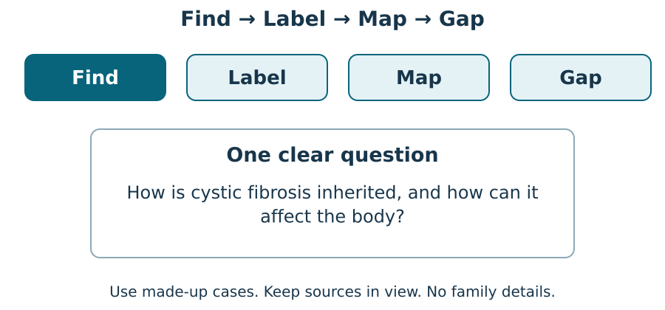
Use a clear question. Find two NHS sources. Keep the question beside your work. What does each source help you find out?

Label
Paraphrase accurately and label the source.
Compare agreement and differences in emphasis.
Remove or qualify unsupported individual predictions.

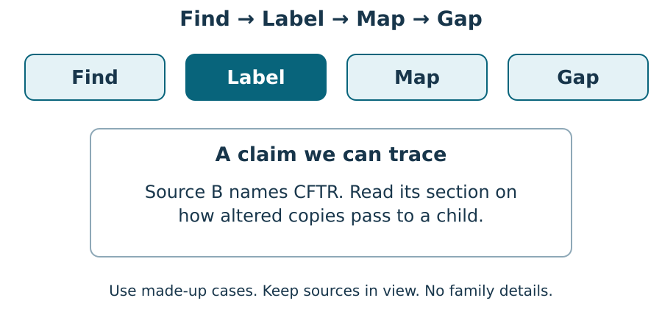
Name who wrote it and the page title. Keep the date and the claim. Show the line you used. What does it support?

Map
Paraphrase accurately and label the source.
Compare agreement and differences in emphasis.
Remove or qualify unsupported individual predictions.

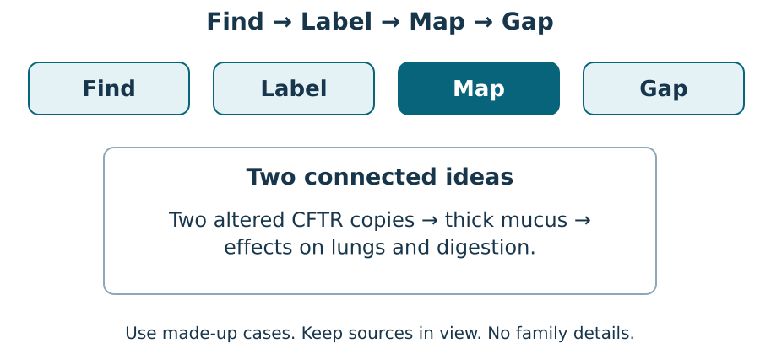
Link the gene copies to an effect on the body. Keep one limit. Point to each link and say what the sources show.

Keep a gap visible
Paraphrase accurately and label the source.
Compare agreement and differences in emphasis.
Remove or qualify unsupported individual predictions.

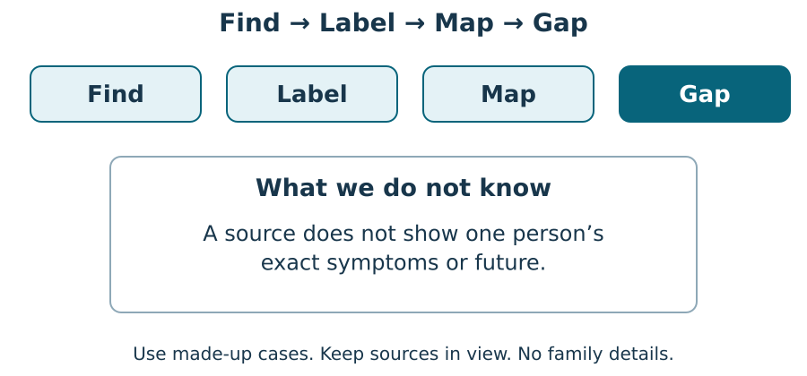
Say what the source shows. Then say what it cannot show about one person. What would you need to check next?

We do · sort with evidence
Paraphrase accurately and label the source.
Compare agreement and differences in emphasis.
Remove or qualify unsupported individual predictions.

Choose a group for each card. Give the source clue for one choice.
Card | Your group
CFTR is involved in cystic fibrosis | ________________
Two carriers have a 25% model chance each pregnancy | ________________
Thick mucus can affect lungs and digestion | ________________
Every affected person has identical symptoms | ________________
The next child is affected because the previous three were not | ________________
We can diagnose someone from this classroom model | ________________

Groups: Supported by the supplied sources / Not established by these sources.
One partner explains. The other asks for the clue. Swap roles. Keep your own first answer, feedback and next step.

I do 2 · a worked example
Paraphrase accurately and label the source.
Compare agreement and differences in emphasis.
Remove or qualify unsupported individual predictions.

The source says that effects can vary. How can you say this in your own words?
Find the source line. Read it, then cover it.
Keep this meaning: CF can affect people in different ways.
Write: the effects can differ from person to person. Name Source B.
Check your words against the source. Do not add a claim about who will have the worst effects.

A claim–evidence ledger
Paraphrase accurately and label the source.
Compare agreement and differences in emphasis.
Remove or qualify unsupported individual predictions.

Trace each claim. Give A, B or not established. Add the precise source section, a paraphrase and a limit. Do not invent a quotation.
Claim | Source / section | Limit
CF involves altered CFTR copies | ________ | ________
Thick mucus can affect breathing | ________ | ________
A particular person will have severe symptoms | ________ | ________

My first claim in my own words: ____________________
Its source and the line I used: ____________________
My second claim in my own words: ____________________
Its source and the line I used: ____________________

Agreement, difference and next step
Paraphrase accurately and label the source.
Compare agreement and differences in emphasis.
Remove or qualify unsupported individual predictions.

Both sources say: ____________________
Source A emphasises: ____________________
Source B gives more detail about: ____________________
A commercial page promises a guaranteed cure. My checks before using this claim: ____________________
Keep your first answer. Hear what the adult noticed. Make one real change, or give a reason to keep it. Ask for a read-back if it helps.
Actual feedback and next response: ____________________

Staff answers · shared work
Starter
A traceable note identifies the source, the specific claim and how it answers the question.
Worked example
Paraphrase the idea “severity varies” without making a prediction about an individual.
Locate the relevant source statement.
Keep its meaning: people can have different effects or severity.
Write: “The effects are not identical for every person” (Source B).
Do not add an unsupported claim about who will be affected most.
Shared evidence task
CFTR: Source B, but many variants and individual effects vary. Thick mucus: Source A, but it does not predict each individual. Severe symptoms for one person: not supported; leave this claim out or state the gap.
Card placements
Card | Group
CFTR is involved in cystic fibrosis | Supported by the supplied sources
Two carriers have a 25% model chance each pregnancy | Supported by the supplied sources
Thick mucus can affect lungs and digestion | Supported by the supplied sources
Every affected person has identical symptoms | Not established by these sources
The next child is affected because the previous three were not | Not established by these sources
We can diagnose someone from this classroom model | Not established by these sources

Staff answers · Supported
Arrival
1. Attribution: The publisher/title or source identifier and the relevant location/link.
2. Paraphrase: No; it means expressing the meaning accurately in your own words.
3. Model: 25%.
4. Limit: No.
Independent / application
1. Trace: B for CFTR; A for mucus; individual severe symptoms are not supported.
2. Paraphrase: Accept accurate paraphrases with correct A/B attribution, preserving probability and variation.
3. Compare: Both explain inherited CF; A emphasises public effects/care, while B gives CFTR and inheritance detail. This is not necessarily a contradiction.
Two-check exit
1. Trace: It is linked to an identifiable source and the relevant statement or section.
2. Compare: No. Different audiences may explain the same evidence at different levels of detail.

Staff answers · Independent
Arrival
1. Attribution: The publisher/title or source identifier and the relevant location/link.
2. Paraphrase: No; it means expressing the meaning accurately in your own words.
3. Model: 25%.
4. Limit: No.
Independent / application
1. Trace: B for CFTR; A for mucus; individual severe symptoms are not supported.
2. Paraphrase: Accept accurate paraphrases with correct A/B attribution, preserving probability and variation.
3. Compare: Both explain inherited CF; A emphasises public effects/care, while B gives CFTR and inheritance detail. This is not necessarily a contradiction.
Two-check exit
1. Trace: It is linked to an identifiable source and the relevant statement or section.
2. Compare: No. Different audiences may explain the same evidence at different levels of detail.

Staff answers · Aspire
Arrival
1. Attribution: The publisher/title or source identifier and the relevant location/link.
2. Paraphrase: No; it means expressing the meaning accurately in your own words.
3. Model: 25%.
4. Limit: No. Accept a scientifically correct reason that uses the relevant model or evidence.
Independent / application
1. Trace: B for CFTR; A for mucus; individual severe symptoms are not supported.
2. Paraphrase: Accept accurate paraphrases with correct A/B attribution, preserving probability and variation.
3. Resolve a conflict: Check the actual supporting studies and whether the claim agrees with reliable reviewed clinical guidance; identify commercial purpose and avoid repeating a guarantee without adequate evidence.
Two-check exit
1. Trace: It is linked to an identifiable source and the relevant statement or section.
2. Resolve a conflict: Check the actual supporting studies and whether the claim agrees with reliable reviewed clinical guidance; identify commercial purpose and avoid repeating a guarantee without adequate evidence.

Staff guidance · pair, access and feedback
The pair works with a shared model and individual evidence. One explains and one asks for the clue, then they swap. Hear both independent reasons before moving on. Re-model an unsure learner’s step and use a fresh parallel question while the other continues.
No cold calling or forced public reading. A learner may pass. Point, sign, speak, draw, type, write, direct an adult or use exact scribing. Read the task exactly when needed. Keep the science challenge and allow planning in any language. EAL is language, not SEN.
Use a stable tray or large cards and the agreed accessible input. Give processing time. Agree a quiet supervised pause and a brief first–then cue. Re-enter at the last completed step. Do not gather evidence while a learner is distressed.
Record actual VF, WS, I, NS(+), E, R, // and ? only when they occur. Keep deepest adult prompt separate from the pupil response. A real adult receives and names back the science. R requires the pupil’s response to an NS(+) next step and real Audience; never award it for a click or completion. Keep the pupil’s own wording and own-colour response.

Staff guidance · evidence and handover
Keep each first response, result or labelled explanation, the feedback and the pupil’s edit or justified decision to keep it. E requires an observable curriculum action on [SYS]. Use SCI-LAUNCH-A2-W06-L2 for written, spoken, practical or photographic evidence. Record prompt level, response mode, support faded and what was independent.
At Independent agree actual adult roles and swap across the week. If one adult attends, use the actual staffing plan. Follow individual support and behaviour plans. Record access, regulation and curriculum actions against the learner’s own targets without recording a diagnosis as evidence.
If behind, preserve each source-linked claim, each learner’s response and the safety teaching. After a secure check shorten repeated oral rehearsal. Record any change, reason and coverage impact. Pass checked understanding, deepest prompt and unresolved errors to Week 7. Do not replace incomplete individual work with a group product.
Evaluation: date taught; delivered as planned; criteria met; actual adaptations and reasons; changes to the scheme and coverage; evidence banked. Source evidence mapping remains [AWARD] [QUAL]; no unit or qualification award is claimed by this lesson.

Staff · sources and lesson scope
Weekly outcome: Research a genetic condition online; present.
Exact goal: Paraphrase and compare source evidence, keeping supported claims separate from inference and uncertainty.
Source: Launch/W14-W15_2026-27/SCI_L_W14L2_Genetic_Condition_Source_Evidence_Explore.html; revision c4ca8ffab98e6186a9ef2fed3921644b177f0d6d.
Workbook: _authoring/science_2026-27/_toolchain/scheme_references/LAUNCH_SOW.xlsx; LAUNCH Weekly - Autumn B44 Aut2·W6; C44 above.
The workbook says online. Preserve the accepted prepared offline source-card route; teacher-opened full sources are optional, with no automatic external loads and no pupil phone required.
Source A: NHS, Cystic fibrosis. https://www.nhs.uk/conditions/cystic-fibrosis/
Source B: NHS Genomics Education, Cystic fibrosis. https://www.genomicseducation.hee.nhs.uk/genotes/knowledge-hub/cystic-fibrosis/
Both pages checked 24 October 2026. Use the source cards for classroom access, with the full source for checking. Do not diagnose or invite personal medical disclosure.
The two NHS sources serve different audiences and are not fully independent. Current Source A does not explicitly state the salt/water mechanism; the classroom card does not attribute that sentence to it.
No [AWARD] or [QUAL] assessment alignment is newly asserted. Career link: a genetic counsellor explains chances and limits with care.

TA brief · access and source checks
Agree who supports each learner. Swap roles across the week. Hear each learner’s first response. Point, sign, speak, draw, type or write. You may pass or pause. An adult can read or scribe your exact words. Plan in any language.
Use large source cards and a clear desk. Keep the question and source beside the task. Let the pupil point to the line before asking for a full explanation.
Least prompt first: wait; point to the source; ask one short question; rephrase; model a different example, then return the task. Record deepest prompt separately from independence.
I do: name the source and the claim. We do: ask which line supports it. Independent: help access the card while keeping the learner’s science decision.
No cold calling, forced public reading or disclosure. Agree a private pause and re-entry at the last completed step. No evidence collection during distress.
Use fictional cases. Do not ask for family details or predict a person’s future. Inheritance and infection precautions are separate matters.
Use prepared cards and fictional cases. No biological samples, family history or diagnosis. Staff check local risk assessment and internet access.

TA brief · feedback and handover
Keep the first answer. The adult names back the pupil’s meaning. The pupil chooses a real edit or explains why to keep it.
Use VF, WS, I, NS(+), E, R, // and ? only when they occur. R requires the real response loop; a click or completed sheet alone is not enough.
Record valid spoken, written or directed evidence under SCI-LAUNCH-A2-W06-L2 on [SYS]. Keep each learner’s own claim, source, limit, actual feedback and next response.
Handover: checked criteria, misconception, prompt depth, independence, valid mode, adaptation and reason, next example. Follow the learner’s own plan and targets.
If behind, shorten secure rehearsal. Preserve each learner’s sourced explanation and exit. Record any coverage moved. Week 7 reviews autumn science.
Timing: Arrival 4 min; Starter 4 min; I do 5 min; We do 5 min; I do 2 4 min; We do 2 4 min; Independent 10 min; Exit 4 min. Total 40 minutes. Alternate route views share the same stage time.

