Arrival
Look at the kit. Point to one thing you know.
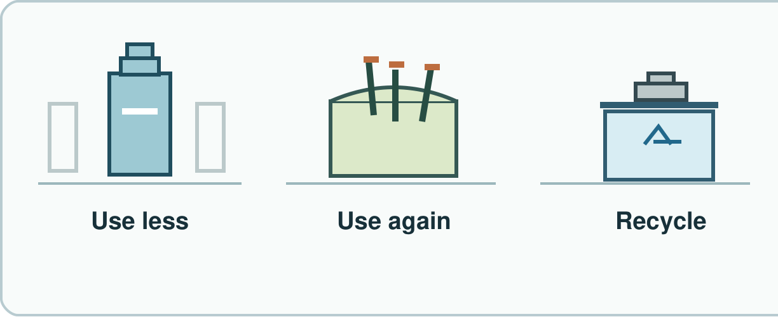
My response

Starter
Think back. Say it, sign it or point.
1. Where do animals get food?

2. What helps bones move?

3. What helps hold your body up?

Talk-then-sort
Sort the clean cards with us.
This sheet has a blank back. I can write there. I put it in ____.
Choices: Use less · Use again · Check local bin
Card or step | My group or match
Write on a sheet's blank back
Fill a clean tub again
Check the local bin for a can

Choose a clean item. Show what you can do.
Independent F
Pick one way to use less.
I use less when I ____.
My response

Independent M
Show one item you can use again. Say why.
I can use ____ again because ____.
My response

Independent H
Which uses less new stuff: fill a clean tub again or take a new tub? Why?
I choose ____ because it needs less ____.
My response

Go deeper
Could one safe item be used again before it is sorted for a bin? Show how.
My response

Tub or sheet: pick a first step for each. Which avoids a new item? Why?
My response

Exit
Show how you know. Tell your teacher.
My exit response

Read it back: I am learning to choose ways to care for a place.
My feedback was… I showed…
Next I need to… try one small fix.
Word help
Word | Meaning | Example | My language
reduce | use less | I use the back. I need less paper.
reuse | use a thing again | I fill a clean tub again.
recycle | make new things from old stuff | An old can can be made into a new thing.
material | what a thing is made of | This can is made of metal.

