Arrival
Look at two safe rocks. Point to one you know.
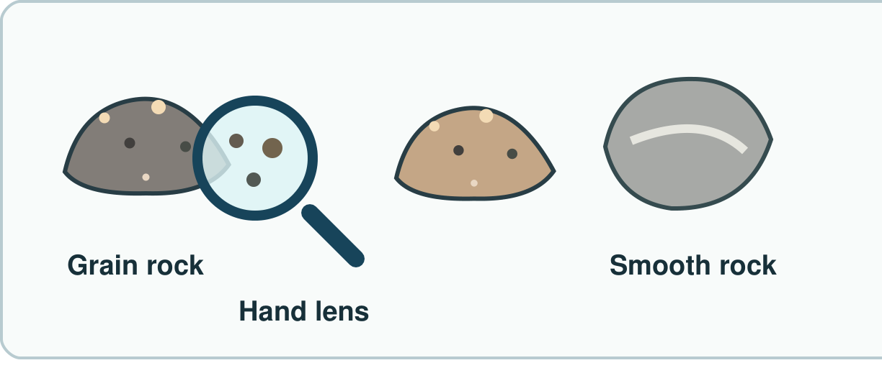
My response

Starter
Think back. Say, sign or point.
1. What are three ways to use less waste?

2. How do animals get food?

3. Which part helps you move with bones?

Talk-then-sort
Feel two rocks. Sort safe samples.
This rock feels smooth. I put it with the ____ rocks.
Choices: Smooth · Rough
Card or step | My group or match
Practice clue: smooth face
Practice clue: bumpy face
Practice clue: jagged edge

Sort a safe rock. Show your rule.
Independent F
Look at two rocks. Point to one change.
This one feels ____.
My response

Independent M
Sort two rocks by one thing you can check.
I put these in one group as they are ____.
My response

Independent H
Sort the same rocks in two ways. Tell why.
I can sort them by ____ and by ____.
My response

Go deeper
Could one rock fit two groups? Show both rules.
My response

Swap the rule. Which rocks move group, and why?
My response

Exit
Show your rule to an adult.
My exit response

Read it back: I am learning to look at rocks and sort them.
My feedback was… I showed…
Next I need to… try one small fix.
Word help
Word | Meaning | Example | My language
rock | a solid thing from the ground | I hold a safe rock.
grain | a small bit in a rock | I see tiny grains.
property | a thing you can check | This rock feels rough.
group | things put together by a rule | These rocks are smooth.

