Arrival
Point to a safe rock.
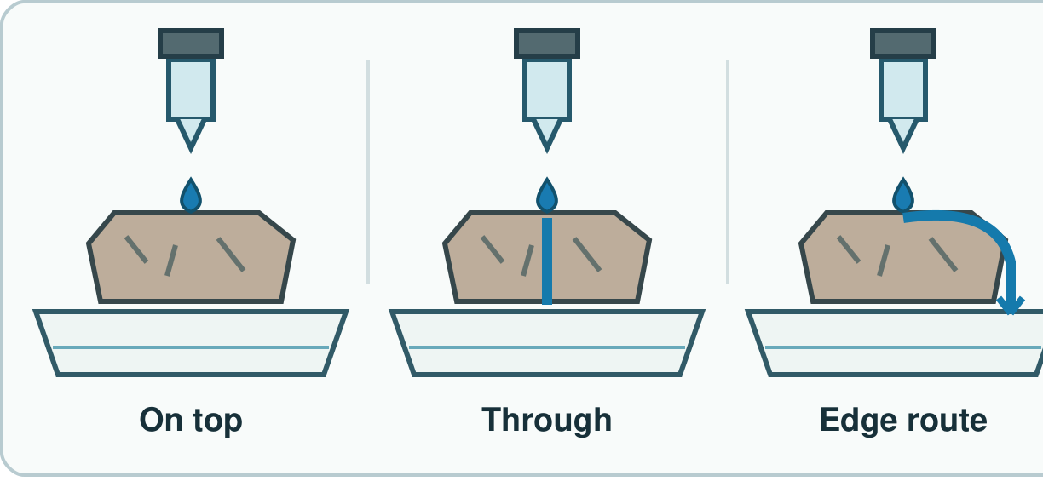
My response

Starter
Think back. Say, sign or point.
1. How can we sort two rocks?

2. What can we do with a clean tub?

3. Name one body part that helps protect organs.

Talk-then-sort
Test two safe rocks.
Mark B. Add three drops. The drops ____.
Choices: Mark test · Water test
Card or step | My group or match
Use an adult-held blunt tool
Add three drops
Look in the tray below

Show each test. Record what you saw.
Independent F
Point to a mark and a wet rock.
I can see ____ on the rock.
My response

Independent M
Show both tests. Tell what you saw.
The drops ____ on sample ____.
My response

Independent H
Why use the same tool and drops?
This is fair as I kept ____ the same.
My response

Go deeper
Could a hard rock also let water through? Use each test result.
My response

A drop slides off. How will you fix the test?
My response

Exit
Tell an adult what you saw.
My exit response

Read it back: I am learning to test a rock in two ways.
My feedback was… I showed…
Next I need to… try one small fix.
Word help
Word | Meaning | Example | My language
hardness | how hard a thing is to mark | The tool marks this rock.
absorb | take in a liquid | Water soaks in.
water | a liquid used in our test | I add three drops.
test | a check to find out | I test two rocks.

