Arrival
Pick a safe model or card to look at.
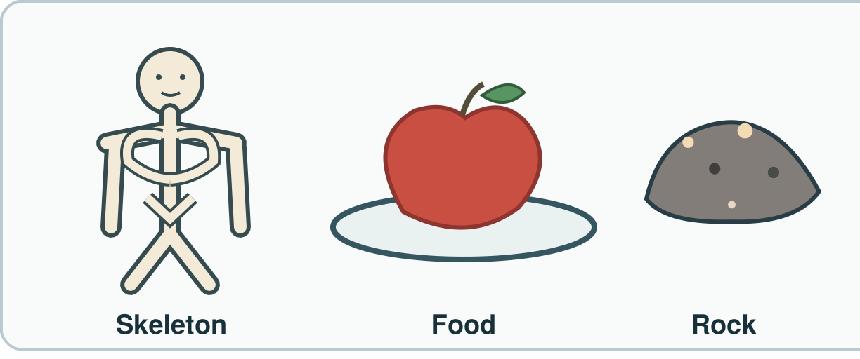
My response

Starter
Think back. Say, sign or point.
1. What stays the same in a fair water test?

2. Is a finished brick raw or made?

3. Where do animals get food?

Talk-then-sort
Match a real model to a fact.
I point to a safe rock. I felt a rough side. My fact is ____.
Choices: Body · Food · Rock
Card or step | My group or match
Bone model
Food-group picture
Safe rough sample

Show work you did about body, food or rock.
Independent F
Show one fact about a body or rock.
I show ____.
My response

Independent M
Show two facts. Tell how you found one.
I know ____ as I saw ____.
My response

Independent H
Pick your best real evidence. Why does it fit?
This is good evidence as ____.
My response

Go deeper
Pick a claim you cannot show. What could you check?
My response

Pick the best real result. Why does it fit?
My response

Exit
Tell an adult what you know and how.
My exit response

Read it back: I am learning to show a fact about bodies, food and rocks.
My feedback was… I showed…
Next I need to… try one small fix.
Word help
Word | Meaning | Example | My language
skeleton | bones that help hold a body up | I point to the bone model.
nutrition | what a body gets from food to grow and stay well | An animal gets nutrition from food.
rock | a solid thing from the ground | I can test a safe rock.
evidence | what you saw or did that helps show a claim | My rock sort shows my rule.

