Arrival
Sort a coin, paper circle and ball: flat or solid?
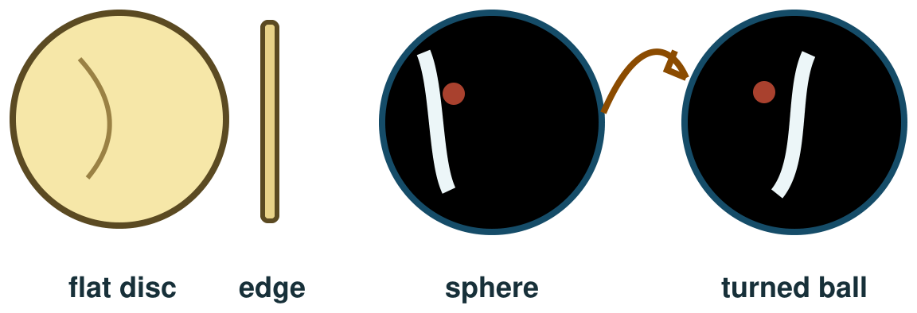
My response

Starter
Think back. Say, point or write one answer for each question.
1. What makes day turn to night at one place?

2. What goes around the Sun?

3. Name one force you have explored.

Talk-then-sort
Use a ball and a paper circle. The model and first label are ready. Turn the ball and complete the missing label: new side or the same flat face?
Ball → turn it → see ____ → useful because ____.
Choices: flat · solid
Card or step | My group or match
Paper circle
Coin face
Ball

Turn a shape model. Explain one way it helps and one limit. You can show, say or draw.
Independent F
Choose a ball rather than a flat circle.
I choose the ___ to show shape.
My response

Independent M
Turn the ball and explain what new view it gives.
When I turn it, I see ___ because ___.
My response

Independent H
Explain what a ball model reveals and how its scale may mislead.
The model helps because ___; its limit is ___.
My response

Go deeper
Compare a ball and a photo. What can each show, and what does each hide?
My response

A photo shows Earth as a circle. Choose another observation or model to test its full shape. Explain why one photo is not enough.
My response

Exit
Show which shape model helps. Say one way it helps and one thing it cannot show exactly.
My exit response

? Read it back: show how a ball models the Sun, Earth and Moon.
My feedback was… say what changed. Next I need to… name a fix.
Word help
Word | Meaning | Example | My language
spherical | shaped roughly like a ball | Earth is approximately spherical.
curve | a line or surface that bends | The ball has a curved surface.
shadow | a dark area where an object blocks light | The ball makes a shadow on the card.
model | a simple way to show an object or idea | A ball is a model of Earth’s shape.

