Arrival
Sort these: weather today; climate over many years. Point to the long-term idea.
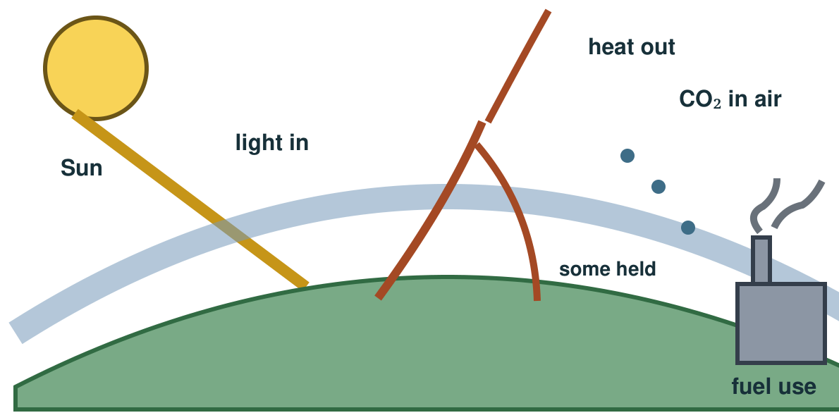
My response

Starter
Think back. Say, point or write one answer for each question.
1. Name one fact about the Solar System and its class card.

2. Why does one place have night?

3. Name one way friction can affect motion.

Talk-then-sort
The burn fuel and impact cards are in place. Sort the missing gas and warming cards. Explain the link.
Burn fuel → add carbon dioxide → ____ → heat risks.
Choices: cause · middle link · impact · action
Card or step | My group or match
Burn fossil fuel
More greenhouse gas
Heat risk in some places
Cut fuel use

Build a cause-to-impact chain. Compare an emissions cut with help for an impact. Give one reason for each.
Independent F
Order one cause and effect.
First ___, then ___.
My response

Independent M
Explain two chain links.
Burning ___ adds ___; this leads to ___ because ___.
My response

Independent H
Compare an emissions cut with an adaptation.
Action A changes ___, while action B helps with ___; I would choose ___ because ___.
My response

Go deeper
Why might a council cut fuel use and plan flood defences? Name a limit of each.
My response

Choose a council goal, justify the first action and explain the problem still left.
My response

Exit
Name a cause, an effect and an action. Which link does your action change?
My exit response

? Read it back: explain a cause and an effect of global warming, then compare two kinds of action.
My feedback was… say what changed. Next I need to… name a fix.
Word help
Word | Meaning | Example | My language
climate | the pattern of weather over many years | Climate is not the weather on one day.
carbon dioxide | a gas added to the air when fossil fuels burn | Burning coal adds carbon dioxide to the air.
greenhouse gas | a gas in the air that slows heat leaving Earth | Carbon dioxide is a greenhouse gas.
impact | an effect on people or places | More heat can have an impact on people.

