Arrival
Choose the question card: does surface change how far this toy goes? Point to what we will change.
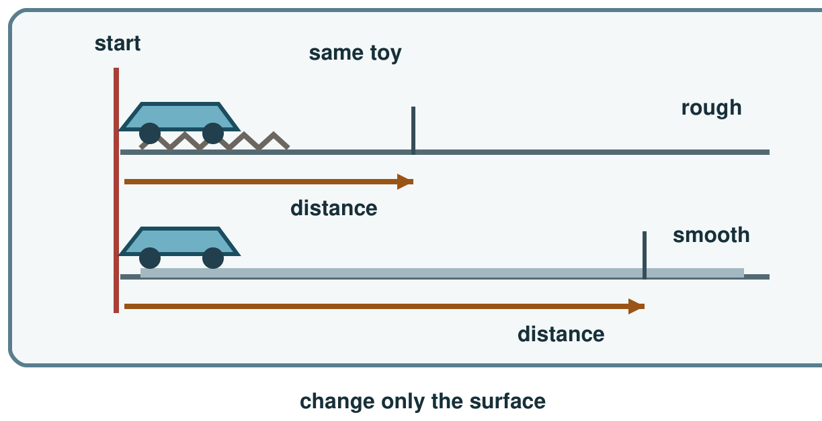
My response

Starter
Think back. Say, point or write one answer for each question.
1. What should match a science claim?

2. Name an effect of added greenhouse gases.

3. What do we keep the same in a fair test?

Talk-then-sort
The plan has a fixed toy and start line. Add the missing launch control. Name the surface to change.
Change ____ → keep toy and ____ the same → measure distance.
Choices: change · keep same · measure
Card or step | My group or match
Surface type
Toy
Start line
Travel distance

Test two runs per surface or observe. Record distance. Name what changed, stayed the same and could limit the test.
Independent F
Point to the factor that changes.
I change the ___; I keep ___ the same.
My response

Independent M
Name two controls and record a result.
I changed ___ and kept ___ the same. My result was ___.
My response

Independent H
Explain why repeat runs help and identify a method limit.
My result suggests ___, but I would repeat ___ because ___.
My response

Go deeper
Two runs differ. Name a reason and fix a method step.
My response

Two repeats differ. Name a safe conclusion, then improve the method for the next test.
My response

Exit
Name the change, one control, one result and a next step.
My exit response

? Read it back: plan a fair investigation, record a result and explain a limit.
My feedback was… say what changed. Next I need to… name a fix.
Word help
Word | Meaning | Example | My language
variable | a factor that can change in a test | The surface is our changed variable.
fair test | a test that changes one key factor and keeps other key factors the same | We use the same toy in both runs for a fair test.
result | what you observe or measure in a test | Our result is the distance the toy travelled.
repeat | do the test again under the same conditions | We repeat each run to check our result.

