Arrival
Choose a model used this term. Point to one question it could help answer.
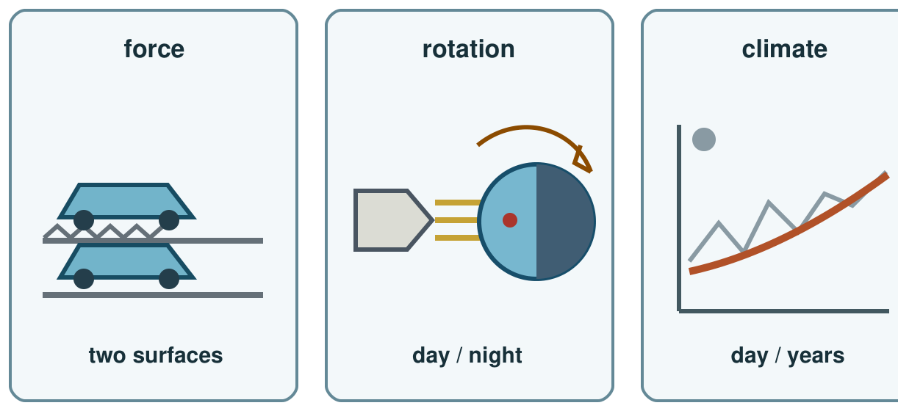
My response

Starter
Think back. Say, point or write one answer for each question.
1. What changed in last week’s fair test?

2. What model can help with a toy motion question?

3. Name one force you learned in Autumn 1.

Talk-then-sort
In practice, the question and torch-and-ball model are supplied. Complete the missing clue: what happens to the marked place as the ball turns?
Question: what slowed the toy? → choose toy and surface → observe ____ → explain a possible force; check with repeat runs.
Choices: toy and surface · torch and ball · long-term cards
Card or step | My group or match
Question about friction
Question about day and night
Question about climate

Choose two science questions from forces, space or climate. Show an answer with a model and a matching clue. Use only your agreed support if this is formal evidence.
Independent F
Match one question to its model.
For ___, I choose ___.
My response

Independent M
Use a model and matching clue to explain a science idea.
My answer is ___; I saw ___ in the model.
My response

Independent H
State one limit of a model and suggest a further check.
The model suggests ___, but I would check ___ because ___.
My response

Go deeper
For one claim, give two checks and one model limit. Say which extra observation you would seek.
My response

Compare two model limits. Choose a claim neither can settle alone and name a new observation that would help.
My response

Exit
Tell the adult what you learned, which clue you used, your feedback and one next step. They use your answer to plan the next model or support.
My exit response

? Read it back: use a model and a matching clue to show what you know in science.
My feedback was… say what changed. Next I need to… name a fix.
Word help
Word | Meaning | Example | My language
evidence | a result or observation that supports a claim | A measured distance is evidence about a toy run.
force | a push or pull on an object | Friction is a contact force.
rotation | a turn around an axis | Earth’s rotation makes day and night.
climate | weather patterns over many years | Climate is not the weather on one day.

